**SL9. Asking for Clarification**

Student Name: _________________________________ Student ID Number: ________________________

Instructor: _____________________________________ Level: ___________Date: ___________________

**IMPORTANT NOTE: Sections 1-3 in the SDLA must be completed before meeting with a tutor and receiving a stamp. Write/type and record all your answers on this handout.**

**After completing this SDLA, you will be able to:**

* Clarify information that you said
* Ask for clarification from others
* Identify clarification expressions and questions in a conversation
* Use appropriate clarification expressions and questions in a conversation

**Sections 1-3 (approximately 45 minutes):** Read the information. Follow each step below to complete this SDLA. Be prepared to explain your answers when you meet with a tutor.

**Section 1: Introduction**

Go to YouTube and watch the following FedEx commercial: [**http://tinyurl.com/y66okf**](http://tinyurl.com/y66okf)

**How much of what the man said did you understand?** Please circle one: 0% 25% 50% 75% 100%

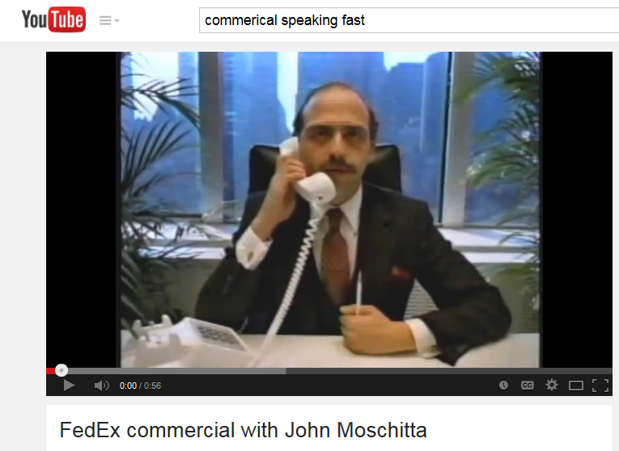Don’t worry if you didn’t understand much of what the man said. The man in the video, John Moschitta, held the world record for the "Fastest Talker" in the Guinness Book of World Records. It’s no wonder it was difficult to understand him.

Another reason why it was difficult to understand him was because you couldn’t ask him to rephrase, reword, or repeat what he had said. In everyday conversations, we can ask people to **clarify1** what we do not understand. Asking others to clarify what they have said is an important skill that can help you in any situation, whether it is at work, school, home, etc.

**Brainstorm:** How could you have asked the man to **clarify** what you did not understand? Write down some phrases you could have used.

Example: *Excuse me. Could you say that again?*

1. _______________________________________________________
2. _______________________________________________________
3. _______________________________________________________

**1Clarify:** to make something easier to understand; to make something clear.

**Section 2: How to Clarify**

**A: Clarification Expressions:** When speaking with other people, you will need to use clarification expressions or questions in the following situations:

**Situation 1:** You may need to clarify information when someone does not understand **what you said**.

|  |
| --- |
| **Clarifying an Idea** |
| * Let me explain ... * Let me explain that in more detail... * Let me put it in another way... * In other words... * To say this differently... * To put it differently... * To clarify, that means … |

**Situation 2:** You may need to **ask** for clarification when you do not understand **what someone said**.When you ask for clarification, you should think about how formal the situation is. The situation could be…

* Informal – a conversation between friends or family members
* Neutral - any conversation
* Formal – a conversation at work, at school, in a meeting, in an interview, etc.

|  |  |  |
| --- | --- | --- |
| **Informal** | **Neutral** | **Formal** |
| * I didn't / don't get that. * What was that? * You lost me. * What did you say? * Again, please. * Say that again. * I don't get it. * I'm lost / confused. * What? * Huh? * One more time? * So, you’re saying … | * Do you think we can go over that again? * Would you mind repeating that? * Could you say that again, (please)? * Sorry, but I'm not sure I'm following you. * Excuse me, but I didn't catch the part about... * I'm sorry, but what did you say about...? * What do you mean by …? * Could you be more specific? | * I beg your pardon, but I don't quite understand. * Pardon me. * Would you repeat that again, please? * I wonder if you could say that in a different way. |

**B: Sample Conversations:** Listen to and read the conversations below. To listen to the conversations, log in to the ESL tutoring website at [www.mtsac.edu/llc](http://www.mtsac.edu/llc). Go to the *Resources and Links* for SL9 and select **@Audio File 1** for conversation 1 and **@Audio File 2** for conversation 2. Please ask an ESL tutor or a person at the LLC desk if you need help listening to these audio files. You may listen to the conversations as many times as needed.

One conversation is more formal and one is more informal. Underline all the expressions or questions used to clarify or ask for clarification.

**Conversation 1: The Drive Thru**

**Employee:** Hi, welcome to McDonald’s! How can I help you?

**Customer:** Hi. I’d like a Big Mac and a small Coke.

**Employee:** What was that?

**Customer:** I’ll have a Big Mac and a small Coke.

**Employee:** Oh ok. Would you like to make that a combo for two more dollars?

**Customer:** So, you’re saying for two more dollars I can get a large drink and a large fry?

**Employee:** Yep!

**Customer:** Okay. I’ll do that.

**Employee:** Okay. So I have a Big Mac combo. That’ll be $7.18 at the second window.

**Customer:** Wait, what? I didn’t get that.

**Employee:** Your meal will cost $7.18. You can pay that at the second window.

**Customer:** Oh! I thought you said $17.00!

**Conversation 2: Cooking Class**

**Ms. Ramos (Instructor):** Okay, so now that we have put our pizza crust in the oven, we are going to make the sauce to put on top! First, we want to finely chop our garlic cloves. Then we will dice our tomatoes and onions. We put all three of those in a pan with olive oil and bring it to a simmer. After that, you want to add the basil leaves and let it simmer for a while before adding the salt and pepper.

**Student A:** Pardon me. But I didn’t catch how many garlic cloves we need to chop.

**Ms. Ramos:** That’s because I didn’t say. I usually use 3 to 4 cloves. It really depends on how much you like garlic. In other words, it’s completely up to you. You’re the chef, after all.

**Student B:** I’m sorry, but would you repeat the part about the olive oil again? Do we heat the oil in the pan before we add the garlic?

**Ms. Ramos:** Yes, you want to heat the oil for about 1 minute before you add the other ingredients.

**Student A:** I’m sorry, Ms. Ramos, but I’m lost. Could you please be more specific about how long we need to simmer the sauce for?

**Ms. Ramos:** Of course. Let me explain it all in more detail and demonstrate it for you . . .

**C: Fill-in-the-blanks:** Read the conversation below. Decide whether the situation is formal or informal. Fill in the blanks with an appropriate clarification expression or question. More than one expression or question may be possible for some blanks.

**Conversation at a Clothing Store:**

**Store Clerk**: Hi. Welcome to *Charlotte’s*. Can I help you find something or are you just looking?

**Marianne**: I'm not sure. Aren't you having a sale right now?

**Store Clerk**: We are! Everything with a red sign above it is on sale. And every red sign with a black sticker means that you can get an additional 10% off if you are a member. If you are not a member, you could sign up today to get the 10% off and an additional $10 coupon just for signing up today.

**Marianne**: I’m sorry, ________________________. It sounds too good to be true. _______________________

___________________________________________________?

**Store Clerk:** Sure, ________________________________. If you sign up for our membership card today, you get $10 off your purchase. All the items in the store with a red sign above are on sale. If the red sign has a black sticker, then you will also get 10% off because you have your new membership card.

**Marianne:** Wow! That red sign says 40% off, and it has a black sticker. ___________________________ if I get the membership card today, I can get 50% off those items? Can I also use a 10% off coupon that I got from the Internet?

**Store Clerk**: You sure can!

**Section 3: Student Self-Assessment**

C:\Documents and Settings\wcuser1553\Local Settings\Temporary Internet Files\Content.IE5\Z02HHZPN\MC900072629[1].gif*Complete this self-assessment before meeting with a tutor.* **Now that you’ve completed sections 1 to 3, check the things you can do:**

* I can clarify information when someone does not understand what I said.
* I can ask for clarification when I do not understand what someone said.
* I can identify clarification expressions and questions in a conversation.
* I can use appropriate clarification expression and questions in a conversation.

**DON’T FORGET! Write your name on the clipboard to work with a tutor. The tutor will call your name when he/she is ready.**

**Section 4: Practice with a Tutor!**

After completing the self- assessment, meet with a tutor and give this completed SDLA to the tutor. To make sure you understand how to clarify, the tutor will read you a short story, and you will need to write it down. If you do not understand what the tutor says, you will have to provide an appropriate clarification expression or question. The tutor will give you feedback in the chart below.

|  |  |  |  |
| --- | --- | --- | --- |
| **Area of Focus** | **1 Point** | **3 Points** | **5 Points** |
| **Content** | Not enough clarification expressions and questions provided. | Sufficient clarification expressions and questions provided. | All necessary information was provided. |
| **Skill: Speaking** | Student’s speech is unclear and requires frequent listener effort. | Student’s speech is generally clear but requires occasional listener effort. | Student’s speech is clear and smooth and requires minimal listener effort. |
| **Oral Fluency** | Uses incomplete clarification expressions and questions that do not flow. | Uses clarification expressions and questions with frequent pauses. | Uses clarification expressions and questions naturally in a conversation with occasional pauses. |
|  |  |  | **Total Points: /15** |

**\*Students must receive at least 10 points to move on.**

**Tutor Recommendations:**

|  |  |
| --- | --- |
| * **Congratulations! Move on**   *Student has successfully completed this SDLA and is ready to continue to the next.* | * **Repeat**   *Student hasn’t yet mastered this SDLA. It is recommended that the student complete it again.* |

**Tutor Signature: __________________________________________ Date: _______________________**