**SL8. Small Talk**

Student Name: _________________________________ Student ID Number: ________________________

Instructor: _____________________________________ Level: ___________Date: ___________________

**IMPORTANT NOTE: Sections 1-4 in the SDLA must be completed before meeting with a tutor and receiving a stamp. Write/type all your answers on this handout.**

**After completing this SDLA, you will be able to:**

* Make appropriate small talk
* Form tag questions
* Create a small talk dialogue with tag questions

**Sections 1-4 (approximately 45 minutes):** Read the information. Follow each step below to complete this SDLA. Be prepared to explain your answers when you meet with a tutor.

**Section 1: What is small talk?**

Small talk is informal, friendly conversation about general topics. Small talk is extremely important to make a good first impression and build positive relationships with other people. Think about it: Many of your closest relationships you have today began with small talk! With this in mind, it is important to always be prepared for small talk and ready to listen.

**Read the comic below**. Dilbert and the woman are trying to participate in “small talk.” Is this attempt at small talk successful? Write 3 things Dilbert should have done to make this a successful conversation:

1. ____________________________
2. ____________________________
3. ____________________________

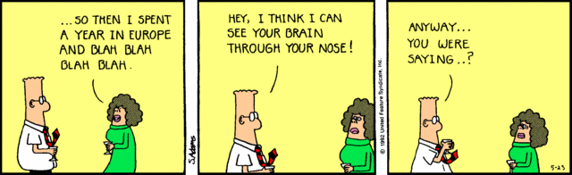

Scott Adams (1992)

**Section 2: How to Small Talk**

**Part 1:**

*Where should you make small talk?*

Small talk can happen anywhere, so you must always be prepared. People usually make small talk when they are waiting for something. For example, common times to make small talk include when you are waiting in the elevator, at the doctor’s office, waiting for the bus, waiting for a meeting to begin, waiting in the elevator. Other common times you might need small talk include: at a party, at the grocery store, at work, or in class.

*Who should you make small talk with?*

You usually participate in small talk with people you do not know at all. However, you can also make small talk with acquaintances, or people you know but are not good friends with.

*What should you make small talk about?*

Small talk should always be a friendly conversation about general topics everyone is aware of. You want to choose “safe” topics that will not cause any anger or disagreement. A common “safe” topic people use frequently during small talk is the weather

Below is a list of topics. Circle only the topics that are appropriate for small talk.

|  |  |  |  |  |
| --- | --- | --- | --- | --- |
| Politics | Hobbies | Sports | Your day | Negative comments |
| Gossip | Health problems | Salary | Job description | Relationship status |
| Favorite TV show | Travel | Hometown | Religion | The weekend |

**You Try:** Here is an example of small talk from the TV show, *The Big Bang Theory*. Sheldon is trying to make small talk with his friend Penny. Watch the video and then answer the questions below: <http://tinyurl.com/pxwsxgl>.

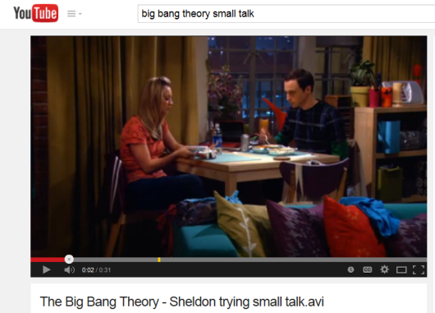

1. Where did Sheldon and Penny make small talk?

____________________________________________________

____________________________________________________

____________________________________________________

1. What topic did they try to discuss in their small talk?

____________________________________________________

____________________________________________________

____________________________________________________

1. Was their small talk successful or unsuccessful? Explain your answer.

____________________________________________________________________________________

____________________________________________________________________________________

____________________________________________________________________________________

(adapted from: *Small Talk: Who, What, Where, When, Why?* (2014), <https://www.englishclub.com/speaking/small-talk_wh.htm>)

**Part 2: Tag questions**

A tag question is a statement followed by a mini-question called a "question tag". Tag questions are a way of asking the other person to make a comment and to keep the conversation going.

We use question tags at the end of statements to ask for confirmation. They mean something like: "Am I right?" or "Do you agree?" They are very common in English. The basic structure of a tag question is:

**Topic: Hobbies**

**Topic: Weather**

|  |  |
| --- | --- |
| **Statement** | **Question Tag** |
| +  Positive statement, | -  negative tag? |
| It **is** going to rain, | **isn’t** it? |
| -  Negative statement, | +  positive tag? |
| It **isn’t** going to rain, | **is** it? |

|  |  |
| --- | --- |
| **Statement** | **Question Tag** |
| +  Positive statement, | -  negative tag? |
| You **swim**, | **don’t** you? |
| -  Negative statement, | +  positive tag? |
| You **don’t** swim, | **do** you? |

Notice that the question tag repeats the helping verb (or main verb when *be*) from the statement and changes it to negative or positive. The question tag should also include the same subject as the statement.

|  |  |
| --- | --- |
| **Statement** | **Question Tag** |
| It (subject) **is not (negative *be* verb)** going to rain, | **is (positive *be* verb)** it (subject)? |
| You (subject) **have (positive helping verb)** eaten, | **haven’t (negative helping verb)** you (subject)? |

**Note:** In the *Hobbies* example, the helping verb *do* in the statement - "You swim," - is not stated because the tense is simple present. However, the question tag uses *do* to make "don’t you?" It is also possible to say: "You do swim, don't you?"

|  |  |
| --- | --- |
| **Statement** | **Question Tag** |
| You (subject) **swim (main verb),** | **don’t (helping verb – no main verb)** you (subject)? |

**You try:** For the following tag questions, read the statement and then write an appropriate question tag to follow it.

*Example:* She has been to the zoo, hasn’t she?

1. It's windy today, ____________________?
2. You’re not a doctor, ____________________?
3. She didn’t feel good yesterday, ________________________?
4. They will have fun this weekend, ________________________?
5. You watched the football game on Sunday, _______________________?

**Section 3: Create a Comic!**

**Step 1:** Before you begin writing your comic, answer these questions to help guide your comic:

1. Where are the characters in the comic making small talk? _____________________________________

___________________________________________________________________________________.

1. What is the relationship between the characters in the comic? __________________________________

___________________________________________________________________________________.

1. What topic(s) are they discussing? _______________________________________________________

___________________________________________________________________________________.

**Step 2:** Remember to add tag questions. Use at least 2 tag questions in your comic.

**Step 3:** Use what you’ve learned in this SDLA about small talk to complete the comic below. Be as creative as you’d like.

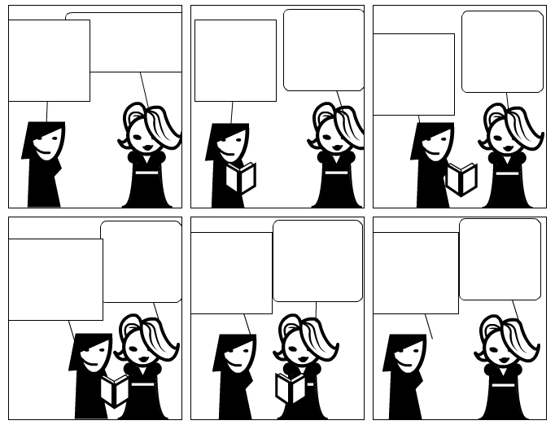

Source: *Strip Generator.* (2011). http://stripgenerator.com/strip/507265/blank-comic-strip/view/fresh/

**Section 4: Student Self-Assessment**

C:\Documents and Settings\wcuser1553\Local Settings\Temporary Internet Files\Content.IE5\Z02HHZPN\MC900072629[1].gif*Complete this self-assessment before meeting with a tutor.* **Now that you’ve completed sections 1 to 3, check the things you can do:**

* + - * + I can make appropriate small talk.
        + I can form tag questions.
        + I can create a small talk dialogue with tag questions.

**DON’T FORGET! Write your name on the clipboard to work with a tutor. The tutor will call your name when he/she is ready.**

**Section 5: Practice with a tutor!**

After completing the self- assessment, meet with a tutor and give this completed SDLA to the tutor. The tutor will review your work on this SDLA. To make sure you understand how to make small talk, you will participate in small talk with the tutor. The tutor will give you recommendations for improvement below.

|  |  |  |  |
| --- | --- | --- | --- |
| **Area of Focus** | **1 Point** | **3 Points** | **5 Points** |
| **Content** | Not enough information provided in small talk conversation. | Sufficient information provided in small talk conversation. | All necessary information was provided in small talk conversation. |
| **Skill: Speaking** | Student’s speech is unclear and requires frequent listener effort. | Student’s speech is generally clear but requires occasional listener effort. | Student’s speech is clear and smooth and requires minimal listener effort. |
| **Oral Fluency** | Speaks in incomplete sentences that do not flow. | Speaks in complete sentences some of the time with frequent pauses. | Speaks in complete sentences with occasional pauses most of the time. |
|  |  |  | **Total points: /15** |

**\*Students must receive at least 10 points to move on.**

**Tutor Recommendations:**

|  |  |
| --- | --- |
| * **Congratulations! Move on**   *Student has successfully completed this SDLA and is ready to continue to the next.* | * **Repeat**   *Student hasn’t yet mastered this SDLA. It is recommended that the student complete it again.* |

**Tutor Signature: __________________________________________ Date: _______________________**