**SL8B. Small Talk Part 2**

Student Name: _________________________________ Student ID Number: ________________________

Instructor: _____________________________________ Level: ___________Date: ___________________

**IMPORTANT NOTE: Please complete the SL8A *Small Talk: Part 1* before beginning this SDLA.** Sections 1-4 in the SDLA must be completed before meeting with a tutor and receiving a stamp. Write/type all your answers on this handout.

**After completing this SDLA, you will be able to:**

* Form tag questions
* Create a small talk dialogue with tag questions

**Sections 1-4 (approximately 45 minutes):** Read the information. Follow each step below to complete this SDLA. Be prepared to explain your answers when you meet with a tutor.

**Section 1: Small Talk Review**

As you learned in Part 1 of this SDLA, small talk is informal, friendly conversation about general topics. Small talk is extremely important to make a good first impression and build positive relationships with other people. Do you remember how to have successful small talk? Complete the chart below.

|  |  |
| --- | --- |
| **Good places for small talk:** | **Good topics for small talk:** |
|  |  |

After completing Part 1 of this SDLA, you were challenged to try to make small talk with a stranger or acquaintance in English. How did it go? Answer the questions below.

1. Where did you make the small talk?

____________________________________________________________________________________

1. What did you talk about? How did you keep the conversation going?

____________________________________________________________________________________

1. In your opinion, was it successful small talk? Why or why not?

____________________________________________________________________________________

**Section 2: Tag Questions**

A tag question is a statement followed by a mini-question called a "question tag". Tag questions are a way of asking the other person to make a comment and to keep the conversation going; as a result, tag questions are very important to use when making small talk. We use question tags at the end of statements to ask for confirmation. They mean something like: "Am I right?" or "Do you agree?" The basic structure of a tag question is:

**Topic: Hobbies**

**Topic: Weather**

|  |  |
| --- | --- |
| **Statement** | **Question Tag** |
| +  Positive statement, | -  negative tag? |
| It **is** going to rain, | **isn’t** it? |
| -  Negative statement, | +  positive tag? |
| It **isn’t** going to rain, | **is** it? |

|  |  |
| --- | --- |
| **Statement** | **Question Tag** |
| +  Positive statement, | -  negative tag? |
| You **swim**, | **don’t** you? |
| -  Negative statement, | +  positive tag? |
| You **don’t** swim, | **do** you? |

Notice that the question tag repeats the helping verb (or main verb when *be*) from the statement and changes it to negative or positive. The question tag should also include the same subject as the statement.

|  |  |
| --- | --- |
| **Statement** | **Question Tag** |
| It (subject) **is not (negative *be* verb)** going to rain, | **is (positive *be* verb)** it (subject)? |
| You (subject) **have (positive helping verb)** eaten, | **haven’t (negative helping verb)** you (subject)? |

**Note:** In the **Hobbies** example above, the helping verb *do* in the statement - "You swim," - is not stated because the tense is simple present. However, the question tag uses *do* to make "don’t you?" It is also possible to say: "You do swim, don't you?"

|  |  |
| --- | --- |
| **Statement** | **Question Tag** |
| You (subject) **swim (main verb),** | **don’t (helping verb – no main verb)** you (subject)? |

**You try:** For the following tag questions, read the statement and write an appropriate question tag to follow it.

*Example:* She has been to the zoo, hasn’t she?

1. It's windy today, ____________________?
2. You’re not a doctor, ____________________?
3. She didn’t feel good yesterday, ________________________?
4. They will have fun this weekend, ________________________?
5. You watched the football game on Sunday, _______________________?

**Section 3: Create a Comic!**

You will create a comic between two people that are having small talk. Be sure to use **tag questions** in your comic!!

**Step 1:** Before you begin writing your comic, answer these questions to help guide your comic:

1. Where are the characters in the comic making small talk? _____________________________________

___________________________________________________________________________________.

1. What is the relationship between the characters in the comic? (Remember: we don’t usually make small talk with close friends or family) _____________________________________________________________________.
2. What topic(s) are they discussing? _______________________________________________________

___________________________________________________________________________________.

**Step 2:** Remember to add tag questions. Use at least 3 tag questions in your comic.

**Step 3:** Use what you’ve learned in Part 1 and Part 2 of this SDLA to complete the comic below. Be as creative as you’d like!

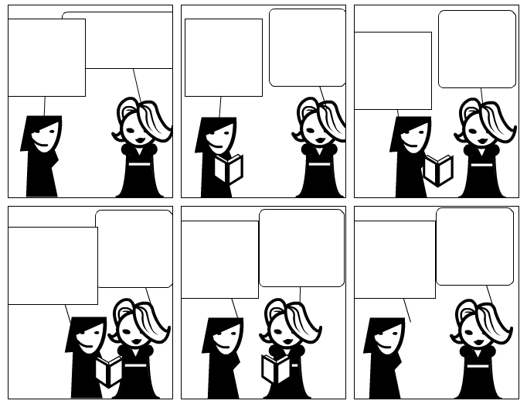

Source: *Strip Generator.* (2011). http://stripgenerator.com/strip/507265/blank-comic-strip/view/fresh/

**Section 4: Student Self-Assessment**

C:\Documents and Settings\wcuser1553\Local Settings\Temporary Internet Files\Content.IE5\Z02HHZPN\MC900072629[1].gif*Complete this self-assessment before meeting with a tutor.* **Now that you’ve completed sections 1 to 3, check the things you can do:**

* + - * + I can form tag questions.
        + I can create a small talk dialogue with tag questions.

**DON’T FORGET! Write your name on the clipboard to work with a tutor. The tutor will call your name when he/she is ready.**

**Section 5: Practice with a tutor!**

After completing the self- assessment, meet with a tutor and give this completed SDLA to the tutor. The tutor will review your work on this SDLA. To make sure you understand how to use tag questions in small talk, you will practice the conversation you created in the comic in Section 3 with the tutor. The tutor will give you recommendations for improvement below.

|  |  |  |  |
| --- | --- | --- | --- |
| **Area of Focus** | **1 Point** | **3 Points** | **5 Points** |
| **Content** | Not enough information provided in small talk conversation. | Sufficient information provided in small talk conversation. | All necessary information was provided in small talk conversation. |
| **Skill: Speaking** | Student’s speech is unclear and requires frequent listener effort. | Student’s speech is generally clear but requires occasional listener effort. | Student’s speech is clear and smooth and requires minimal listener effort. |
| **Oral Fluency** | Speaks in incomplete sentences that do not flow. | Speaks in complete sentences some of the time with frequent pauses. | Speaks in complete sentences with occasional pauses most of the time. |
|  |  |  | **Total points: /15** |

**\*Students must receive at least 10 points to move on.**

**Tutor Recommendations:**

|  |  |
| --- | --- |
| * **Congratulations! Move on**   *Student has successfully completed this SDLA and is ready to continue to the next.* | * **Repeat**   *Student hasn’t yet mastered this SDLA. It is recommended that the student complete it again.* |

**Tutor Signature: __________________________________________ Date: _______________________**