**SL8A. Small Talk Part 1**

Student Name: _________________________________ Student ID Number: ________________________

Instructor: _____________________________________ Level: ___________Date: ___________________

**IMPORTANT NOTE: Sections 1-4 in the SDLA must be completed before meeting with a tutor and receiving a stamp. Write/type all your answers on this handout.**

**After completing this SDLA, you will be able to:**

* Determine the appropriate topics for small talk
* Participate in small talk
* Initiate small talk

**Sections 1-4 (approximately 45 minutes):** Read the information. Follow each step below to complete this SDLA. Be prepared to explain your answers when you meet with a tutor.

**Section 1: What is Small Talk?**

Small talk is informal, friendly conversation about general topics. Small talk is extremely important to make a good first impression and build positive relationships with other people. Think about it: Many of your closest relationships you have today began with small talk! With this in mind, it is important to always be prepared for and ready to listen to small talk. Watch the short video to learn more about why small talk is important: [**http://tinyurl.com/p8kx5pb**](http://tinyurl.com/p8kx5pb)**.** Answer the questions below after you watch the video.

1. Why is small talk important? ____________________________________________________________

____________________________________________________________________________________

1. What does the acronym ARE stand for? ___________________________________________________

____________________________________________________________________________________

1. What are two important things you need to do to make small talk successful? _____________________

____________________________________________________________________________________

Scott Adams (1992)

**Section 2: How to Make Small Talk**

*Where should you make small talk?*

Small talk can happen anywhere, so you must always be prepared. People usually make small talk when they are waiting for something. For example, common times to make small talk include when you are waiting in the elevator, at the doctor’s office, for the bus, or for a meeting to begin. Other common times you might need small talk include: at a party, at the grocery store, at work, or in class.

*Who should you make small talk with?*

You usually participate in small talk with people you do not know at all. However, you can also make small talk with acquaintances, or people you know but are not good friends with.

*What should you make small talk about?*

Small talk should always be a friendly conversation about general topics everyone is aware of. You want to choose “safe” topics that will not cause any anger or disagreement. A common “safe” topic people use frequently during small talk is the weather.

**Below is a list of topics. Circle only the topics that are appropriate for small talk.**

|  |  |  |  |  |
| --- | --- | --- | --- | --- |
| Politics | Hobbies | Sports | Your day | Negative comments |
| Gossip | Health problems | Salary | Job description | Relationship status |
| Favorite TV show | Travel | Hometown | Religion | The weekend |

**You Try:** Here is an example of small talk from the TV show, *The Big Bang Theory*. Sheldon is trying to make small talk with his friend Penny. Watch the video and then answer the questions below: <http://tinyurl.com/pxwsxgl>.

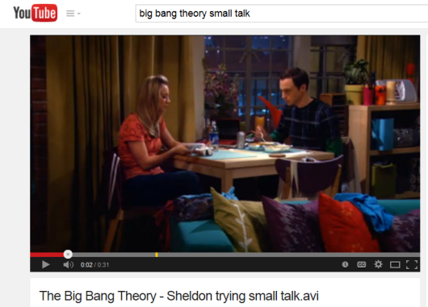

1. Where did Sheldon and Penny make small talk?

____________________________________________________

____________________________________________________

____________________________________________________

1. What topic did they try to discuss in their small talk?

____________________________________________________

____________________________________________________

____________________________________________________

1. Was their small talk successful or unsuccessful? Explain your answer.

____________________________________________________________________________________

____________________________________________________________________________________

____________________________________________________________________________________

(adapted from: *Small Talk: Who, What, Where, When, Why?* (2014), <https://www.englishclub.com/speaking/small-talk_wh.htm>)

**Section 3: How to Initiate Small Talk**

How can you start small talk in these situations? Below are different situations in which small talk is often needed. Write a different question for each situation that could successfully start small talk.

1. At a bus stop

____________________________________________________________________________________

1. In an elevator with an attractive person

____________________________________________________________________________________

1. In line waiting for coffee

____________________________________________________________________________________

1. At a party where you don’t know many people

____________________________________________________________________________________

1. At the doctor’s office

____________________________________________________________________________________

**Section 4: Student Self-Assessment**

C:\Documents and Settings\wcuser1553\Local Settings\Temporary Internet Files\Content.IE5\Z02HHZPN\MC900072629[1].gif*Complete this self-assessment before meeting with a tutor.* **Now that you’ve completed sections 1 to 3, check the things you can do:**

* + - * + I can determine the appropriate topics for small talk.
        + I can participate in small talk.
        + I can initiate small talk.

**DON’T FORGET! Write your name on the clipboard to work with a tutor. The tutor will call your name when he/she is ready.**

**Section 5: Practice with a tutor!**

After completing the self- assessment, meet with a tutor and give this completed SDLA to the tutor. The tutor will review your work on this SDLA. To make sure you understand how to make small talk, you will participate in small talk with the tutor. The tutor will give you recommendations for improvement below.

**CHALLENGE!!!** Your challenge for SL8A is to try to make small talk with one stranger or acquaintance. Remember to use the information you learned in this SDLA. Be prepared to talk about your experience in Part 2 (SL8B)!!

|  |  |  |  |
| --- | --- | --- | --- |
| **Area of Focus** | **1 Point** | **3 Points** | **5 Points** |
| **Content** | Not enough information provided in small talk conversation. | Sufficient information provided in small talk conversation. | All necessary information was provided in small talk conversation. |
| **Skill: Speaking** | Student’s speech is unclear and requires frequent listener effort. | Student’s speech is generally clear but requires occasional listener effort. | Student’s speech is clear and smooth and requires minimal listener effort. |
| **Oral Fluency** | Speaks in incomplete sentences that do not flow. | Speaks in complete sentences some of the time with frequent pauses. | Speaks in complete sentences with occasional pauses most of the time. |
|  |  |  | **Total points: /15** |

**\*Students must receive at least 10 points to move on.**

**Tutor Recommendations:**

|  |  |
| --- | --- |
| * **Congratulations! Move on**   *Student has successfully completed this SDLA and is ready to continue to the next.* | * **Repeat**   *Student hasn’t yet mastered this SDLA. It is recommended that the student complete it again.* |

**Tutor Signature: __________________________________________ Date: _______________________**