SL4. Visiting a Doctor
Student Name: _________________________________ Student ID Number: ________________________
Instructor: _____________________________________ Level: ___________Date: ___________________
IMPORTANT NOTE: Sections 1-6 in the SDLA must be completed before meeting with a tutor and receiving a stamp. Write/type and record all your answers on this handout.
After completing this SDLA, you will be able to:
- Use new vocabulary to describe illnesses and treatments.
- Organize different illnesses, their symptoms, and their treatments in a chart according to a conversation.
- Identify illnesses and treatment options based on patients’ descriptions.

Sections 1-6 (approximately 45 minutes): Read the information. Follow each step below to complete this SDLA. Be prepared to explain your answers when you meet with a tutor.
Section 1: Introduction
In the comics below, can you guess what is wrong with each of the patients? How do you know? When you think you know the answers, read the comic answers at the bottom of this page.
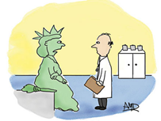Comic 1 | 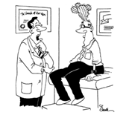Comic 2 | 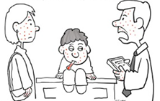Comic 3
http://zoominmedical.com/funny-doctor-who-cartoons/ http://www.cartoonstock.com/directory/d/dry_scalp.asp http://www.cartoonstock.com/directory/c/chicken-pox.asp

Even though these comics are supposed to make you laugh, not feeling well or getting injured is definitely not funny. In real life, when you visit a doctor, it can be a challenge because you may not know how to explain exactly how you feel. Although you know how your body feels, choosing the wrong words can greatly affect how the doctor understands your illness and provides you with appropriate treatment. This SDLA will help you learn how to better express how you are feeling to a doctor.

Comic Answers: In comic 1, the Statue of Liberty is experiencing arm pain because she has been holding her torch for many years without any rest. The patient in comic 2 is suffering from a dry scalp. One major symptom includes a cactus growing out of his head. Finally, in comic 3, the young boy has a contagious illness called the chicken pox which has spread to his mother and the doctor. The most common sign is the itchy red rash all over their bodies.

Section 2: Vocabulary Matching
In the word bank below, there are some useful words that you might say or hear during your doctor’s visit.
Word Bank
antibiotics | crutches | runny nose | sore muscles
bandage | over-the-counter medication | cold compress | nausea
diagnose | swollen | prescription | cast

Use the word bank above and write each word in the box under the picture it describes. The first one has been done for you. You may use the www.learnersdictionary.com for any words you don’t know.
  Antibiotics | 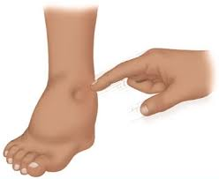  _____________________ | 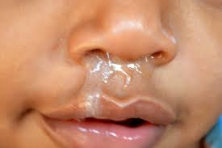
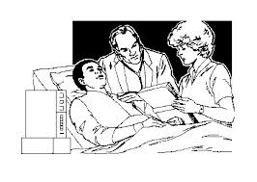  ______________________ |   _______________________ |   _______________________
  ______________________ |   _____________________ |   _____________________
  ______________________ | 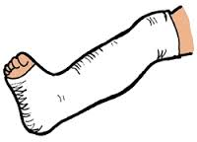  ____________________ | 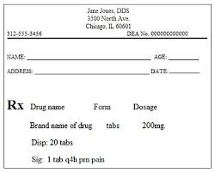  ________________________

Section 3: Illnesses, Symptoms, and Treatments
Fill in the chart below with your own knowledge of two illnesses. You may use the dictionary www.learnersdictionary.com to help you complete the chart.
Illness  What is the name of the illness? | Symptoms  How do you know when you have this illness? | Treatments  What can you do or take to feel better?
- Strep Throat  - Sprained Ankle | - Light sensitivity, nausea, head pain, fatigue  - Runny nose, fever, sore muscles | - Sleep, drink water, take pain medication  - Ice, elevation, rest, compression, bandage

Section 4: Listening to a Conversation
Listen to the conversation between two friends. Go to the following website to listen to the conversation: http://www.esl-lab.com/sick1/sicscr1.htm. You can also read the audio script as you listen. After you listen, complete the chart below.

Steve’s problem | Steve’s symptoms | Doctor’s treatments | Carla’s treatments

Section 5: Diagnosis and Treatment
Read the sample conversations below. Each patient is describing their problem to the doctor. Pay attention to how they describe their problem and then decide what the illness is from Section 3 and list some possible treatments.

Patient 1
Doctor: So what seems to be the problem?

Patient: I’ve had a really painful headache for the last 24 hours. I feel very nauseous, and I haven’t been able to eat anything. All I can do is sit in a dark room with my eyes closed.

What is the illness? _________________________________

What are some possible treatments? __________________________________________________________

Patient 2
Doctor: What brought you in today?

Patient: Well, I’ve had a runny nose and a fever for the last couple days. My muscles are really sore, and I’ve been very tired.

What is the illness? _________________________________

What are some possible treatments? __________________________________________________________

Patient 3
Doctor: So why did you decide to come in today?

Patient: I am in a lot of pain. My throat is swollen, and I cannot swallow any food without pain. It even hurts when I drink water! I’ve also had a fever, and I’ve been really tired.

What is the illness? _________________________________

What are some possible treatments? __________________________________________________________

Patient 4
Doctor: So how did this happen?

Patient: I went hiking with some friends yesterday, and we were having a great time. I was busy talking to them, so I wasn’t really paying attention to where I was going. I suddenly stepped into a hole, and my ankle turned. I have been in a lot of pain since then.

What is the illness? _________________________________

What are some possible treatments? __________________________________________________________

Section 6: Student Self-Assessment
Complete this self-assessment before meeting with a tutor. Now that you’ve completed sections 1 - 5, check
the things you can do:

  - I can use new vocabulary to describe illnesses and treatments.
  - I can organize different illnesses, their symptoms, and their treatments in a chart according to a conversation.
  - I can identify illnesses and treatment options based on patients’ descriptions.

DON’T FORGET! Write your name on the clipboard to work with a tutor. The tutor will call your name when he/she is ready.
Section 7: Practice with a tutor!
After completing the self- assessment, meet with a tutor and give this completed SDLA to the tutor. To help you practice explaining how you feel to a doctor, you will do a role play with a tutor. The tutor will ask you to describe an illness that you learned about in this SDLA. The tutor will give you feedback in the chart below.

Area of Focus | 1 Point | 3 Points | 5 Points
Content | Not enough information provided about the illness. | Sufficient information provided about the illness using medical related terms and expressions. | All necessary information provided about the illness using medical related terms and expressions.
Skill: Speaking | Student’s speech is unclear and requires frequent listener effort. | Student’s speech is generally clear but requires occasional listener effort. | Student’s speech is clear and smooth and requires minimal listener effort.
Oral Fluency | Speaks in incomplete sentences that do not flow. | Speaks in complete sentences some of the time with frequent pauses. | Speaks in complete sentences with occasional pauses most of the time.
 |  |  | Total points: /15
*Students must receive at least 10 points to move on.
Tutor Recommendations:

- Congratulations! Move on  Student has successfully completed this SDLA and is ready to continue to the next. | - Repeat  Student hasn’t yet mastered this SDLA. It is recommended that the student complete it again.

Tutor Signature: __________________________________________ Date: _______________________

