**SL4A. Visiting a Doctor: Part 1**

Student Name: _________________________________ Student ID Number: ________________________

Instructor: _____________________________________ Level: ___________Date: ___________________

**IMPORTANT NOTE: Sections 1-4 in the SDLA must be completed before meeting with a tutor and receiving a stamp. Write/type all your answers on this handout.**

**After completing this SDLA, you will be able to:**

* Use new vocabulary to describe illnesses and treatments

**Sections 1-4 (approximately 45 minutes):** Read the information. Follow each step below to complete this SDLA. Be prepared to explain your answers when you meet with a tutor.

**Section 1: Introduction**

In the comics below, can you guess what is wrong with each of the patients? How do you know? When you think you know the answers, read the comic answers at the bottom of this page.

|  |  |  |
| --- | --- | --- |
| **Comic 1** | **Comic 2** | **Comic 3** |

<http://zoominmedical.com/funny-doctor-who-cartoons/> <http://www.cartoonstock.com/directory/d/dry_scalp.asp> <http://www.cartoonstock.com/directory/c/chicken-pox.asp>

Even though these comics are supposed to make you laugh, not feeling well or getting injured is definitely not funny. In real life, when you visit a doctor, it can be a challenge because you may not know how to explain exactly how you feel. Although you know how your body feels, choosing the wrong words can greatly affect how the doctor understands your illness and provides you with appropriate treatment. This SDLA will help you learn important words to better express how you are feeling to a doctor.

**Comic Answers:** In comic 1, the Statue of Liberty is experiencing arm pain because she has been holding her torch for many years without any rest. The patient in comic 2 is suffering from a dry scalp. One major symptom includes a cactus growing out of his head. Finally, in comic 3, the young boy has a contagious illness called the chicken pox which has spread to his mother and the doctor. The most common sign is the itchy red rash all over their bodies.

**Section 2: Vocabulary Matching**

In the word bank below, there are some useful words that you might say or hear during your doctor’s visit.

**Word Bank**

|  |  |  |  |
| --- | --- | --- | --- |
| antibiotics | crutches | runny nose | sore muscles |
| bandage | over-the-counter medication | cold compress | nausea |
| diagnose | swollen | prescription | cast |

Use the word bank above and write each word in the box under the picture it describes. The first one has been done for you. You may use the [www.learnersdictionary.com](http://www.learnersdictionary.com) for any words you don’t know.

|  |  |  |
| --- | --- | --- |
| **Antibiotics** | **_____________________** |  |
| **______________________** | **_______________________** | **_______________________** |
| **______________________** | **_____________________** | **_____________________** |
| **______________________** | **____________________** | **________________________** |

**Section 3: Crossword Puzzle**

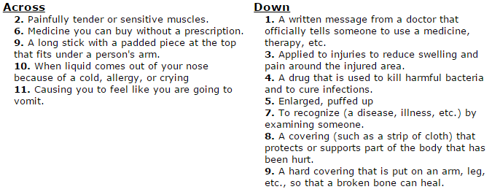Complete the crossword puzzle by using the vocabulary words you learned in Section 2 and the clues below.

**Section 4: Student Self-Assessment**

*Complete this self-assessment before meeting with a tutor.* **Now that you’ve completed sections 1 - 3, check**

C:\Documents and Settings\wcuser1553\Local Settings\Temporary Internet Files\Content.IE5\Z02HHZPN\MC900072629[1].gif **the things you can do:**

* + I can use new vocabulary to describe illnesses and treatments.

**DON’T FORGET! Write your name on the clipboard to work with a tutor. The tutor will call your name when he/she is ready.**

**Section 5: Practice with a tutor!**

After completing the self- assessment, meet with a tutor and give this completed SDLA to the tutor. To review the vocabulary, the tutor will ask you questions about the new words learned in this SDLA. The tutor will give you feedback in the chart below.

|  |  |  |  |
| --- | --- | --- | --- |
| **Area of Focus** | **1 Point** | **3 Points** | **5 Points** |
| **Content** | Not enough information provided for each question. | Sufficient information provided for each question. | All necessary information provided for each question using new vocabulary accurately. |
| **Skill: Speaking** | Student’s speech is unclear and requires frequent listener effort. | Student’s speech is generally clear but requires occasional listener effort. | Student’s speech is clear and smooth and requires minimal listener effort. |
| **Oral Fluency** | Speaks in incomplete sentences that do not flow. | Speaks in complete sentences some of the time with frequent pauses. | Speaks in complete sentences with occasional pauses most of the time. |
|  |  |  | **Total points: /15** |

**\*Students must receive at least 10 points to move on.**

**Tutor Recommendations:**

|  |  |
| --- | --- |
| * **Congratulations! Move on**   *Student has successfully completed this SDLA and is ready to continue to the next.* | * **Repeat**   *Student hasn’t yet mastered this SDLA. It is recommended that the student complete it again.* |

**Tutor Signature: __________________________________________ Date: _______________________**