**SL28A. Travel Part 1**

Student Name: _________________________________ Student ID Number: ________________________

Instructor: _____________________________________ Level: ___________Date: ___________________

**IMPORTANT NOTE: Sections 1-4 in the SDLA must be completed before meeting with a tutor and receiving a stamp. Write/type all your answers on this handout.**

**After completing this SDLA, you will be able to:**

* use adjectives to describe different types of hotel accommodations
* determine the importance of different hotel amenities based on your travel needs
* match appropriate hotel services to specific guest needs

**Sections 1-4 (approximately 45 minutes):** Read the information. Follow each step below to complete this SDLA. Be prepared to explain your answers when you meet with a tutor.

**Section 1: Introduction**

When you visit a new place, where do you stay? What is important in helping you decide where to stay? Do you want a hotel that allows pets? Do you need a hotel that is close to the airport? Write some of the important factors that help you choose a hotel below:

______________________________________________________________________________________________________________________________________________________________________________________________________________________________________________________________________________

**Section 2: Types of Accommodation**

When you travel, finding the best accommodation for you is very important. You usually need to consider one important factor when selecting the best accommodation: price. In terms of price, you need to determine your price range. Are you traveling on a budget, or are you going to splurge? Based on your price range, you can select the best accommodation for you. Here are some examples of different types of accommodations:

1. Conference and Convention Center Hotel
2. Budget hotel
3. Luxury Hotel
4. Resort
5. Bed and Breakfast
6. Boutique Hotel

The following pictures are examples of the types of accommodations listed above. Use the Internet to find the meaning of each type of accommodation, and write the type of accommodation below each picture. Next, write 2 to 3 adjectives that describe the type of accommodation. The first one has been done as an example.

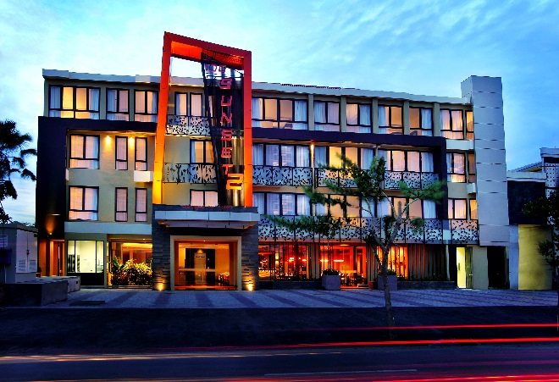

*Boutique Hotel – intimate, trendy, urban*

______________________________________

______________________________________

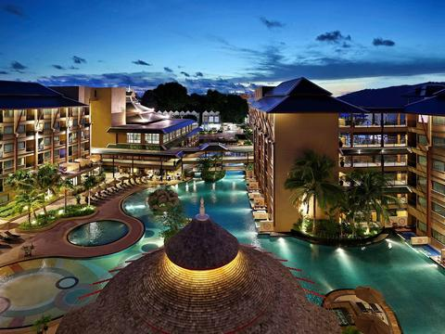

______________________________________

______________________________________

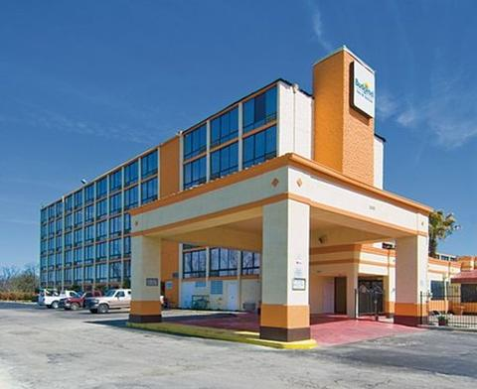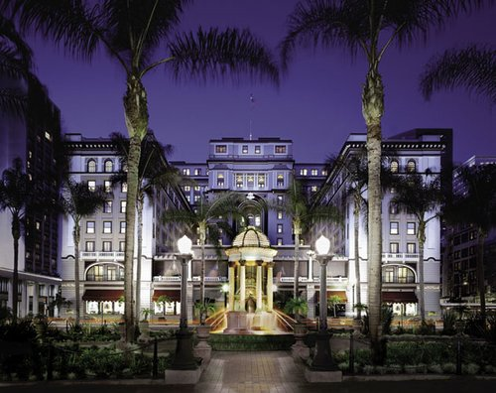

______________________________________

______________________________________

Which hotel from above would you prefer to stay in? Why?

________________________________________________________________________________________

**Section 3: Amenities**

Another factor that can help you to choose the best hotel for your trip is the amenities. Amenities arethings or features that make life easier or more pleasant when you’re on vacation. The following is a list of amenities that a hotel can provide. Check the amenities that you would want a hotel to offer.

|  |  |  |
| --- | --- | --- |
| **Hotel Amenities** | **In-Room Amenities** | **Bathroom Amenities** |
| * Spa * Pool * Business center * Fitness center * Ice machine * Vending machines * Free parking | * TV * Cable * Complimentary Wi-Fi * Air conditioning * Safe * Iron and ironing board * Mini Bar * Mini Fridge | * Shampoo * Conditioner * Soap * Bathrobes * Hair dryer |

What do you think are the 3 **most** important amenities that a hotel could provide?

__________________________________________________________________________________________

What do you think are the 3 **least** important amenities that a hotel could provide?

__________________________________________________________________________________________

**Section 4: Services**

In addition to amenities, hotel services can also help you choose the best hotel for your trip. A hotel’s services supply a need that the guests want. Look at the list of possible hotel services. Write the appropriate service under the need it supplies below. The first one has been done as an example.

|  |  |  |
| --- | --- | --- |
| room service | dry cleaning | laundry service |
| concierge | shuttle service | complimentary morning coffee and tea service |
| valet parking | continental breakfast | morning newspaper delivery |

1. You are on a business trip, and you must wear nice suits that cannot be cleaned in the washing machine.

*Dry cleaning*

_______________________________________________________

2. You want to have a relaxing morning and eat breakfast in your hotel room.

_______________________________________________________

3. You don’t want to have to worry about what you will eat in the morning.

_______________________________________________________

4. You have a question about the best place to eat dinner in the area.

_______________________________________________________

5. You would like to have easy access to your vehicle for the duration of your trip.

_______________________________________________________

6. You do not have a rental car, so you need to have a quick and easy way to get to the airport.

_______________________________________________________

Which services do you expect when staying at a hotel? _____________________________________________

__________________________________________________________________________________________

__________________________________________________________________________________________

**Section 5: Student Self-Assessment**

C:\Documents and Settings\wcuser1553\Local Settings\Temporary Internet Files\Content.IE5\Z02HHZPN\MC900072629[1].gif*Complete this self-assessment before meeting with a tutor.* **Now that you’ve completed sections 1 to 4, check the things you can do:**

* I can identify different types of hotel accommodations.
* I can use adjectives to describe different types of hotel accommodations.
* I can determine the importance of different hotel amenities based on my travel needs.
* I can match appropriate hotel services to specific guest needs.

**DON’T FORGET! Write your name on the clipboard to work with a tutor. The tutor will call your name when he/she is ready.**

**Section 6: Practice with a Tutor!**

After completing the self- assessment, meet with a tutor and give this completed SDLA to the tutor. You will review this SDLA with the tutor and have a conversation about hotels. The tutor will provide you with feedback in the following areas:

|  |  |  |  |
| --- | --- | --- | --- |
| **Area of Focus** | **1 Point** | **3 Points** | **5 Points** |
| **Content** | Student does not provide enough information in responses and does not use appropriate vocabulary. | Student provides sufficient information in responses and uses appropriate vocabulary some of the time. | Student provides all necessary information in responses and uses appropriate vocabulary most of the time. |
| **Skill: Speaking** | Student’s speech is unclear and requires frequent listener effort. | Student’s speech is generally clear but requires occasional listener effort. | Student’s speech is clear and smooth and requires minimal listener effort. |
| **Oral Fluency** | Speaks in incomplete sentences that do not flow. | Speaks in complete sentences some of the time with frequent pauses. | Speaks in complete sentences with occasional pauses most of the time. |
|  |  |  | **Total points: /15** |

**\*Students must receive at least 10 points to move on.**

**Tutor Recommendations:**

|  |  |
| --- | --- |
| * **Congratulations! Move on**   *Student has successfully completed this SDLA and is ready to continue to the next.* | * **Repeat**   *Student hasn’t yet mastered this SDLA. It is recommended that the student complete it again.* |

**Tutor Signature: __________________________________________ Date: _______________________**