**SL27B. Culture**

Student Name: _________________________________ Student ID Number: ________________________

Instructor: _____________________________________ Level: ___________Date: ___________________

**IMPORTANT NOTE: Sections 1-4 in the SDLA must be completed before meeting with a tutor and receiving a stamp. Write/type all your answers on this handout.**

**After completing this SDLA, you will be able to:**

* Describe what culture shock is
* Explain why people experience culture shock
* Talk to other people about their culture shock experiences

**Sections 1-4 (approximately 45 minutes):** Read the information. Follow each step below to complete this SDLA. Be prepared to explain your answers when you meet with a tutor.

**Section 1: Introduction**

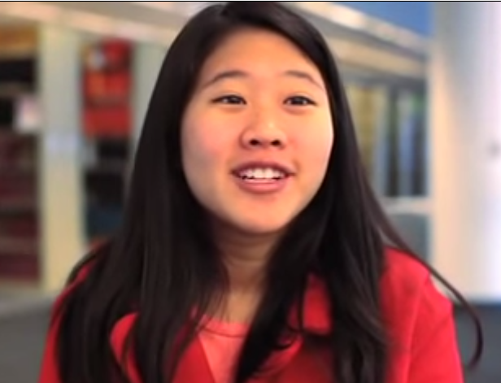How did you feel when you first came to the U.S.? When people first come to the United States from a different country, they experience culture shock. It is a feeling of confusion, doubt, or nervousness caused by being in a place (such as a foreign country) that is very different from what they are used to. It’s very normal to experience culture shock because the culture you have been accustomed to and immersed in your whole life is now completely different. In fact, you’ll realize that most people who have come to the U.S. from a different country have experienced culture shock, so you’re not alone. One such example is Rosanne. Although she was only one semester away from her high school graduation in Singapore, Rosanne’s parents wanted her to finish school in the United States and apply to colleges there. Her brother was already attending a U.S. college, so she moved in with him and enrolled in a local school. Watch and listen to her explain her experience with culture shock and adjusting to life in the U.S. [**http://tinyurl.com/pp88n4y**](http://tinyurl.com/pp88n4y) **.** Then answer the following questions.

1. Why did Rosanne think she wouldn’t experience culture shock?
2. How did Rosanne handle (deal with) culture shock?
3. What happened after she overcame her culture shock?

**Section 2: Understanding Culture Shock**

In order to better understand culture shock, you need to compare life in your Native Country to life in the U.S. This will help you to figure out what factors made you experience culture shock. Complete the table below.

|  |  |  |
| --- | --- | --- |
|  | **In Native Country** | **In the U.S.** |
| What language(s) do you speak? What are some differences between English and your native language(s)? |  |  |
| What type of transportation do you take? How do you get around? |  |  |
| What is a typical dinner? |  |  |
| How do you greet people? |  |  |
| What do you do for fun? |  |  |

**Section 3: Ask Other Students**

1. Using the information from the chart above, answer the questions below about your experience here in the U.S. Write your responses in the chart.
2. Find two other students who have experienced culture shock in the U.S. or another country and ask them the questions below. Write their responses in the chart.

\***Note:** You may politely ask to record their responses using your cell phone. If they allow you to record their response, a tutor can help you with any unknown vocabulary words or pronunciation.

|  |  |  |  |
| --- | --- | --- | --- |
| **Name** | **How did you feel when you first arrived to the new country?** | **Why did you experience culture shock in that country (language, food, people, etc.)?** | **How did you overcome culture shock?** |
| *Me* |  |  |  |
|  |  |  |  |
|  |  |  |  |

**Section 4: Student Self-Assessment**

C:\Documents and Settings\wcuser1553\Local Settings\Temporary Internet Files\Content.IE5\Z02HHZPN\MC900072629[1].gif*Complete this self-assessment before meeting with a tutor.* **Now that you’ve completed sections 1 to 3, check the things you can do:**

* + - I can describe what culture shock is.
    - I can explain why people experience culture shock.
    - I can talk to other people about their culture shock experiences.

**DON’T FORGET! Write your name on the clipboard to work with a tutor. The tutor will call your name when he/she is ready.**

**Section 5: Practice with a Tutor!**

After completing the self-assessment, meet with a tutor and give this completed SDLA to the tutor. You will review this SDLA with the tutor and have a conversation about culture shock. After your conversation, the tutor will provide you with feedback in the following areas:

|  |  |  |  |
| --- | --- | --- | --- |
| **Area of Focus** | **1 Point** | **3 Points** | **5 Points** |
| **Content** | Student does not provide enough information in responses and does not use appropriate vocabulary. | Student provides sufficient information in responses and uses appropriate vocabulary some of the time. | Student provides all necessary information in responses and uses appropriate vocabulary most of the time. |
| **Skill: Speaking** | Student’s speech is unclear and requires frequent listener effort. | Student’s speech is generally clear but requires occasional listener effort. | Student’s speech is clear and smooth and requires minimal listener effort. |
| **Oral Fluency** | Speaks in incomplete sentences that do not flow. | Speaks in complete sentences some of the time with frequent pauses. | Speaks in complete sentences with occasional pauses most of the time. |
|  |  |  | **Total points: /15** |

**\*Students must receive at least 10 points to move on.**

**Tutor Recommendations:**

|  |  |
| --- | --- |
| * **Congratulations! Move on**   *Student has successfully completed this SDLA and is ready to continue to the next.* | * **Repeat**   *Student hasn’t yet mastered this SDLA. It is recommended that the student complete it again.* |

**Tutor Signature: __________________________________________ Date: _______________________**