**SL27A. Culture**

Student Name: _________________________________ Student ID Number: ________________________

Instructor: _____________________________________ Level: ___________Date: ___________________

**IMPORTANT NOTE: Sections 1-2 in the SDLA must be completed before meeting with a tutor and receiving a stamp. Write/type all your answers on this handout.**

**After completing this SDLA, you will be able to:**

* Identify elements of culture
* Rate elements of your culture by their value
* Describe traditions in your culture

**Sections 1-2 (approximately 45 minutes):** Read the information. Follow each step below to complete this SDLA. Be prepared to explain your answers when you meet with a tutor.

**Section 1: Culture**

**What is culture?** Is culture easy to understand? Sometimes the iceberg metaphor is used to describe culture. Why do you think this is? Culture is often compared to an iceberg because, just as we only see 1/8 of an iceberg above the water, we only see a small part of culture in daily life. There are many larger aspects of culture that can’t be seen because they are hidden below the surface (under the water).

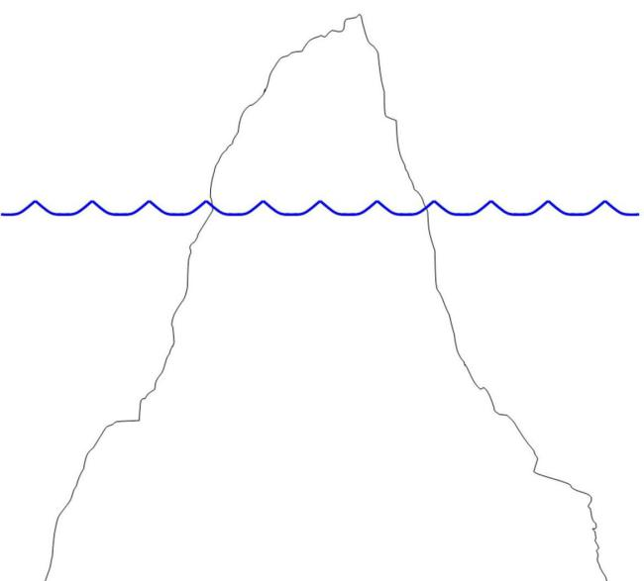

Adapted from: Cultural Kinetics, https://culturalkinetics.wordpress.com/2013/04/09/culture-an-iceberg-analogy/

*beliefs*

*language*

Check the items below that are elements of culture. Add additional items you can think of to the list.

|  |  |  |  |
| --- | --- | --- | --- |
| _______ Clothing | _______ traditions | _______ games | _______ ceremonies |
| _______ Food | _______ gender roles | _______ attitudes | _______ architecture |
| _______ family structure | _______ communication style | _______ government | _______ concept of beauty |
| ____________________ | ____________________ | _________________ | ____________________ |

Now add the elements of culture from above to the iceberg on page 1. Which elements are visible (above the water), and which elements are invisible (below the water)?

**Section 2: Your Culture**

**Part 1:** Write one sentence or phrase to answer each question below. Then rate each item 1-8 (1 is most important, 8 is least important) according to what value it has in your culture.

1. _____ What language(s) do you speak?
2. _____ What is your religion?
3. _____ What music do you listen to?
4. _____ What dances do you know?
5. _____ What foods do you eat at home?
6. _____ What is most important to you?
7. _____ What things do you believe are right and wrong?
8. _____ How important is your extended family?

**Part 2:** Every culture has important dates, holidays, and celebrations. What are some of these important traditions in your culture? Complete the chart below with 3 of the most important traditions in your culture.

|  |  |  |  |
| --- | --- | --- | --- |
| **What is the name of this special day?** | **When do you celebrate it?** | **How do you celebrate it?** | **Why do you celebrate it?** |
|  |  |  |  |
|  |  |  |  |
|  |  |  |  |

**Part 3:** Choose one special day from above. Imagine someone from a different culture is watching you celebrate this special day. This person knows nothing about how and why you celebrate this day. What do you think this person would see as important parts of this celebration? And what do you think this person would not see but is an important part of the celebration? Write the things this person would see (above the water) and the things this person would not see (below the water).



**Section 3: Student Self-Assessment**

C:\Documents and Settings\wcuser1553\Local Settings\Temporary Internet Files\Content.IE5\Z02HHZPN\MC900072629[1].gif*Complete this self-assessment before meeting with a tutor.* **Now that you’ve completed sections 1 to 2, check the things you can do:**

* I can identify elements of culture.
* I can rate elements of my culture by their value.
* I can describe traditions in my culture.

**DON’T FORGET! Write your name on the clipboard to work with a tutor. The tutor will call your name when he/she is ready.**

**Section 4: Practice with a Tutor!**

After completing the self-assessment, meet with a tutor and give this completed SDLA to the tutor. You will review this SDLA with the tutor and have a conversation about culture. After your conversation, the tutor will provide you with feedback in the following areas:

|  |  |  |  |
| --- | --- | --- | --- |
| **Area of Focus** | **1 Point** | **3 Points** | **5 Points** |
| **Content** | Student does not provide enough information in responses and does not use appropriate vocabulary. | Student provides sufficient information in responses and uses appropriate vocabulary some of the time. | Student provides all necessary information in responses and uses appropriate vocabulary most of the time. |
| **Skill: Speaking** | Student’s speech is unclear and requires frequent listener effort. | Student’s speech is generally clear but requires occasional listener effort. | Student’s speech is clear and smooth and requires minimal listener effort. |
| **Oral Fluency** | Speaks in incomplete sentences that do not flow. | Speaks in complete sentences some of the time with frequent pauses. | Speaks in complete sentences with occasional pauses most of the time. |
|  |  |  | **Total points: /15** |

**\*Students must receive at least 10 points to move on.**

**Tutor Recommendations:**

|  |  |
| --- | --- |
| * **Congratulations! Move on**   *Student has successfully completed this SDLA and is ready to continue to the next.* | * **Repeat**   *Student hasn’t yet mastered this SDLA. It is recommended that the student complete it again.* |

**Tutor Signature: __________________________________________ Date: _______________________**