**PL5: The “Be” Verb**

Student Name: _________________________________ Student ID Number: ________________________

Instructor: _____________________________________ Level: ___________Date: ___________________

**Section 1: The “Be” verb**



1. 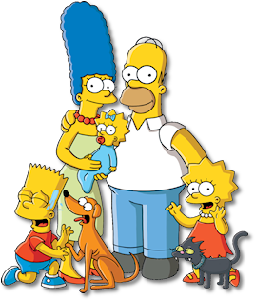Watch the video here: <https://youtu.be/rC6bmDuHsWE> .
2. Write the correct form of the **“Be”**verb below.

**Example:** He/ She/ It (be) ­are happy.

He

**1)** Homer (be) _______ happy. He (be) _______

She

the father.

She

**2)** Marge (be) _______ tall. She (be) _______ the mom.

She

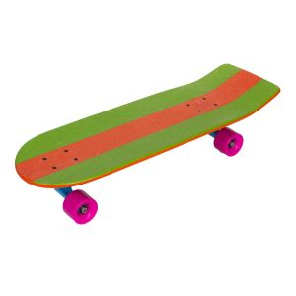**3)** Bart (be) _______ a boy. He ______ happy.

**4)** The skateboard (be) ______ green and orange. It ______ fast.

He

It

**5)** Lisa (be) ______ the sister. She (be) ______

excited.

**Example:** I/ You/ We/ They (be) ­are happy.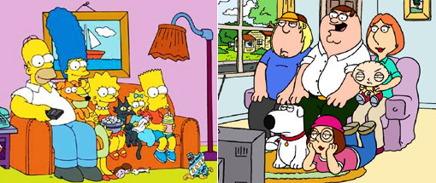

**1)** The Simpsons (be) _______ happy. They (be) _______ on the couch.

**2)** The Griffins (be) _______ also happy. They (be) _______ also on the couch.

They

We



**Example:** I (be) ­am happy.

I

You

**1)** I (be) __________ excited.

**2)** You (be) _____________ happy.

**3)** I (be) ____________ bald.

**4)** You (be) ___________ tall.

**Peter**

**Homer**

**Section 2: Nouns and the “Be” verb**

**Directions:** Write the correct form of the **“Be”** verb below.

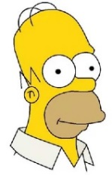**1)** Homer (be) ________ excited.

**2)** Peter (be) ________ happy.

**3)** Homer and Peter (be) ________ dads.

**4)** The skateboard (be) ________ green and orange.

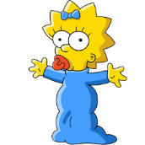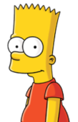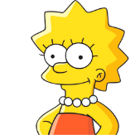**5)** The dog and cat (be) ________ hungry.

**6)** Marge (be) ________ Lisa’s mother.

**7)** Lisa (be) ________ Marge’s daughter.

**8)** Bart (be) ________ Marge’s son.

**9)** Homer and Marge (be) ­­­­­________ Lisa, Bart and Maggie’s parents.

**10)** The dog and cat (be) ________ the Simpson’s pets.

**11)** Simpson (be) ________ the family’s last name.

**12)** Lisa, Bart and Maggie (be) ________ Homer and Marge’s kids.

**Section 4: Find the Mistakes**

**Directions:** Find and fix the mistakes.

**Example 1:** She happy. **Example 2:** I is happy.

**^ am**

**is**

|  |  |
| --- | --- |
| **1)** He from China.  **2)** Are happy.  **3)** They is hungry.  **4)** The weather very hot.  **5)** I not excited. | **6)** Bart and Lisa is brother and sister.  **7)** Am very cold.  **8)** Homer Bart’s father.  **9)** I is smart.  **10)** I amn’t thirsty. |

**Section 5: Describing the Weather**

**Directions:** Describe the weather using the **“Be”** verb. Then draw a line **­­­** to the correct picture.

|  |  |  |
| --- | --- | --- |
| 1. The weather (be) __**­is**__ windy.  2. The sky (be) ___________ clear.  3. It (be) ____________ cold.  4. The Simpsons (be) ___________ hot.  5. It (be) ___________ winter.  6. It (be) ___________ summer.  7. It (be) ___________ raining.  8. Homer (be) ___________ hot. |  | C:\Users\mmclaughlin2\Desktop\clear skies.gifC:\Users\mmclaughlin2\Desktop\simpsons warm.jpgC:\Users\mmclaughlin2\Desktop\summer.jpgC:\Users\mmclaughlin2\Desktop\snowing.jpegC:\Users\mmclaughlin2\Desktop\windy.gif |

**Section 4: Student Self-Assessment**

*Complete this self-assessment before meeting with a tutor.* **Now that you’ve completed sections 1 to 2, check the things you can do:**

* I can use the **“Be”** verb to make a sentence.
* I can use the correct form of the **“Be”** verb.
* I can use the **“Be”** verb to talk about people.
* I can use the **“Be”** verb to talk about the weather.

**DON’T FORGET! Write your name on the clipboard to work with a tutor. The tutor will call your name when he/she is ready.**

**Section 5: Practice with a Tutor!**

Meet with a tutor. Give this paper to the tutor. The tutor will review your work and do dictations with you.

**Dictation 1:** Write the sentences you hear on the lines below.

1. ________________________________________________________________________________________

2. ________________________________________________________________________________________

3. ________________________________________________________________________________________

4. ________________________________________________________________________________________

|  |  |  |  |
| --- | --- | --- | --- |
| **Area of Focus** | **1 Point** | **3 Points** | **5 Points** |
| **Skill: Dictation - Spelling** | Student makes more than 4 errors in capitalization and punctuation. | Student makes 3-4 errors in spelling. | Student makes 0-2 errors in spelling. |
| **Skill: Dictation - Capitalization and Punctuation** | Student makes more than 4 errors in capitalization and punctuation. | Student makes 3-4 errors in capitalization and punctuation. | Student makes 0-2 errors in capitalization and punctuation. |
| **Skill: Dictation- Content Accuracy** | Student misses more than 4 words from the dictation | Student misses 1-3 words from the dictation. | All the words from the dictation are in the work. |
|  |  |  | **Total points: /15** |

**\*Students must receive at least 10 points to move on.**

**Tutor Recommendations:**

|  |  |
| --- | --- |
| * **Congratulations! Move on**   *Student has successfully completed this SDLA and is ready to continue to the next.* | * **Repeat**   *Student hasn’t yet mastered this SDLA. It is recommended that the student complete it again.* |

**Tutor Signature: __________________________________________ Date: _______________________**