**PL4: Numbers**

Student Name: _________________________________ Student ID Number: ________________________

Instructor: _____________________________________ Level: ___________Date: ___________________

**Section 1a: Counting Numbers**

1. Listen to the audio here: <https://tinyurl.com/y7tlax9r> and *repeat*.
2. Next, say and record the words below on your cell phone.

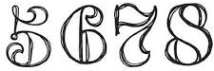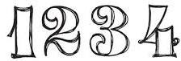

**Section 1b: Counting Numbers**

**Directions: Spell the numbers below.**

|  |  |  |  |
| --- | --- | --- | --- |
| **Number** | **Spelling** | **Number** | **Spelling** |
| **60** | **­____ ____ ____ ____ ____** | **7** | **____ ____ ____ ____ ____** |
| **8** | **____ ____ ____ ____ ____** | **5** | **____ ____ ____ ____** |
| **24** | **____ ____ ____ ____ ____ ____ -**  **____ ____ ____ ____** | **50** | **____ ____ ____ ____ ____** |
| **83** | **___ ___ ___ ___ ___ ___ -**  **___ ___ ___ ___ ___** | **14** | **___ ___ ___ ___ ___ ___ ___ ___** |
| **71** | **___ ___ ___ ___ ___ ___ ___ -**  **___ ___ ___** | **45** | **___ ___ ___ ___ ___ -**  **___ ___ ___ ___** |
| **19** | **___ ___ ___ ___ ___ ___ ___ ___** | **99** | **___ ___ ___ ___ ___ ___ -**  **___ ___ ___ ___** |
| **100** | **___ ___ ___ - ___ ___ ___ ___ ___ ___** | **11** | **____ ____ ____ ____ ____ ____** |
| **10** | **___ ___ ___** | **33** | **___ ___ ___ ___ ___ ___ -**  **___ ___ ___ ___ ___** |
| **12** | **____ ____ ____ ____ ____ ____** | **13** | **___ ___ ___ ___ ___ ___ ___ ___** |
| **15** | **___ ___ ___ ___ ___ ___ ___** | **0** | **___ ___ ___ ___** |

**Section 2: Matching**

**Directions:** Match the correct numbers below.

|  |  |
| --- | --- |
| **22** | **sixty** |
| **133** | **On-hundred ten** |
| **51** | **Fifty-one** |
| **49** | **Seventy** |
| **3** | **Thirteen** |
| **4** | **Three** |
| **60** | **Sixty-one** |
| **111** | **Twenty-two** |
| **70** | **Thirty-two** |
| **41** | **One-hundred eleven** |
| **32** | **Fourteen** |
| **13** | **One-hundred thirty-three** |
| **14** | **Forty-one** |
| **61** | **Four** |
| **59** | **Fifty-nine** |
| **110** | **Forty-nine** |

**Section 3: Unscramble**

**Directions:** Write the correct numbers below.

**Example:** Neo 🡪____One_____

1. Yvsteen 🡪_____________­­___ 6. Tonteyewn 🡪_____________­­___

2. Evihyfitrt 🡪________________ 7. Tiffowty 🡪_____________­­___

3. Renofetu 🡪________________ 8. Tixyxsis 🡪_____________­­___

4. Venestene 🡪________________ 9. Weltev 🡪_____________­­___

5. Getinytenh 🡪________________ 10. Teniforny 🡪_____________­­___

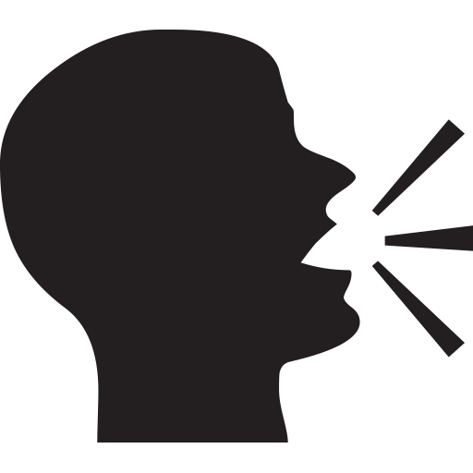

**Section 3: Dictation**

**

**A.** Listen to the audio here: <https://tinyurl.com/ybp2exe5> and *spell* the numbers below.

|  |  |
| --- | --- |
| 1. **___ ___ ___ ___**  2. **___ ___ ___**  3. **___ ___ ___ ___ ___ ___ ___**  4. **___ ___ ___ ___ ___ ___**  5. **___ ___ ___ ___ ___ - ___ ___ ___ ___ ___** | 6. **___ ___ ___ ___ ___ - ___ ___ ___**  7. **___ ___ ___ ___ ___ ___ - ___ ___ ___**  8. **___ ___ ___ ___ ___ ___ - ___ ___ ___ ___ ___**  9. **___ ___ ___ ___ ___ ___ ___ - ___ ___ ___ ___ ___**  10. **___ ___ ___ ___ ___ ___** |

**

**B.** Listen to the audio here:[**https://tinyurl.com/y95j26zc**](https://tinyurl.com/y95j26zc)and *write* the numbers.

1. Nancy is _______ years old.

2. Nancy’s son is _______ years old.

3. Her father is _______ years old.

4. Her mother is _______ years old.

5. Her sister is _______ years old.

6. Her sister’s husband is _______ years old.

7. Her niece is _______ years old.

8. Nancy’s friend is _______ years old.

**Section 4: Student Self-Assessment**

C:\Documents and Settings\wcuser1553\Local Settings\Temporary Internet Files\Content.IE5\Z02HHZPN\MC900072629[1].gif*Complete this self-assessment before meeting with a tutor.* **Now that you’ve completed sections 1 to 2, check the things you can do:**

* I learned new vocabulary about numbers.
* I can spell words about numbers.
* I can complete sentences about numbers.
* I can listen and write words and sentences about numbers.

**DON’T FORGET! Write your name on the clipboard to work with a tutor. The tutor will call your name when he/she is ready.**

**Section 5: Practice with a Tutor!**

Meet with a tutor. Give this paper to the tutor. The tutor will review your work and do dictations with you.

**Dictation 1:**  Listen to each word or words. Spell the word or words you hear.

1. _________________________________________
2. _________________________________________
3. _________________________________________
4. _________________________________________
5. _________________________________________

**Dictation 2:** Write the sentences you hear on the lines below.

1. ________________________________________________________________________________________

2. ________________________________________________________________________________________

3. ________________________________________________________________________________________

|  |  |  |  |
| --- | --- | --- | --- |
| **Area of Focus** | **1 Point** | **3 Points** | **5 Points** |
| **Skill: Dictation - Spelling** | Student makes more than 4 errors in capitalization and punctuation. | Student makes 3-4 errors in spelling. | Student makes 0-2 errors in spelling. |
| **Skill: Dictation - Capitalization and Punctuation** | Student makes more than 4 errors in capitalization and punctuation. | Student makes 3-4 errors in capitalization and punctuation. | Student makes 0-2 errors in capitalization and punctuation. |
| **Skill: Dictation- Content Accuracy** | Student misses more than 4 words from the dictation | Student misses 1-3 words from the dictation. | All the words from the dictation are in the work. |
|  |  |  | **Total points: /15** |

**\*Students must receive at least 10 points to move on.**

**Tutor Recommendations:**

|  |  |
| --- | --- |
| * **Congratulations! Move on**   *Student has successfully completed this SDLA and is ready to continue to the next.* | * **Repeat**   *Student hasn’t yet mastered this SDLA. It is recommended that the student complete it again.* |

**Tutor Signature: __________________________________________ Date: _______________________**