SLP2. In the Classroom

Pair #
STOP: Before you begin this activity, open and follow recording instructions here.

Partner A:
Student ID:
Instructor:
Language:
Level: Date:
Partner B:
Student ID:
Instructor:
Language:
Level: Date:

Section 1: Vocabulary Mastery
Instructions: Describe the sign of the following words and phrases using the 5 Parameters of ASL. Try to use your book and your partner before using other materials or the internet. Use the third column to help you remember the sign in your target language (ASL) by drawing a picture or writing a note to yourself.
Vocabulary | Translate into Target Language | Notes/Pictures/Pronunciation Guide (anything to help you)
- a closet
- a desk
- a chair
- a backpack
- a pencil
- an eraser
- a computer
- a window
- a blackboard/whiteboard
- a calculator
- a lesson
- a book
- a page
- a notebook
- a name
- a professor
- a student

Section 2: Sentence Answer and Translation
Instructions: Take turns translating and then answering these questions in the target language. When it asks to translate, please write in ASL syntax (word order). Practice asking and answering in ASL.
- What days do you go to class?

- Do you need a backpack?

- What do you need for history class?

- Do you already have a calculator?

- Are you going to buy a notebook?

Section 3: Classroom Items
Instructions: Use your textbook and your partner’s help to label as many items in this classroom as you can.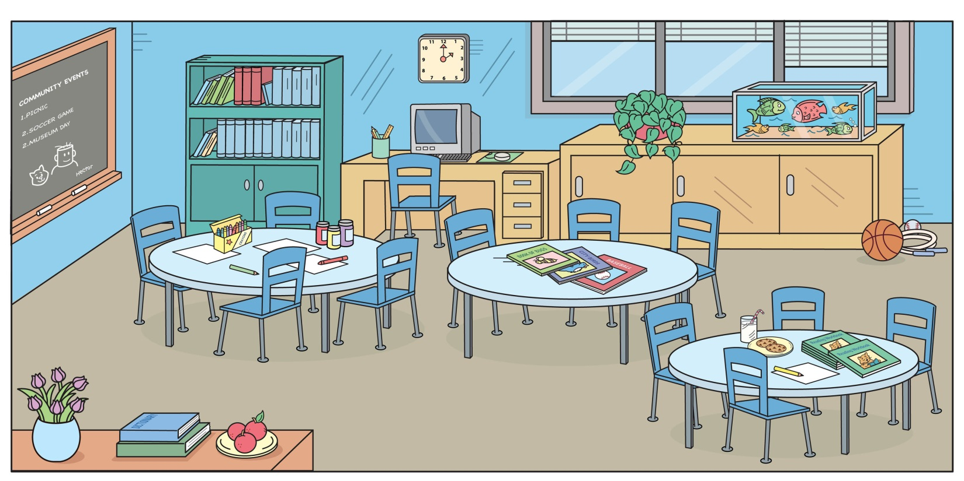

Section 4: Dialogue Creation
Instructions: Imagine that tomorrow is the first day of school and you and your partner need some new supplies. You may ask your partner what they need and point out the items they already have. Write questions you will ask your partner in the target language (ASL word order). Then write your partner’s answers in the target language. If you don’t know a sign, look it up online. Attach a piece of notebook paper if you need more space. Practice asking and answering.
Signer 1:
Signer 2:
Signer 1:
Signer 2:
Signer 1:
Signer 2:
Signer 1:
Signer 2:

