KLP05 At the Bookstore
STOP: Before you begin this activity, open and follow recording instructions for online activities or on-campus activities.

Pair # __________

Partner A: ________________________________
Student ID: _______________________________
Instructor: ________________________________
Level: ______________ Date: _________________
Partner B: ________________________________
Student ID: _______________________________
Instructor: ________________________________
Level: ______________ Date: _________________

All links in this activity direct to the KLP Activities page on the LLC website. Find your activity number and click the drop down to find links to videos used in this activity.

Section 1: Vocabulary Mastery
Instructions: Write the translation of the following words and phrases into Korean. Try to use your book and your partner before using other materials or the internet. In the third column, draw a picture, write a note to yourself or put some kind of pronunciation guide for the target language. Use the third column to help remember your target language.
Vocabulary | Translation | Notes/Pictures/Pronunciation Guide (anything to help you)
- Park
- Department store
- Coffee shop
- Store
- Birthday
- Present
- Lunch
- Clothes
- Health club, fitness center
- Long time no see
- To work
- To listen
- To practice
- To play tennis
- To shop
- To walk
- To teach
- To buy
- To exercise
- To listen / to take a course

Concept Check: Particles 에and 에서 & (으)러 “in order to”
The two particles 에and 에서have multiple functions which will allow you to create longer sentences. Also the suffix (으)러 “in order to” allows you to explain the purpose of going and coming. (으)러only occurs with 가요/와요.
Remember “who when where what do” order when creating sentences. Be consistent and use the order “who when where what do” and put appropriate particles.
- The 에particle has multiple functions: 1) static location particle 2) time particle 3) destination particle.
- Static location particle is translated as “at, in”
I am at the café. 커피숍에 있어요.
I am in the library. 도서관에 있어요.
I am not at home.집에 없어요.
- Time particle is translated as “at, in”
I am meeting my friend at 2 pm. 친구를 오후 2시에 만나요.
I drink coffee in the morning. 아침에 커피를 마셔요.
- Destination particle is translated as “to” and occurs with the verbs to go 가다 and to come 오다
I go to school. 저는 학교에 가요.
I come to Starbucks in the morning. 아침에 스타벅스에 와요.
- The 에서particle is called a dynamic location particle because an action has to take place at a location. It is referred to as “dynamic” because only action verbs are used. If it is static with no movement, then 에 is used.
I eat breakfast at Starbucks. 저는 스타벅스에서 아침을 먹어요.
Sophia reads at the library. 소피아가 도서관에서 책을 읽어요.
Steve works at the bookstore. 스티브가 책방에서 일을 해요.
Think of “who when where what do” construction. For example, your sentence is “Michael eats pizza at the school cafeteria in the evening.” Let’s break this sentence down like below:
Who 이/가 | When 에 | Where 에서 | what 을/를 | Do 어요/아요
Michael | In the evening | School cafeteria | Pizza | Eat
마이클이 | 저녁에 | 학교 식당에서 | 피자를 | 먹어요
The suffix (으)러explains the purpose of going and coming. It only occurs with the verbs to go and to come.
You can only use verbs with (으)러. For a consonant ending, add 으러to a stem, and for a vowel ending, add러to a stem.
먹다 ➔ 먹으러in order to eat
듣다 ➔들으러  in order to take a course/listen
쇼핑하다 ➔쇼핑하러  in order to shop
만나다 ➔만나러  in order to meet
Steve goes to school. 스티브가 학교에 가요. Why is he going to school? You want to add that he goes to school to meet a friend. Add “to meet a friend” before your main clause 학교에 가요. The complete sentence would read as follows: 스티브가 친구를 만나러 학교에 가요.
Michael goes to the library to study. 마이클이 공부하러 도서관에 가요.
Sophia comes to school cafeteria to drink coffee. 소피아가 커피를 마시러 학교 식당에 와요.

Section 2: Sentence Translation
Instructions A: Take turns translating the following sentences into Korean. Then practice asking and answering. Write down your partner’s answers in Korean. Make sure you use the appropriate particles. Remember to use 에for destination and 에서 for action verbs. For “why” questions, you need to use (으)러 to answer the purpose going to a place.
- Where are you going?
____________________________________________________________________________
- Where do you work?
____________________________________________________________________________
- What do you do at the coffee shop?
____________________________________________________________________________
- Why are you going to the department store?
____________________________________________________________________________
- What do you at the park?
____________________________________________________________________________
- Where do you meet your friends?
____________________________________________________________________________
- Why are you going to the store?
____________________________________________________________________________

Section 3: Where, what, and why?
Instructions A: You and your partner will take turns asking questions and answering. Look at each picture and come up with at least 3 questions: where, what, and why. Then your partner will answer using the appropriate particles to answer depending on where, what, and why. Follow the example below.
Example:

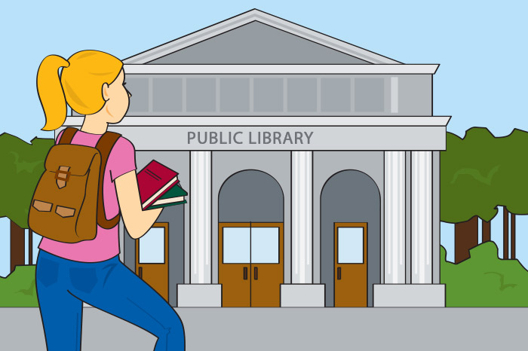
Q: 어디에 가요?
A: 도서관에 가요.
Q: 도서관에서 뭐 해요?
A: 도서관에서 공부해요.
Q: 왜 도서관에 가요?
A: 공부하러 도서관에 가요.

1.
2.
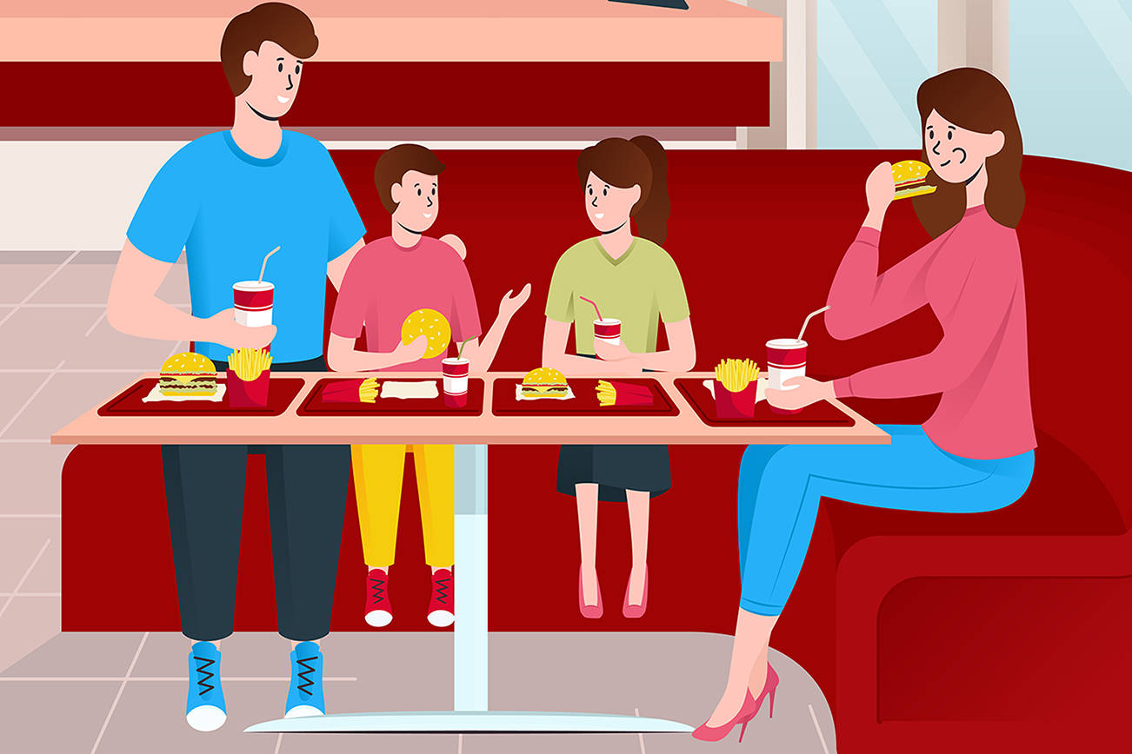
3.
4.
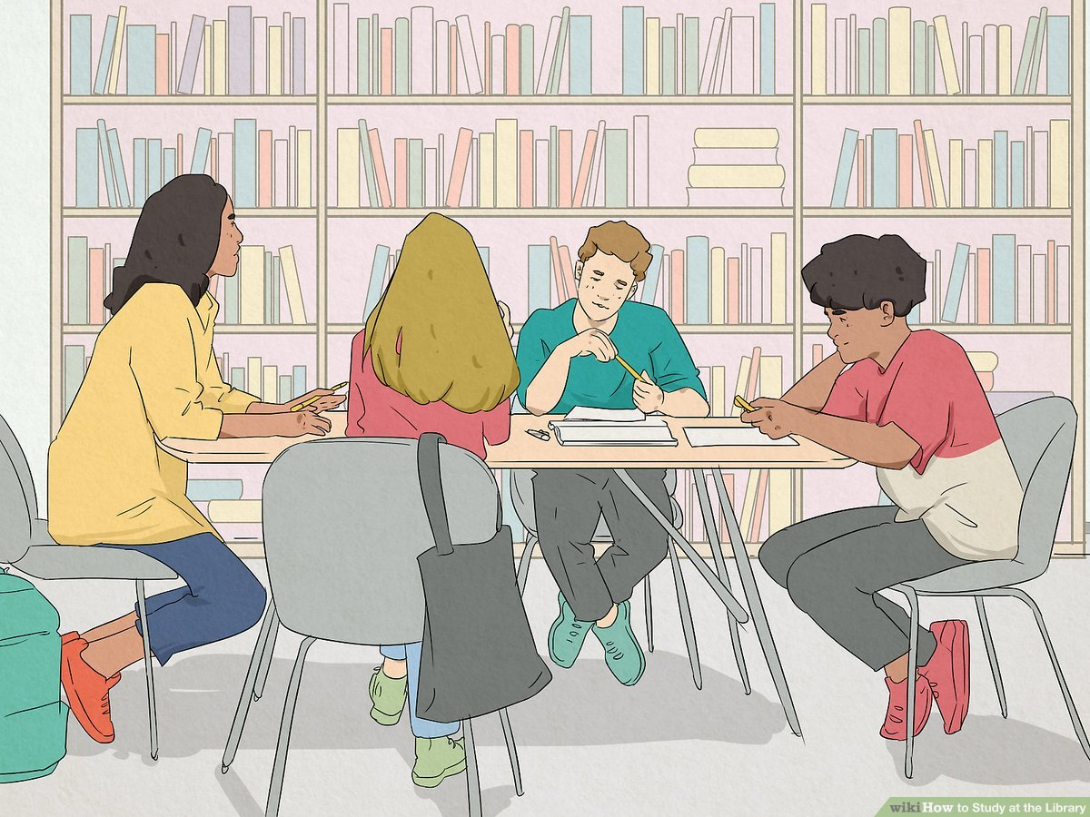
5.
6.
7.
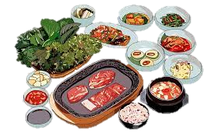
8.
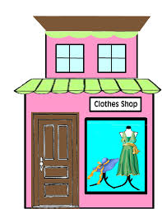

Section 4: Where are you going?
Part A: You run into your friend you haven’t seen for a while on campus. Say hello to each other and use “where, what and why” questions. Translate and practice the following conversation with your partner in Korean.
A:
Speaker 1: Hello, ____________ 씨. Long time no see!
Speaker 2: Long time no see, ____________씨! Where are you going?
Speaker 1: I’m going to the department store.
Speaker 2: Why are going to the department store?
Speaker 1: I’m going to the department store to work. What about you?
Speaker 2: I am going home to eat lunch. And I work.
Speaker 1: Where do you work?
Speaker 2: I work at a clothing store.
Part B: You run into your partner outside the library. Find out where one is going and for what purpose. Ask “where, what, and why” questions to practice 에, 에서, (으)러. Make sure to use the same in your answers. Use the space below to help create the conversation. The conversation should be 30 seconds to 1.5 minutes. You will record this dialogue in the next section. Ask for help if necessary.
B:
Speaker 1:__________________________________________________________
Speaker 2: __________________________________________________________
Speaker 1: __________________________________________________________
Speaker 2: __________________________________________________________
Speaker 1: __________________________________________________________
Speaker 2: __________________________________________________________
Speaker 1: __________________________________________________________
Speaker 2: __________________________________________________________

Section 5: Record and Save Your Recording
Instructions: Perform the dialogue you created with your partner. Make sure you do not end your Zoom meeting until you have performed your dialogue with your partner.

