KLP04 At Home
STOP: Before you begin this activity, open and follow recording instructions for online activities or on-campus activities.

Pair # __________

Partner A: ________________________________
Student ID: _______________________________
Instructor: ________________________________
Level: ______________ Date: _________________
Partner B: ________________________________
Student ID: _______________________________
Instructor: ________________________________
Level: ______________ Date: _________________

All links in this activity direct to the KLP Activities page on the LLC website. Find your activity number and click the drop down to find links to videos used in this activity.

Section 1: Vocabulary Mastery
Instructions: Write the translation of the following words and phrases into Korean. Try to use your book and your partner before using other materials or the internet. In the third column, draw a picture, write a note to yourself or put some kind of pronunciation guide for the target language. Use the third column to help remember your target language.
Vocabulary | Translation | Notes/Pictures/Pronunciation Guide (anything to help you)
- Parents
- Father
- Mother
- Grandfather
- Grandmother
- Uncle
- Aunt
- Boss
- Older sister of a female/male
- Older brother of a female/male
- Younger sister
- Young brother
- Family
- To be tall
- To learn
- To give
- To have (possession) honorific
- To be (existence) honorific
- To live
- To be pretty

Concept Check: Honorifics (으)세요 form
The suffix ~(으)세요 form is an honorific form which is used to show respect to someone older or higher social status. You need to use the ~(으)세요 form when you are talking to someone like your teacher or your boss or your grandparents to show respect. This form is also used when you are talking about your teacher or grandparents with your friend. Since the subject of your conversation is your teacher or your boss or your grandparents, you need to use the ~(으)세요 form to show respect.
The ~(으)세요 form is also a polite command form. If you want to say “Please read” or “Please write” you can use the ~(으)세요 form.
The ~(으)세요 form is easy to conjugate. Drop 다and look at the last syllable of the stem. If it ends in a consonant, add 으세요. If it ends in a vowel, add 세요. Remember to pay attention to exceptions!
많다 많 많으세요
앉다 앉 앉으세요
만나다 만나 만나세요
공부하다 공부하 공부하세요
Exceptions:
이다 이에요/예요 이세요/세요
아니다 아니에요 아니세요
그렇다 그래요 그러세요
어떻다 어때요 어떠세요
It is important to pay close attention to있어요 / 없어요 in the honorific form because they are completely different. In the polite form, you only need to pay attention to the particles to determine whether it’s used as existence or possession. However, in the honorific form, you need to make sure you use 에 계세요 / 에 안 계세요for existence and non-existence and이/가 있으세요 / 없으세요for possession and non-possession.
Let’s compare the following sentences.
Polite form
스티브는 키가 커요. (Steve is tall.)
소피아가 예뻐요. (Sophia is pretty.)
유미는 언니가 있어요. (Yumi has an older sister.)
마이클이 집에 있어요. (Michael is at home.)
리사가 월넛에 살아요. (Lisa lives in Walnut.)
Honorific form
아버지는 키가 크세요. (Father is tall.)
어머니가 예쁘세요. (Mother is pretty.)
선생님은 언니가 있으세요. (Teacher has an older sister.)
아버지가 집에 계세요. (Father is at home.)
선생님이 월넛에 사세요. (Teacher lives in Walnut.)

Even though you are not old, depending on the context, the speaker might use the honorific form to ask questions. However, you cannot use the honorific form in your reply because you cannot honor yourself. In your reply, you need to use the 어요/아요form.
Situation 1: A question is directed at you and you are replying so you cannot use the honorific form.
A: 공부하세요?
B: 네, 공부해요.
Situation 2: A student is talking to the teacher. The student needs to use the honorific form, but the teacher cannot use the honorific form to answer.
학생: 선생님, 바쁘세요?
선생님: 네, 바빠요.
Situation 3: This conversation is taking place between two students and the subject of their conversation is their teacher. Since both students are talking about their teacher, they both need to use the honorific form.
학생 1: 선생님은 키가 크세요?
학생 2: 네, 키가 크세요.

Section 2: Sentence Translation
Instructions: Take turns translating the following sentences into Korean. Then practice asking and answering. Write down your partner’s answers in Korean. Make sure to use honorifics for all questions. However, you need to pay attention when answering. If the subject of your sentence is you mother or father, you need to use the honorific form. If you are talking about your older sibling or you are answering the question for yourself, you do not use the honorific form. Pay extra attention when replying.
- Where do you live?
____________________________________________________________________________
- Where do your parents live?
____________________________________________________________________________
- Boss, are you busy these days?
____________________________________________________________________________
- Do you have an older sister?
____________________________________________________________________________
- Is your mother pretty?
____________________________________________________________________________
- Is your father tall?
____________________________________________________________________________
- What is mother doing?
____________________________________________________________________________

Section 3: Talk about family members
Instructions: Watch Section 3 Video A and practice saying each family member in Korean.
*Note: 엄마and 아빠are casual forms for mother and father. Make sure you use the formal form to do this activity.
You can do this activity after watching Section 3 Video B and Section 3 Video C.
There are four photos. You and your partner will take turns asking the question (refer the video) and answering based on the photos.
Picture 1:
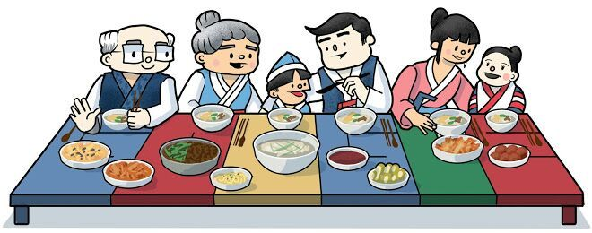
Picture 2:
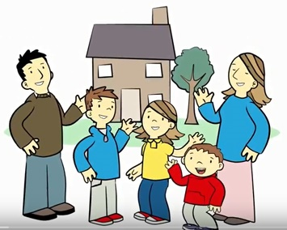
Picture 3:
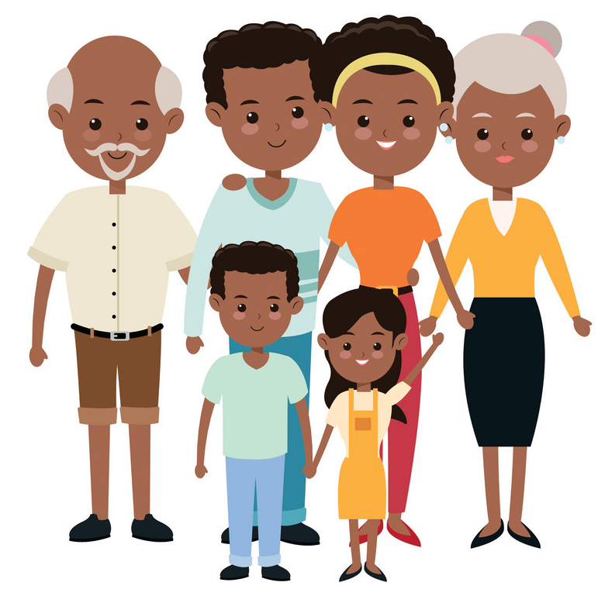
Picture 4:

Section 4: Where do you live?
Part A: You are having a conversation with your teacher. Make sure you use the honorific form. Translate and practice the following conversation with your partner in Korean.
A:
Speaker 1 (Student): Teacher, where do you live?
Speaker 2 (Teacher): I live in Los Angeles. What about you?
Speaker 1 (S): I live in Walnut. Where do your parents live?
Speaker 2 (T): My parents live in Korea. Do you have an older brother?
Speaker 1(S): Yes, I have an older brother. Do you have an older sister?
Speaker 2 (T): Yes, I have an older sister. She is also in Korea.
Part B: You are having a conversation with your boss. Make sure you use the honorific form. Use the space below to help create the conversation. The conversation should be 30 seconds to 1.5 minutes. You will record this dialogue in the next section. Ask for help if necessary.
B:
Speaker 1:__________________________________________________________
Speaker 2: __________________________________________________________
Speaker 1: __________________________________________________________
Speaker 2: __________________________________________________________
Speaker 1: __________________________________________________________
Speaker 2: __________________________________________________________
Speaker 1: __________________________________________________________
Speaker 2: __________________________________________________________

Section 5: Record and Save Your Recording
Instructions: Perform the dialogue you created with your partner. Make sure you do not end your Zoom meeting until you have performed your dialogue with your partner.

