JLP30 Childhood Experiences (Chapter 22)
STOP: Before you begin this activity, open and follow recording instructions here.

Pair # _________

Partner A: ________________________________
Student ID: _______________________________
Instructor: ________________________________
Level: ______________ Date: ________________
Partner B: ________________________________
Student ID: _______________________________
Instructor: ________________________________
Level: ______________ Date: ________________

All links in this activity direct to the JLP Activities page on the LLC website. Find your activity number and click the drop down to find links to videos, audio, and/or websites used in this activity.

Section 1: Vocabulary Mastery
Instructions: Write the translation of the following words and phrases into Japanese. Try to use your book and your partner before using other materials or the internet. In the third column, draw a picture, write a note to yourself or put some kind of pronunciation guide for Japanese. Use the third column to help remember the word in Japanese.
Vocabulary | Translation | Notes/Pictures/Pronunciation Guide (anything to help you)
- parent
- child
- mother
- father
- to tidy up
- to play
- to watch
- to read
- to eat
- to drink
- to stay up all night
- to sleep
- video games
- vegetables
- candy/ sweets
- coffee
- cartoons
- to own (a pet)
- to do laundry
- to wash dishes

Concept Check: Causative Sentences
The causative form of a verb can be used to describe who makes someone do something or lets someone do something. Since causative sentences can have two meanings, you need to rely on your knowledge of the situation and context clues to determine the meaning. In this activity you form causative sentences to describe things your parents made you do as a child, things your parents let you do, and what you would let your children do in the future.
To conjugate Ru-verbs into the causative form, drop the final る and add させる
- Ex. 見る becomes 見させる
For u-verbs, you will drop the final う and add あせる
- Ex. よむ becomes よませる
The irregular verb conjugations are as follows:
くる becomes こさせる and する becomes させる.
To form a causative sentence, you can use this basic structure:
(Person who decides what is allowed) は(Person who performs the action)に(action)。
If you want to imply that the meaning of a causative sentence is “let,” you can use the helping verb てあげる, てくれる, or てもらう after the causative verb.
- Ex. 子供の時、親は私に猫を飼わせてくれました。When I was a child, my parents let me own a cat.

Section 2: What Was Your Childhood Like?
Instructions: For each of the pictures below, write a sentence saying if you were allowed or made to do that activity as a child.
- コーヒーを飲む
＿＿＿＿＿＿＿＿＿＿＿＿＿＿＿＿＿＿＿＿＿＿＿＿＿＿＿＿＿＿
- ゲームをする
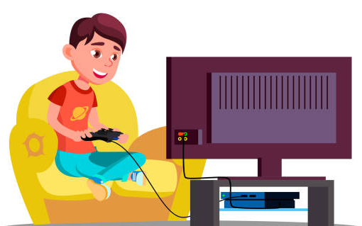＿＿＿＿＿＿＿＿＿＿＿＿＿＿＿＿＿＿＿＿＿＿＿＿＿＿＿＿＿＿＿＿＿
- かたづける
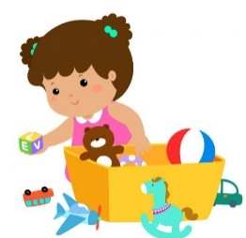＿＿＿＿＿＿＿＿＿＿＿＿＿＿＿＿＿＿＿＿＿＿＿＿＿＿＿＿＿＿＿＿＿＿＿＿
- 犬を飼う
＿＿＿＿＿＿＿＿＿＿＿＿＿＿＿＿＿＿＿＿＿＿＿＿＿＿＿＿＿＿＿＿＿＿

- やさいを食べる
＿＿＿＿＿＿＿＿＿＿＿＿＿＿＿＿＿＿＿＿＿＿＿＿＿＿＿＿＿＿＿＿＿＿＿＿＿
- スポーツをする
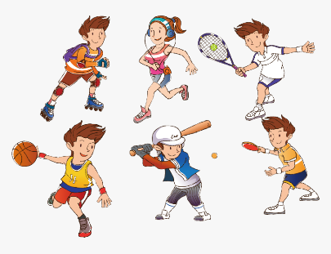＿＿＿＿＿＿＿＿＿＿＿＿＿＿＿＿＿＿＿＿＿＿＿＿＿＿＿＿＿＿＿＿＿＿
- 本を読む
＿＿＿＿＿＿＿＿＿＿＿＿＿＿＿＿＿＿＿＿＿＿＿＿＿＿＿＿＿＿＿＿＿＿＿＿
- アニメ を見る
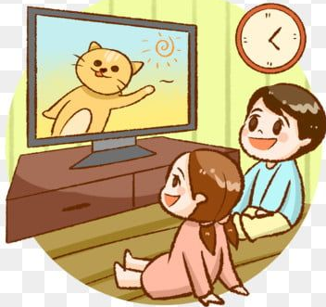＿＿＿＿＿＿＿＿＿＿＿＿＿＿＿＿＿＿＿＿＿＿＿＿＿＿＿＿＿＿＿＿＿＿＿

Section 3: Dialogue Creation
Using causative sentences, discuss with your partner what kinds of things you would let your future children do based on the experiences of your childhood.
Instructions: Use the space below to help create the conversation. The conversation should be 30 seconds to 1.5 minutes for beginning levels and longer for upper levels. You will record this dialogue in the next section. Ask for help if necessary.
Speaker1:
Speaker 2:
Speaker 1:
Speaker 2:
Speaker1:
Speaker 2:
Speaker1:
Speaker 2:
Speaker 1:
Speaker 2:

Section 4: Record and Save Your Recording
Instructions: Perform the dialogue you created with your partner. Make sure you do not end your Zoom meeting until you have performed your dialogue with your partner.

