JLP08 Because ～から (Chapter 6)
STOP: Before you begin this activity, open and follow recording instructions here.

Pair # _________

Partner A: ________________________________
Student ID: _______________________________
Instructor: ________________________________
Level: ______________ Date: ________________
Partner B: ________________________________
Student ID: _______________________________
Instructor: ________________________________
Level: ______________ Date: ________________

All links in this activity direct to the JLP Activities page on the LLC website. Find your activity number and click the drop down to find links to videos, audio, and/or websites used in this activity.

Section 1: Vocabulary Mastery
Instructions: Write the translation of the following words and phrases into Japanese. Try to use your book and your partner before using other materials or the internet. In the third column, draw a picture, write a note to yourself or put some kind of pronunciation guide for Japanese. Use the third column to help remember the word in Japanese.
Vocabulary | Translation | Notes/Pictures/Pronunciation Guide (anything to help you)
- Money
- Electricity/ Electric light
- Window
- Baggage
- Night
- Personal computer
- Textbook
- Next week
- Bath
- Dark
- Later on
- To oversleep
- That would be fine/ That wouldn’t be necessary
- Right away
- Really?
- Tough (situation)
- To be absent from/ To rest
- To borrow
- To turn on
- (Do something) late

Concept Check: ～から
In Chapter 6, we learn how to use ~からto explain the reason for an action or situation.

Watch the video with your partner to review the two different ways of using ~から.
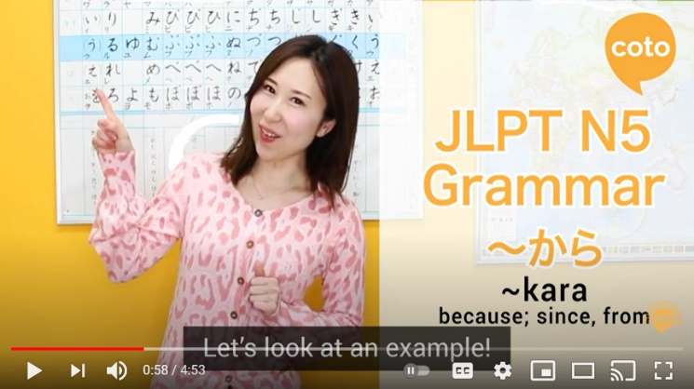

Section 2: Why Did You Do That?
Instructions: Match the situation with the appropriate explanation.
- 今週(こんしゅう)はたいへんです。
- まどをあけました。
- 電気(でんき)をつけました。
- メアリーさんのきょうかしょをかりました。
- 今日(きょう)あさごはんをたべませんでした。
- くらいですから。
- あついですから。
- 朝(あさ)ねぼうしましたから。
- とてもいそがしいですから。
- 家(いえ)でわすれましたから

Section 3: Create Your Own Explanation
Instructions: Make a sentence using ～から with the given situation.
Situation
まどをあげます。
でかけます。
テレビをつけます。
らいねん日本に行きましょう。
パソコンをかいました。
がっこうをやすみました。
くるまはやすいです。
おふろにはいります。
てがみをかきます。
先生に会いました。
Reason
- _______________________________________________________________________
- _______________________________________________________________________
- _______________________________________________________________________
- _______________________________________________________________________
- _______________________________________________________________________
- _______________________________________________________________________
- _______________________________________________________________________
- _______________________________________________________________________
- _______________________________________________________________________
- ______________________________________________________________________

Section 4: Dialogue Creation
You and your friend are making plans for the upcoming weekend. Try to make sentences using ~から to give reasons why certain day/times won’t work.
Instructions: Use the space below to help create the conversation. The conversation should be 1-2 minutes. You will record this dialogue in the next section. Ask for help if necessary.
Speaker1:
Speaker 2:
Speaker 1:
Speaker 2:
Speaker1:
Speaker 2:
Speaker1:
Speaker 2:
Speaker 1:
Speaker 2:

Section 5: Record and Save Your Recording
Instructions: Perform the dialogue you created with your partner. Make sure you do not end your Zoom meeting until you have performed your dialogue with your partner.

