LP5. Nationalities

Pair #
STOP: Before you begin this activity, open and follow recording instructions here.

Partner A:
Student ID:
Instructor:
Language:
Level: Date:
Partner B:
Student ID:
Instructor:
Language:
Level: Date:

Section 1: Vocabulary Mastery
Instructions: Write the translation of the following words and phrases into your target language. Try to use your book and your partner before using other materials or the internet. In the third column, draw a picture, write a note to yourself or put some kind of pronunciation guide for the target language. Use the third column to help remember your target language.
 | Translate in Target Language | Notes/Pictures/Pronunciation Guide (anything to help you)
- Italian/Italy
- Spanish/Spain
- French/France
- German/Germany
- English/England
- American/The United States
- Canadian/Canada
- Mexican/México
- Chinese/China
- Korean/Korea
- Colombian/Colombia

Section 2: Verbal Expressions
Instructions: Remember to consider the gender and number when you are referring to a person’s nationality.
Translate or finish the following phrases with your partner.
- I am __________.
- Penélope Cruz is Spanish. __________________________________
- Jacky Chan is Chinese. ___________________________________
- Charlize Therón and Trevor Noah are South African. ____________________________
- Albert Einstein and Immanuel Kant are German. ____________________________
- Germans are from (country name) ___________________________.
- Cantínflas is Mexican. _________________________
- Mexicans are from __________________________.
- J.K. Rowling is ______________________________.
- Gabriel García Márquez is _____________________.
- Jim Carry is _______________________________.
- Canadians are from _________________________.
- Spaniards are from _________________________.

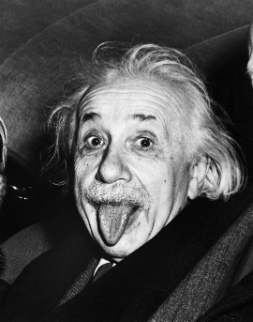

- Varies, f. Germany, h. México, i. British, j. Colombian, k. Canadian, l. Canada, m. Spain

Section 3: International Celebrities
Instructions: Use the internet and your partner’s help to you identify each of the celebrity’s nationalities. Optional Cultural Exchange: If you are not familiar, you and your partner can do some research and talk about their work and role in entertainment (films, music, sports, etc.).

- Emma Watson
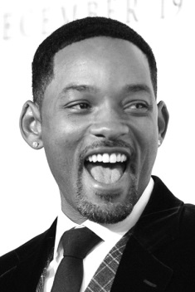
- Will Smith
- Marion Cotillard
- Raoul Bova
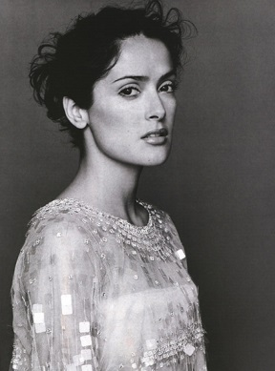
- Salma Hayek
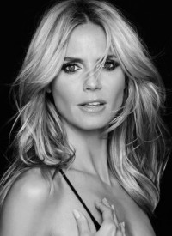
- Heidi Klum
- Fan Bingbing
- Justin Bieber
- Gad Elmaleh

- English/British, b. American, c. French, d. Italian, e. Mexican, f. German, g. Chinese, h. Canandian, i. French

Section 4: Dialogue Creation
Instructions: What is your nationality? What is your favorite celebrity’s nationality? Switch roles and then answer your partner’s questions. Continue below if you need more space. You will perform this dialogue in the next section.
Speaker 1:
Speaker 2:
Speaker 1:
Speaker 2:
Speaker 1:
Speaker 2:
Speaker 1:
Speaker 2:

Section 5: Perform Your Dialogue
Instructions: Perform the dialogue you created with your partner. Make sure you do not end your Zoom meeting until you have performed your dialogue with your partner.

