LP4. Hometown

Pair #
STOP: Before you begin this activity, open and follow recording instructions here.

Partner A:
Student ID:
Instructor:
Language:
Level: Date:
Partner B:
Student ID:
Instructor:
Language:
Level: Date:

Section 1: Vocabulary Mastery
Instructions: Write the translation of the following words and phrases into your target language. Try to use your book and your partner before using other materials or the internet. In the third column, draw a picture, write a note to yourself or put some kind of pronunciation guide for the target language. Use the third column to help remember your target language.
 | Translate into Target Language | Notes/Pictures/Pronunciation Guide (anything to help you)
- an airport
- a hotel
- a bank
- a bar
- a library
- a gym
- a restaurant
- a university
- a train station
- a supermarket
- a theater
- a post office
- a gas station
- a coffee shop
- There is/are . . .
- Where is . . . .?
- My hometown is a . . .
(city, town, village, etc.)

Section 2: Sentences and Questions
Instructions: Translate the expressions that are used when talking about a city, a town, or a village. Answer the questions. Practice speaking and answering and take turns with your partner.
Is your hometown big or small?

Where is your favorite coffee shop?

Does your town have a theater?

How many schools does the city have?

Where is a good place to study?

What do you do on the weekends in your hometown?

What is your favorite restaurant in your hometown?

Section 3: Practice with a Map
Instructions: Label the map and describe this city. Practice speaking with your partner taking turns. 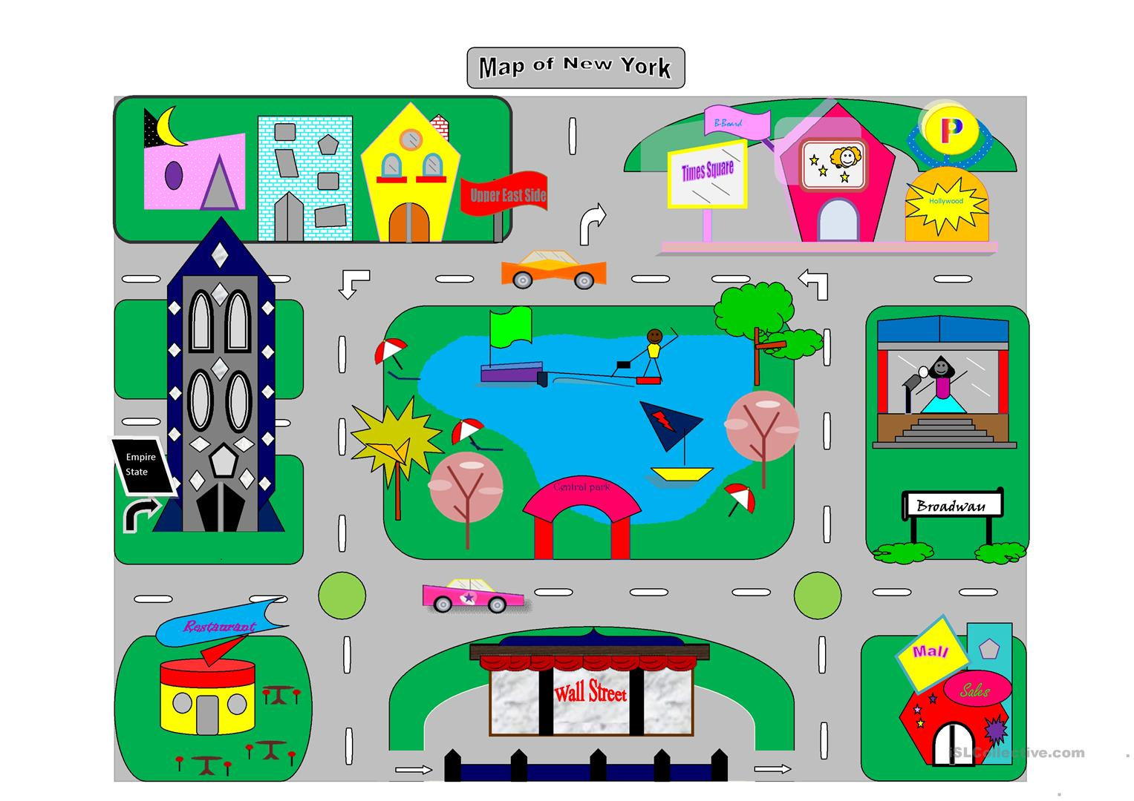

Section 4: Dialogue Creation
Instructions: Write the questions you will ask your partner about their own house in the target language. Then write your partner’s answers in the target language. Practice asking and answering. Switch roles and then answer your partner’s questions. Continue below if you need more space. You will perform this dialogue in the next section.
Speaker 1:
Speaker 2:
Speaker 1:
Speaker 2:
Speaker 1:
Speaker 2:
Speaker 1:
Speaker 2:

Section 5: Perform Your Dialogue
Instructions: Perform the dialogue you created with your partner. Make sure you do not end your Zoom meeting until you have performed your dialogue with your partner.

