LP2. In the Classroom

Pair #
STOP: Before you begin this activity, open and follow recording instructions here.
Partner A:
Student ID:
Instructor:
Language:
Level: Date:
Partner B:
Student ID:
Instructor:
Language:
Level: Date:

Section 1: Vocabulary Mastery
Instructions: Write the translation of the following words and phrases into your target language. Try to use your book and your partner before using other materials or the internet. In the third column, draw a picture, write a note to yourself or put some kind of pronunciation guide for the target language. Use the third column to help remember your target language.
 | Translate into Target Language | Notes/Pictures/Pronunciation Guide (anything to help you)
- a closet
- a desk
- a chair
- a backpack
- a pencil
- an eraser
- a computer
- a window
- a blackboard/whiteboard
- a calculator
- a lesson
- a book
- a page
- a notebook
- a name
- a professor
- a student

Section 2: Sentence Answer or Translation
Instructions: Take turns translating and then answering these questions in the target language. Practice asking and answering.
- What days do you go to class?

- Do you need a backpack?

- What do you need for history class?

- Do you already have a calculator?

- Are you going to buy a notebook?

Section 3: Classroom Items
Instructions: Use your textbook and your partner’s help to label as many items in this classroom as you can.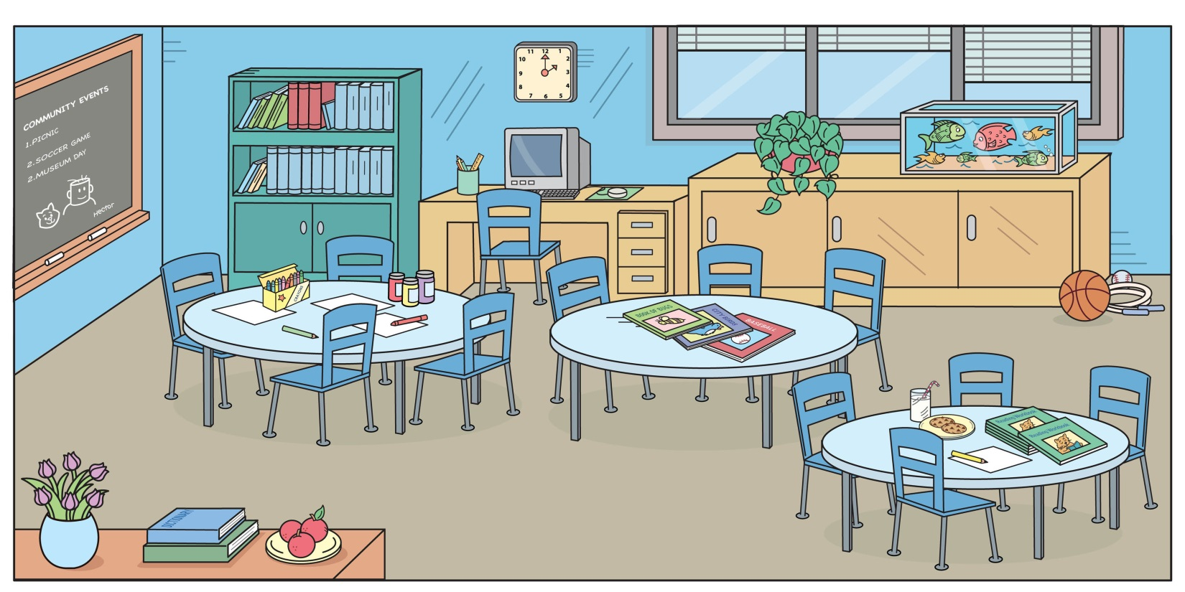

Section 4: Dialogue Creation
Instructions: Imagine that tomorrow is the first day of school and you and your partner need some new supplies. You may ask your partner what they need and point out the items they already have. Write questions you will ask your partner in the target language. Then write your partner’s answers in the target language. Continue below if you need more space. You will perform this dialogue in the next section. Practice asking and answering.
Speaker 1:
Speaker 2:
Speaker 1:
Speaker 2:
Speaker 1:
Speaker 2:
Speaker 1:
Speaker 2:

Section 5: Perform Your Dialogue
Instructions: Perform the dialogue you created with your partner. Make sure you do not end your Zoom meeting until you have performed your dialogue with your partner.

