KLP18 Clothing and Fashion
STOP: Before you begin this activity, open and follow recording instructions for online activities or on-campus activities.

Pair # __________

Partner A: ________________________________
Student ID: _______________________________
Instructor: ________________________________
Level: ______________ Date: _________________
Partner B: ________________________________
Student ID: _______________________________
Instructor: ________________________________
Level: ______________ Date: _________________

Section 1: Vocabulary Mastery
Instructions: Write the translation of the following words and phrases into Korean. Try to use your book and your partner before using other materials or the Internet. In the third column, draw a picture, write a note to yourself or put some kind of pronunciation guide for the target language. Use the third column to help remember your target language.
Vocabulary | Translation | Notes/Pictures/Pronunciation Guide (anything to help you)
- Dress shoes
- Suit, formal dress
- School uniform
- Regular price
- Half price
- Price
- Credit card
- Cash
- To gain weight
- To lose weight
- To be on a diet
- To be stylish
- To pick, choose
- To like (lit. enters one’s heart)
- To be in fashion
- To match, suit
- To fit
- To be bright
- To be dark
- To be popular

Learn More Vocabulary
Watch the Section 1 video to learn clothing words. As you watch, write and say the clothing items you are wearing now.
______________________________________________________________________________________________________________________________________________________________________________________________________________________________________________________________________________________________________

Concept Check: It seems/looks like ~(으)ㄴ/는/(으)ㄹ 것 같다
~(으)ㄴ/는/(으)ㄹ 것 같다is commonly used as an indirect way to speak. Even though it is translated as “it seems or it looks like” as if to express doubt, it is used even though the speaker has no doubt. It is more polite way to speak since the speaker does not use the direct expression. You will learn from examples.
The pattern ~(으)ㄴ/는/(으)ㄹ 것 같다 is used in all three tenses: present, past, and future for both verbs and adjectives. To conjugate, think of the way in which you used the noun modifying form for all three tenses. You are using the noun modifying form and adding것 같다. 것is a thing and is a noun. The verbs and adjectives are modifying the noun “것.”
For example, the verb to eat 먹다, conjugate this verb in the noun modifying form in all three tenses and add 것 같다:
Present 먹는 것 같아요
Past 먹은 것 같아요
Future 먹을 것 같아요
Conjugate the adjective to be cheap “싸다” in the noun modifying form in all three tenses and add 것 같다:
Present 싼 것 같아요
Past 쌌던 것같아요
Future 쌀 것 같아요
Since this expression is used to speak indirectly and to be more polite, let’s look at the situation and how it is used. The situation is that you and your classmate are shopping. Your classmate picks out something that is not very good. You want to say something indirectly using this form.
A: 이 옷 예쁘지요? 어때요?
B: 너무 예쁜데 조금 비싼 것 같아요. 다른 옷 구경해요.
*Note: ~(으)ㄴ/는/(으)ㄹ 거 같다is more colloquial)

Section 2: Sentence Translation
Instructions: Take turns translating the following sentences into Korean. Then practice asking and answering. Write down your partner’s answers in Korean.

- What color is in fashion these days?

- What clothes are in fashion this spring (or summer, fall, winter)?

- What color and clothes suit you well?

- Do you think I’ve gained weight?

- What food is popular now?

- What Korean dramas are popular now?

- What is a popular restaurant in front of campus (around your neighborhood, your city)?

Section 3: How do I look?
Instructions A: Look at each picture and discuss with your partner whether the clothes he or she is wearing are appropriate for occasions specified. Discuss with your partner why it is not appropriate and what type of clothing is appropriate for each occasion using the grammar (으)ㄴ/는/(으)ㄹ 것 같다.
Example:
Q: 이 셔츠가 어때요? 어울려요?
A: 아니요. 너무 커서 일할 때 불편해요. 작은 셔츠를 입어야 될 것 같아요.
1. You are going to work.
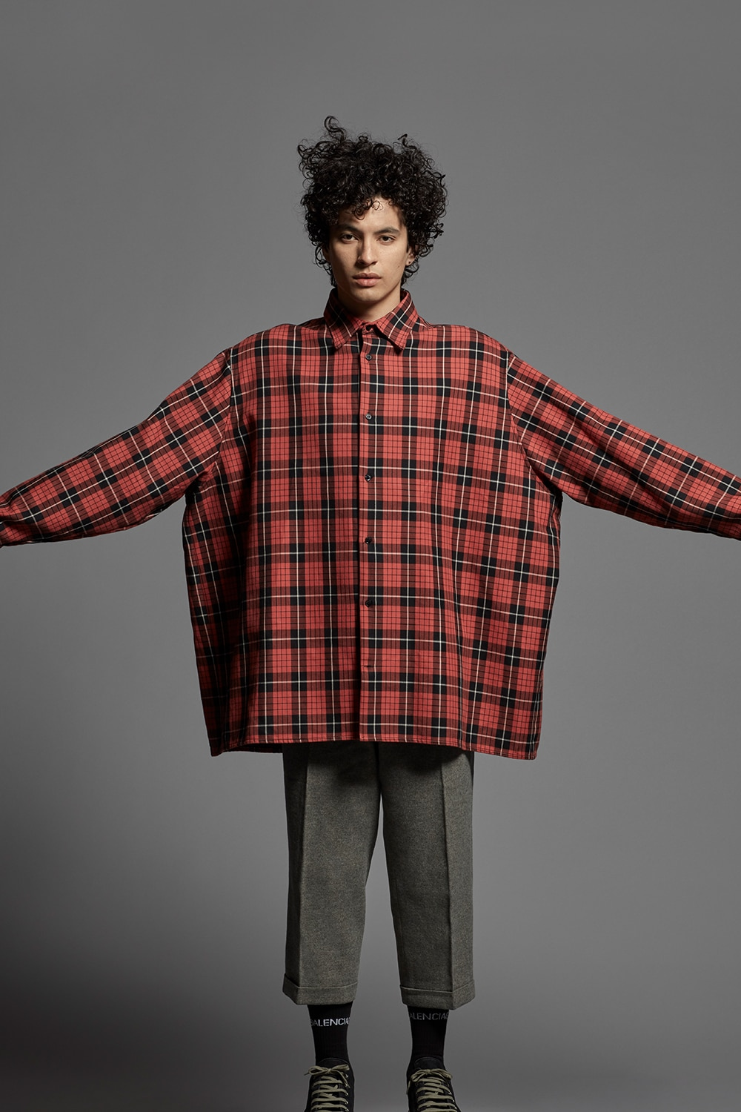

2. You are invited to your boss’s dinner party.
3. You are going to your teacher’s wedding.

4. You have a Korean club meeting to attend.

5. You work at a Korean restaurant as a waiter.
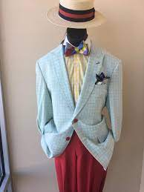

6. Choose 2 images and discuss what each clothing is appropriate and for which occasion.
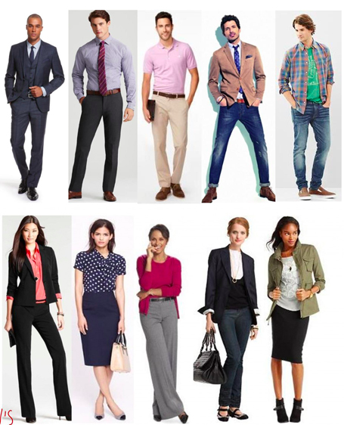

Section 4: Going shopping
Part A: You and your roommate are shopping for clothes. Translate and practice the following conversation with your partner in Korean.
A:
Speaker 1: I have an interview next week, so I need to get new clothes.
Speaker 2: You need to get a suit, don’t you?
Speaker 1: I don’t know. What do you think about this blouse and skirt?
Speaker 2: The skirt seems to be too short. How about this one?
Speaker 1: Do you think this suits me well?
Speaker 2: Yes. But the blouse seems small.
Speaker 1: What about this blouse?
Speaker 2: The color suits you well and goes well with the skirt.
Speaker 1: (You tried on the clothes.) They fit me well.
Speaker 2: You look stylish.
Part B: You and your partner are roommates. You are invited to a party so talk to your roommate about buying something that is fashionable and suits you well. Use the space below to help create the conversation. The conversation should be 30 seconds to 1.5 minutes for beginning levels and longer for upper levels. You will record this dialogue in the next section. Ask for help if necessary.
B:
Speaker 1:__________________________________________________________
Speaker 2: __________________________________________________________
Speaker 1: __________________________________________________________
Speaker 2: __________________________________________________________
Speaker 1: __________________________________________________________
Speaker 2: __________________________________________________________

Section 5: Record and Save Your Recording
Instructions: Perform the dialogue you created with your partner. Make sure you do not end your Zoom meeting until you have performed your dialogue with your partner.

