KLP16 At the Restaurant
STOP: Before you begin this activity, open and follow recording instructions for online activities or on-campus activities.

Pair # __________

Partner A: ________________________________
Student ID: _______________________________
Instructor: ________________________________
Level: ______________ Date: _________________
Partner B: ________________________________
Student ID: _______________________________
Instructor: ________________________________
Level: ______________ Date: _________________

All links in this activity direct to the KLP Activities page on the LLC website. Find your activity number and click the drop down to find links to videos used in this activity.

Section 1: Vocabulary Mastery
Instructions: Write the translation of the following words and phrases into Korean. Try to use your book and your partner before using other materials or the Internet. In the third column, draw a picture, write a note to yourself or put some kind of pronunciation guide for the target language. Use the third column to help remember your target language.
Vocabulary | Translation | Notes/Pictures/Pronunciation Guide (anything to help you)
- Price
- Check, bill
- Side dish
- Beverage
- Menu
- Seat
- Employee
- To order
- To be cool, refreshing
- To be cold (food)
- To be hot (for food)
- To have a meal
- To order (food)
- To be toasty
- To taste bitter
- To taste bland
- To be sour
- To be spicy
- To be sweet
- To be salty

Concept Check: ~어/아 보다 Try Doing
The form ~어/아 보다 asks someone if they have tried or experienced something or to tell or ask someone to try or experience something. To ask “Have you tried on hanbok?” you can say “한복을 입어 봤어요?” If you want to tell the person to try wearing hanbok, you can say “한복을 입어 보세요.” If you are talking to someone in a higher status or older, such as your professors, grandparents, parents, boss, make sure you use the honorific form.
Watch the Concept Check video.
To use ~어/아 보다conjugate the verbs into 어요/아요. Then you can drop and add 봤어요to indicate an experience “have done” or an attempt (try).
먹다 먹어요 먹어 봤어요? 네, 먹어 봤어요.
마시다 마셔요 마셔 봤어요? 아니요, 안 마셔 봤어요.
입다 입어요 입어 봤어요? 네, 입어 봤어요.
듣다 들어요 들어 봤어요? 네, 들어 봤어요.
가다 가요 가 봤어요? 아니요, 안 가 봤어요.
The honorific form of the verb to eat or drink is 드시다. You also need to use the honorific form for the verb 보다 is 보시다.
먹다 먹어요 드셔 보셨어요? 네, 먹어 봤어요.
마시다 마셔요 드셔 보셨어요? 아니요, 안 마셔 봤어요.
입다 입어요 입어 보셨어요? 네, 입어 봤어요.
듣다 들어요 들어 보셨어요? 네, 들어 봤어요.
가다 가요 가 보셨어요? 아니요, 안 가 봤어요.
You can now suggest saying “Please try” by adding 보세요.
먹다 먹어요 먹어 보세요.
마시다 마셔요 마셔 보세요.
입다 입어요 입어 보세요.
듣다 들어요 들어 보세요.
가다 가요 가 보세요.
You can now suggest saying “Please try” by adding 보세요. Make sure you pay attention the verbs that already have the honorific form, such as to eat and drink.
먹다 먹어요 드셔 보세요.
마시다 마셔요 드셔 보세요.
입다 입어요 입어 보세요.
듣다 들어요 들어 보세요.
가다 가요 가 보세요.

Section 2: Sentence Translation
Instructions: Take turns translating the following sentences into Korean. Then practice asking and answering. Write down your partner’s answers in Korean.
Watch Section 2 video to learn useful phrases. *Remember: Do not to translate “you” in Korean. It is understood from the context.
- May I take your order?

- How many people?

- How long do I have to wait?

- Can I have the check/bill please?

- Are there any seats?

- Can I have some more side dishes?

- Can I have a box to go?

Section 3: How does it taste?
Instructions A: Look at each picture and discuss with your partner how these Korean food taste. Use the vocabulary words from the vocabulary section to describe taste. You can use more than one taste to describe each picture using the clausal connective. Look at the example below.
Instructions B: You and your partner can do research and come up with Korean food or beverage that fit into taste description. Give a brief description you selected and upload a picture. Look at the example first.
A: Example:
학생1: 김치가 어때요?
학생 2: 짜고 매워요. / 맵고 맛있어요. / 조금 짜고 매워요.
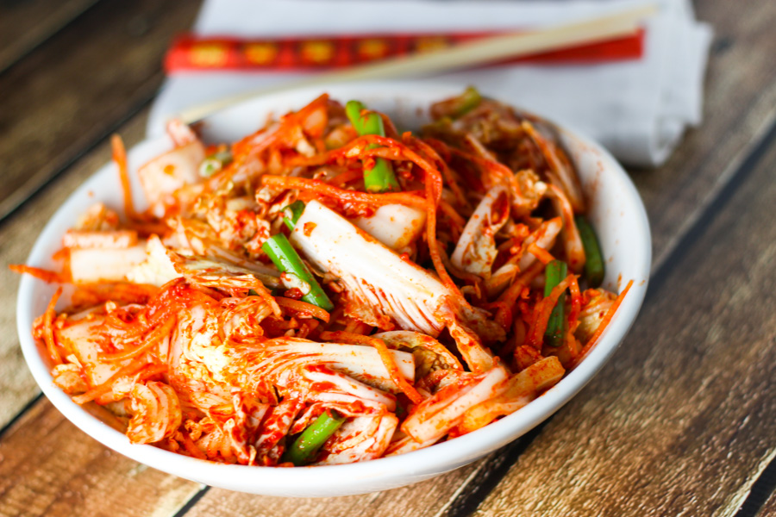

달고나
라면
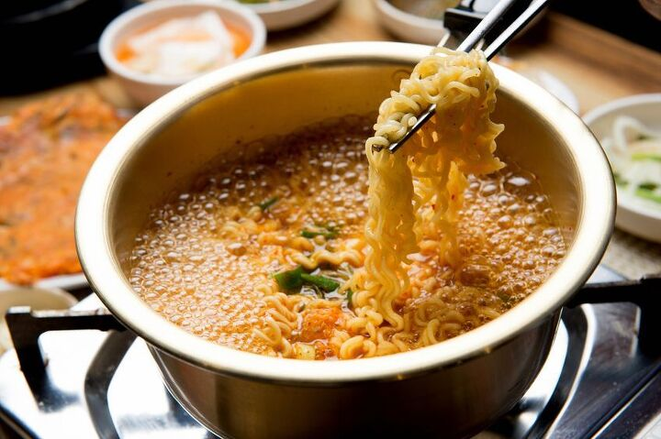
냉면
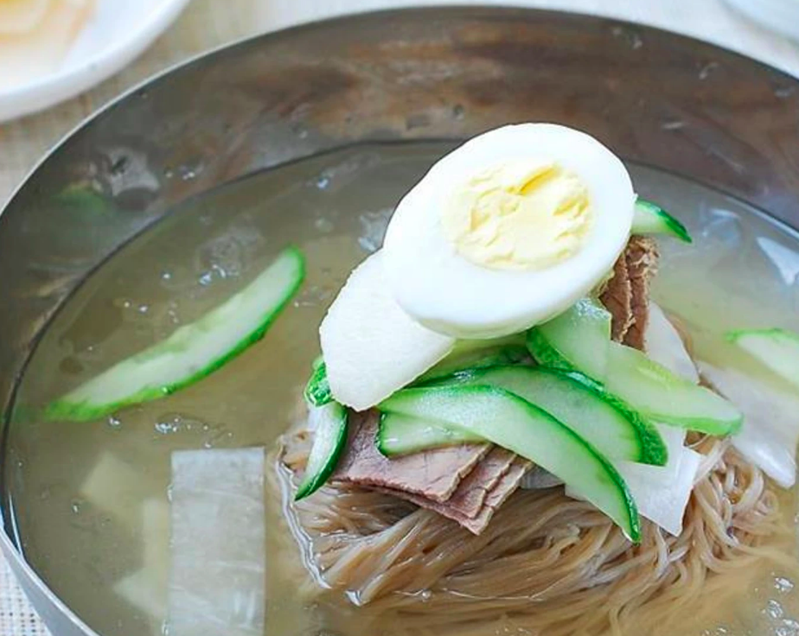
죽
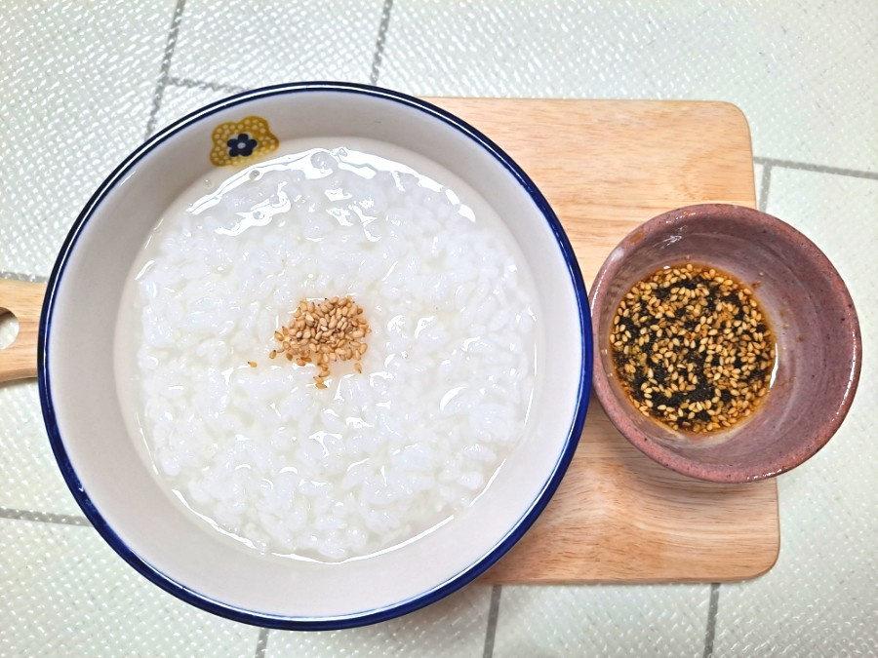
떡
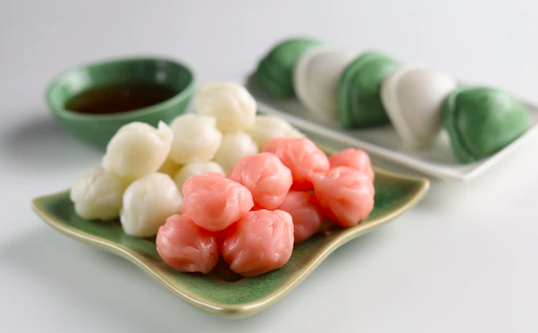
묵
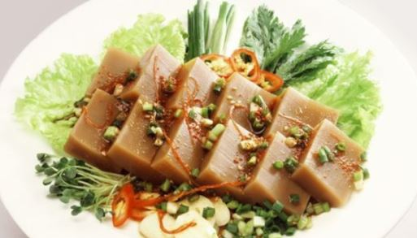

B: Example:
Q: 고소하고 시원한 음식
A: 콩국수 – Cold soy milk noodles taste savory, toasty, and refreshing.
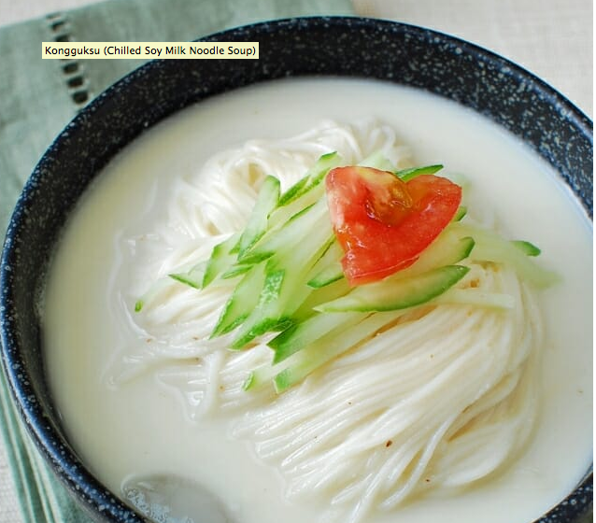
1.
Q: 시원하고 신 음료수
A:

2.
Q: 따뜻하고 쓴 차
A:

Section 4: Korean Restaurant
Part A: You and your friend go to a Korean restaurant to try Korean food. Translate and practice the following conversation with your partner in Korean.
A:
Speaker 1 (Waiter/Waitress): Welcome! How many people?
Speaker 2: There are two people.
(Seated at the table.)
Speaker 2: Excuse me. We are ready to order.
Speaker 1: What would you like?
Speaker 2: We cannot eat meat and spicy food. What would you recommend?
Speaker 1: How about bibimbop? Have you tried bibimbop? It has a lot of vegetables.
Speaker 2: No, we haven’t tried bibimbop. What about kimbop?
Speaker 1: Kimbop is good too. Try bibimbop and kimbop.
Speaker 2: We will have bibimbop and kimbop.
Part B: You and your partner will take on the role of a customer and a restaurant employee. Use the space below to help create the conversation. The conversation should be 30 seconds to 1.5 minutes for beginning levels and longer for upper levels. You will record this dialogue in the next section. Ask for help if necessary.
B:
Speaker 1:__________________________________________________________
Speaker 2: __________________________________________________________
Speaker 1: __________________________________________________________
Speaker 2: __________________________________________________________
Speaker 1: __________________________________________________________
Speaker 2: __________________________________________________________
Speaker 1: __________________________________________________________
Speaker 2: __________________________________________________________

Section 5: Record and Save Your Recording.
Instructions: Perform the dialogue you created with your partner. Make sure you do not end your Zoom meeting until you have performed your dialogue with your partner.

