KLP15 Shopping
STOP: Before you begin this activity, open and follow recording instructions for online activities or on-campus activities.

Pair # __________

Partner A: ________________________________
Student ID: _______________________________
Instructor: ________________________________
Level: ______________ Date: _________________
Partner B: ________________________________
Student ID: _______________________________
Instructor: ________________________________
Level: ______________ Date: _________________

All links in this activity direct to the KLP Activities page on the LLC website. Find your activity number and click the drop down to find links to videos used in this activity.

Section 1: Vocabulary Mastery
Instructions: Write the translation of the following words and phrases into Korean. Try to use your book and your partner before using other materials or the Internet. In the third column, draw a picture, write a note to yourself or put some kind of pronunciation guide for the target language. Use the third column to help remember your target language.
Vocabulary | Translation | Notes/Pictures/Pronunciation Guide (anything to help you)
- Size
- Sale
- Large, Medium, Small
- Not really
- Pair
- Fitting room
- Dressy shoes
- Sneakers
- Scarf
- Shorts
- To exchange
- To refund
- To look around
- To choose
- To come in
- To go in
- To change (clothes)
- To wrap
- To match well
- To bring something to someone

Concept Check: Compound Verbs
There are many compound verbs in Korean which are made up of two verbs. Verbs such as 가다, 오다, 다니다 are commonly combined with other verbs. When using compound verbs in Korean, you need to remember where you are. Depending on where you are, you need to use the appropriate one. See below for examples.
You can explore walking around Insadong in Korea by watching the Concept Check video.
As you watch, say the verbs aloud that reflect what you are watching. For example, “to enter,” “to exit,” etc.
To combine the two verbs together, there are several ways. One is adding ~어/아 가다, 오다. The second one is adding ~고 가다, 오다, 다니다.
들다 to enter 가다 to go (enter and go) 들어가다 to go in
나다 to exit 가다 to go (exit and go) 나가다 to go out
오르다 to ascend 가다 to go (ascend and go) 올라가다 to go up
내리다 to descend 가다 to go (walk and descend) 내려가다 to go down

들다 to enter 오다 to come (enter and come) 들어오다 to come in
나다 to exit 오다 to come (exit and come) 나오다 to come out
오르다 to ascend 오다 to come (ascend and come) 올라오다 to come up
내리다 to descend 오다 to come (descend and come) 내려오다 to come down
It is important where you are in order to use the appropriate one. For example, you want to use들어가다and 들어오다. These two verbs mean to enter and go and enter and come.
You are inside your apartment. And you hear a knocking sound. You want to say “Please come inside.” In Korean, you would use the compound verb 들어오다 since this means, “to come in”. 들어오세요. You would not say “go inside” 들어가세요.
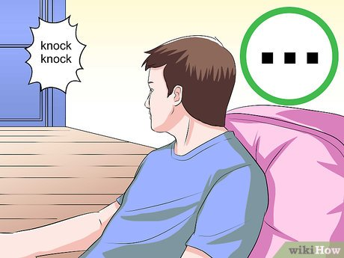
You and the other person are both outside. The person wearing a yellow shirt is holding the door for the person wearing the blue shirt. The person holding the door would say, “Please go inside” 들어가세요. You cannot say “들어오세요” because you two are both outside and you are asking the person to “enter and go.”

When using the compound verbs with 가다 and오다, it is important to keep in mind where you are, so that you know which one to use.
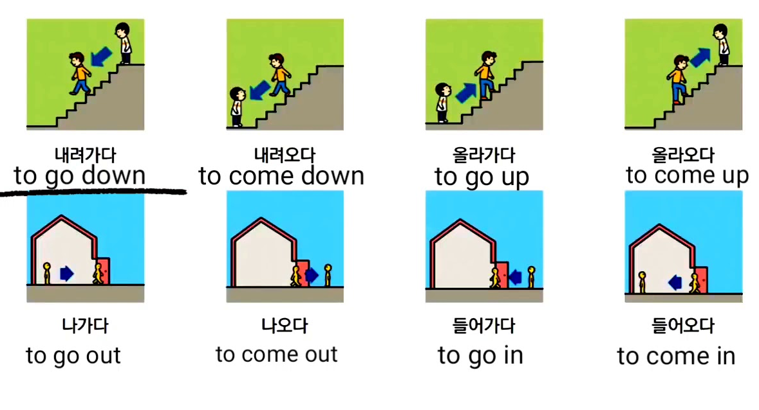
For ~고 가다, 오다, 다니다, you can combine the verb to wear 입다. The word다니다 has the habitual meaning
입다 to wear 가다 to go 입고 가다 to wear and go
입다 to wear 오다 to come 입고 오다 to wear and come
입다 to wear 다니다 to go around 입고 다니다 to wear around

타다 to ride 가다 to go 타고 가다 to ride and go
타다 to ride 오다 to come 타고 오다 to ride and come
타다 to ride 다니다 to go around 타고 다니다 to ride around

갖다 to possess 가다to go 갖고 가다 to possess and go = to take
갖다 to possess 오다 to come 갖고 오다 to possess and come =to bring
갖다 to possess 다니다 to go around 갖고 다니다 to possess and go around =to take around

Section 2: Sentence Translation
Instructions: Take turns translating the following sentences into Korean. Then practice asking and answering. Write down your partner’s answers in Korean.
Watch Section 2 video to learn useful expressions:
*Remember: Do not to translate “you” in Korean. It is understood from the context.
- Do you have a different size?

- What are you looking for?

- How much is it?

- Does this look good on me?

- Can I get a refund?

- May I try this on?

- Can I exchange this?

- Can I pay with credit card?

Section 3: How much is it?
Instructions A: One person will be a salesperson and the other person will be a customer. If you are the customer, name an item and ask how much it is. If you are the salesperson, you will say how much the item the customer is asking. Look at the example below.
Instructions B: You change the role. If you were the salesperson for the A, now you are the customer. You ask how much and the salesperson will tell you.
Example:
손님: 이 모자가 얼마예요? How much is this cap?
점원: 십오 불 구십구 전이에요. It’s fifteen dollars and ninety nine cents.
A:
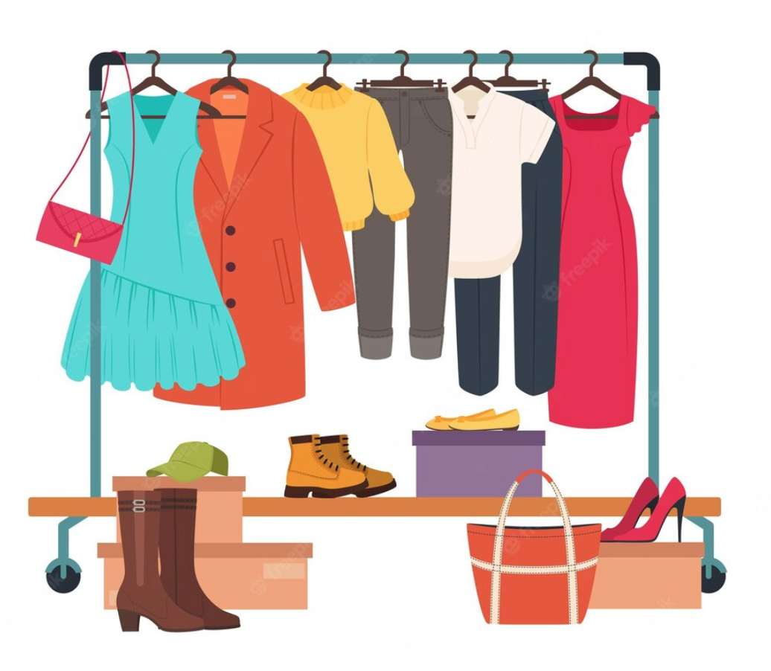
B:
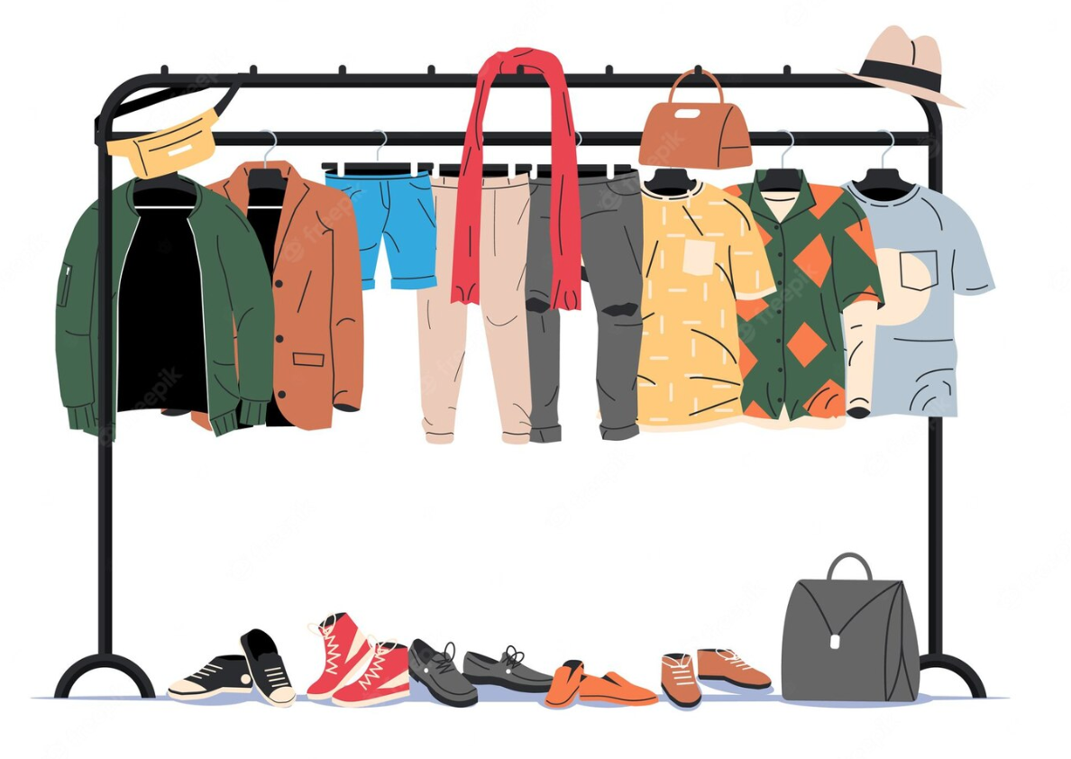

Section 4: Shopping for Clothes
Part A: You and your partner will take the role of a customer and a salesperson. You are outside the shop looking in so the salesperson comes out and invite you in. Translate and practice the following conversation with your partner in Korean.
A:
Speaker 1: Welcome! Please come in. Are you looking for anything?
Speaker 2: I am just looking around.
Speaker 1: Okay. Please look around.
Speaker 2: Do you have this T-shirt in a different color?
Speaker 1: Yes. What size do you wear?
Speaker 2: I wear medium. May I try this on?
Speaker 1: Of course. There is a fitting room. Please go inside. I will bring you the shirt.
Speaker 2: How much is the shirt?
Speaker 1: It’s on sale. It’s $13.99.
Speaker 1: The T-shirt looks good on you.
Speaker 2: Thank you. I will buy this.

Part B: You and your partner will take on the role of a customer and a salesperson. You bought something at the shop but you want to either get a refund or exchange for something else. Use the space below to help create the conversation. The conversation should be 30 seconds to 1.5 minutes for beginning levels and longer for upper levels. You will record this dialogue in the next section. Ask for help if necessary.

B:
Speaker 1:__________________________________________________________
Speaker 2: __________________________________________________________
Speaker 1: __________________________________________________________
Speaker 2: __________________________________________________________
Speaker 1: __________________________________________________________
Speaker 2: __________________________________________________________

Section 5: Record and Save Your Recording
Instructions: Perform the dialogue you created with your partner. Make sure you do not end your Zoom meeting until you have performed your dialogue with your partner.

