Instructions of using online computer service request

Login

Starts from LLC homepage, click Staff – Work Area, you will come to the following web page.

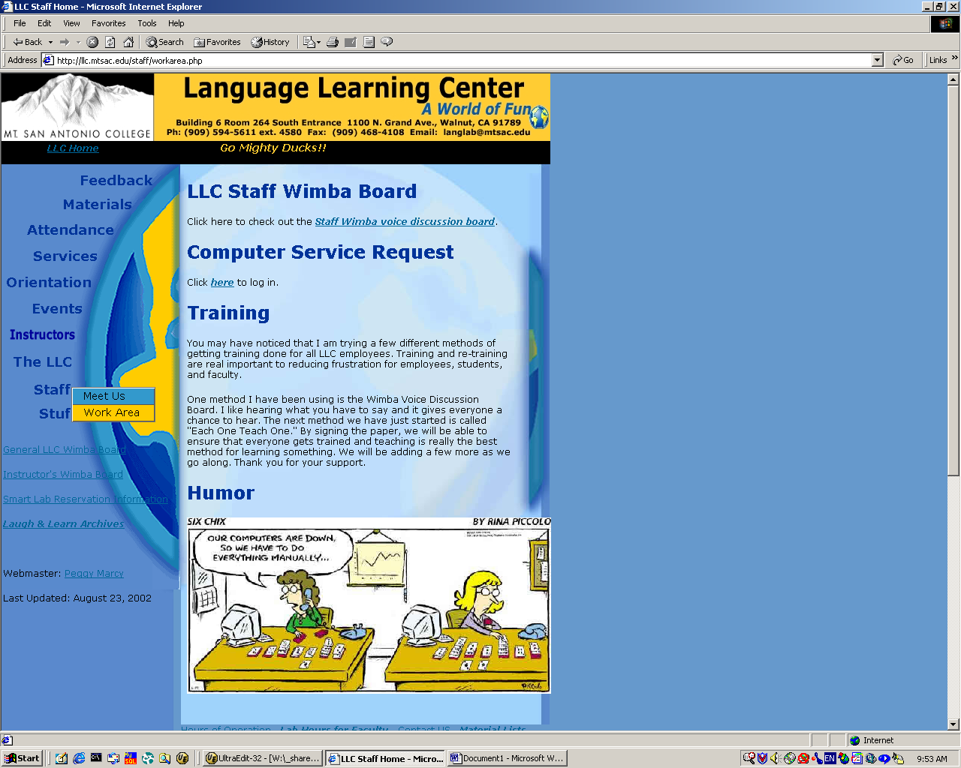

Click the hyperlink under Computer Service Request to the Login page.

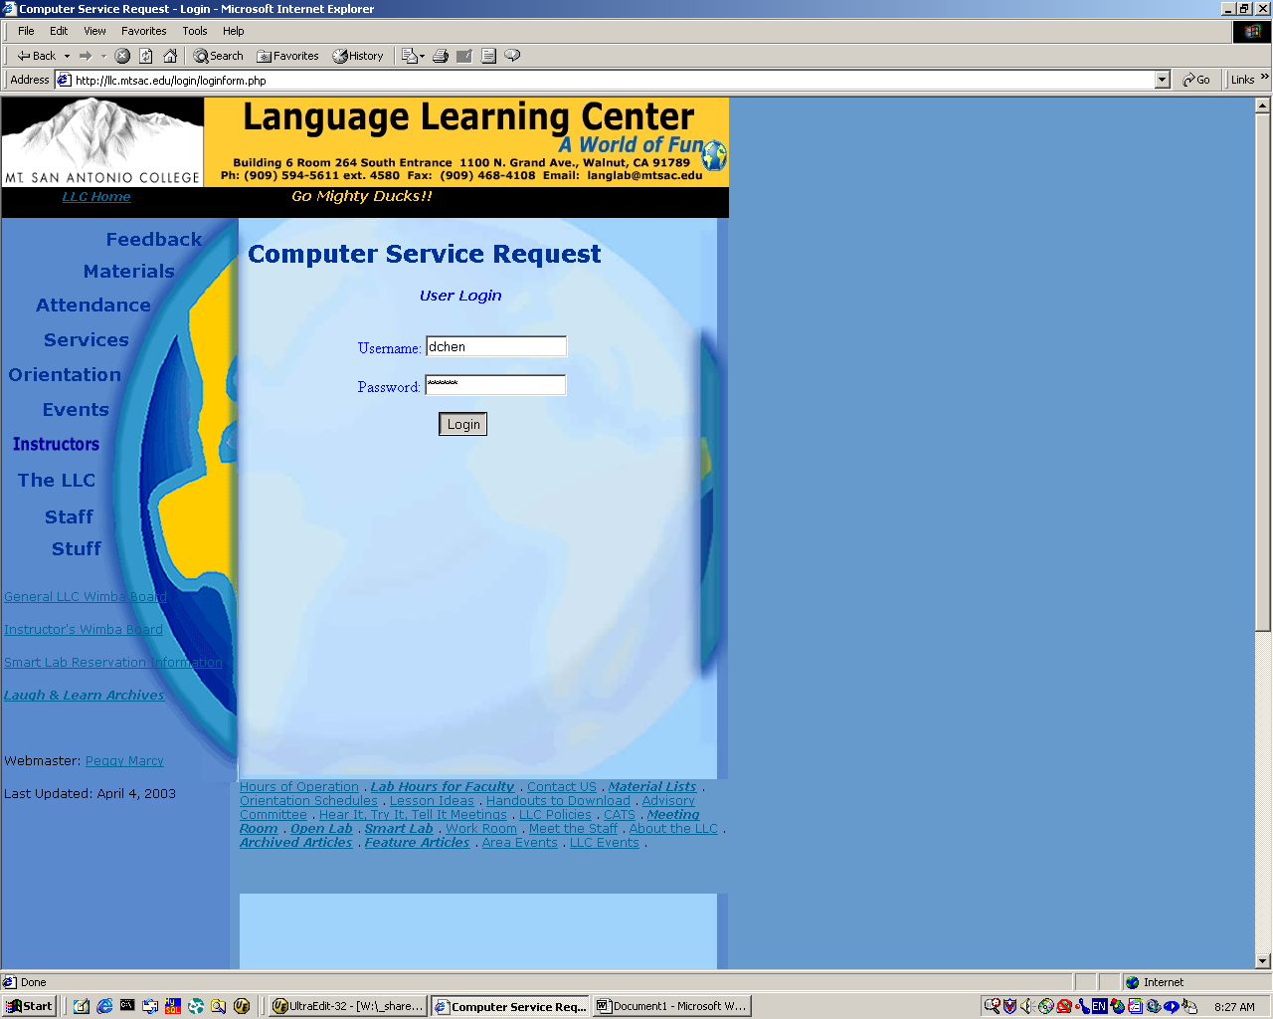

Type in your username (the first letter of your first name and your last name) and password (initial password is the same as your username) to login. You will come to the Function page if you login correctly.

Functions

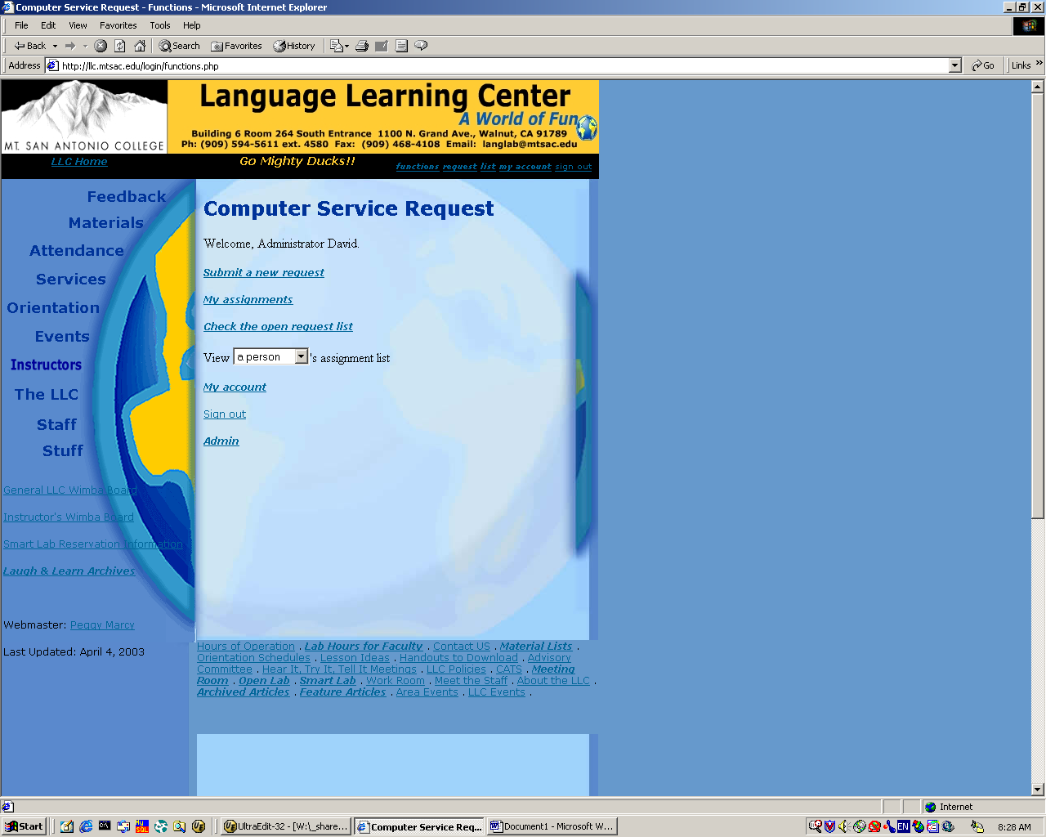

On the Function page, it will have the following list:

Welcome, <your first name>.

Submit a new request

My assignments

Check the open request list

My account

Sign out

A menu bar will also stay on the top-right corner for all the pages.
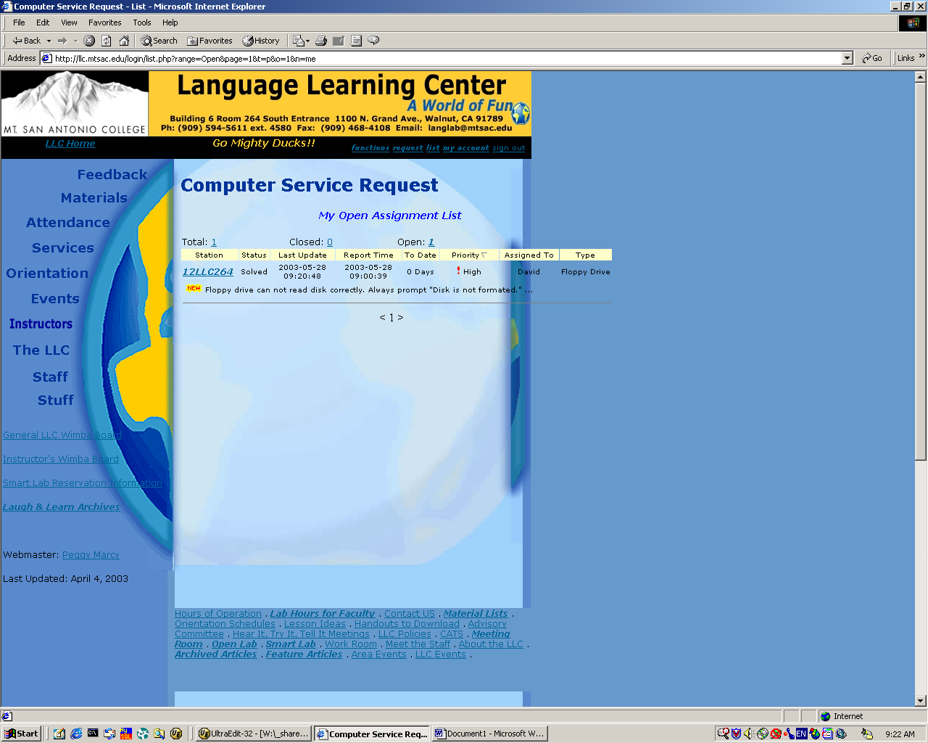

You can click on My Assignments to view the service requests, which were assigned to you to resolve. Assignments are classified as Open or Closed. You can change your view by clicking on the numbers after Total, Closed and Open. Click on the station number, you can see the detail information and all the activities.
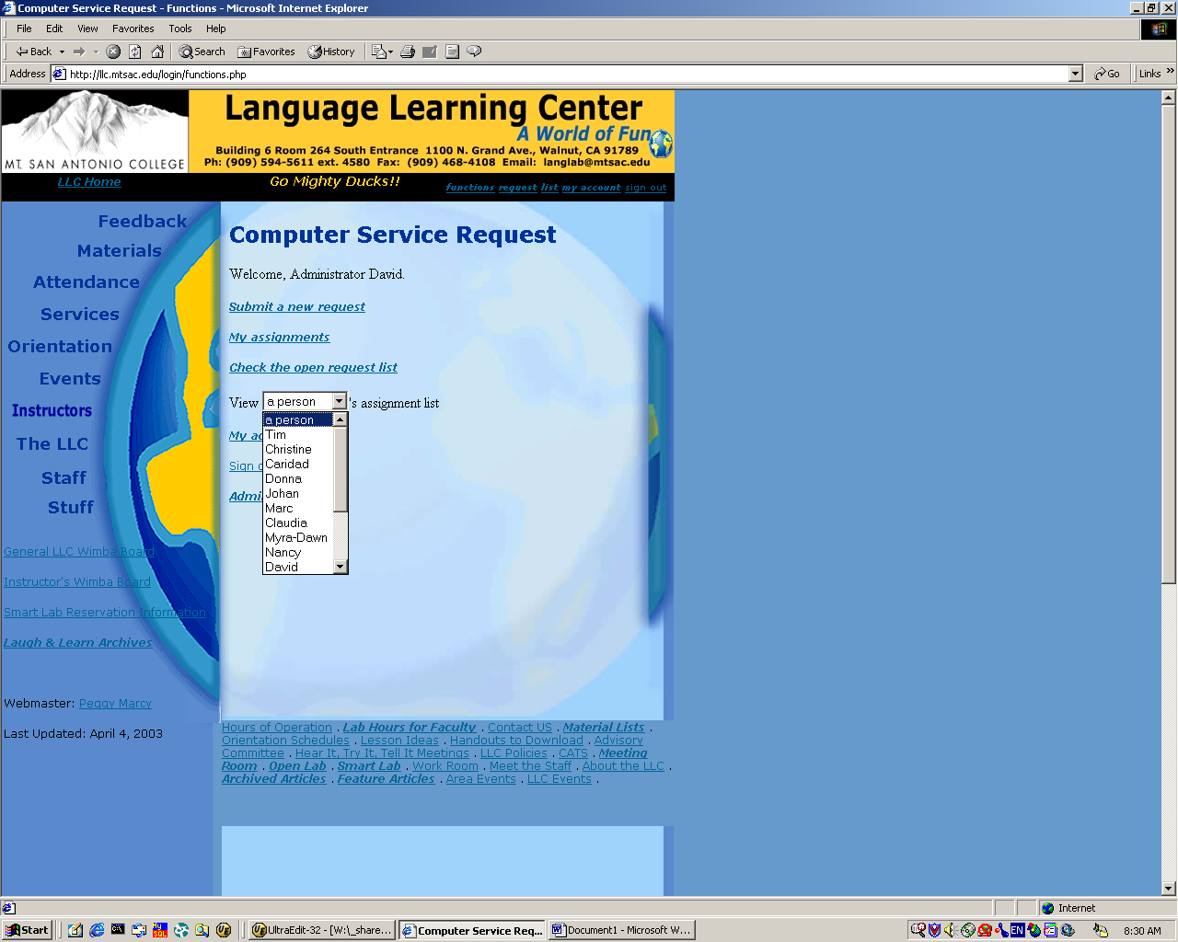

Supervisors will also be able to view individual assignment list while regular users do not have this option.

Submit a new request

Click Submit a new request in the function page.

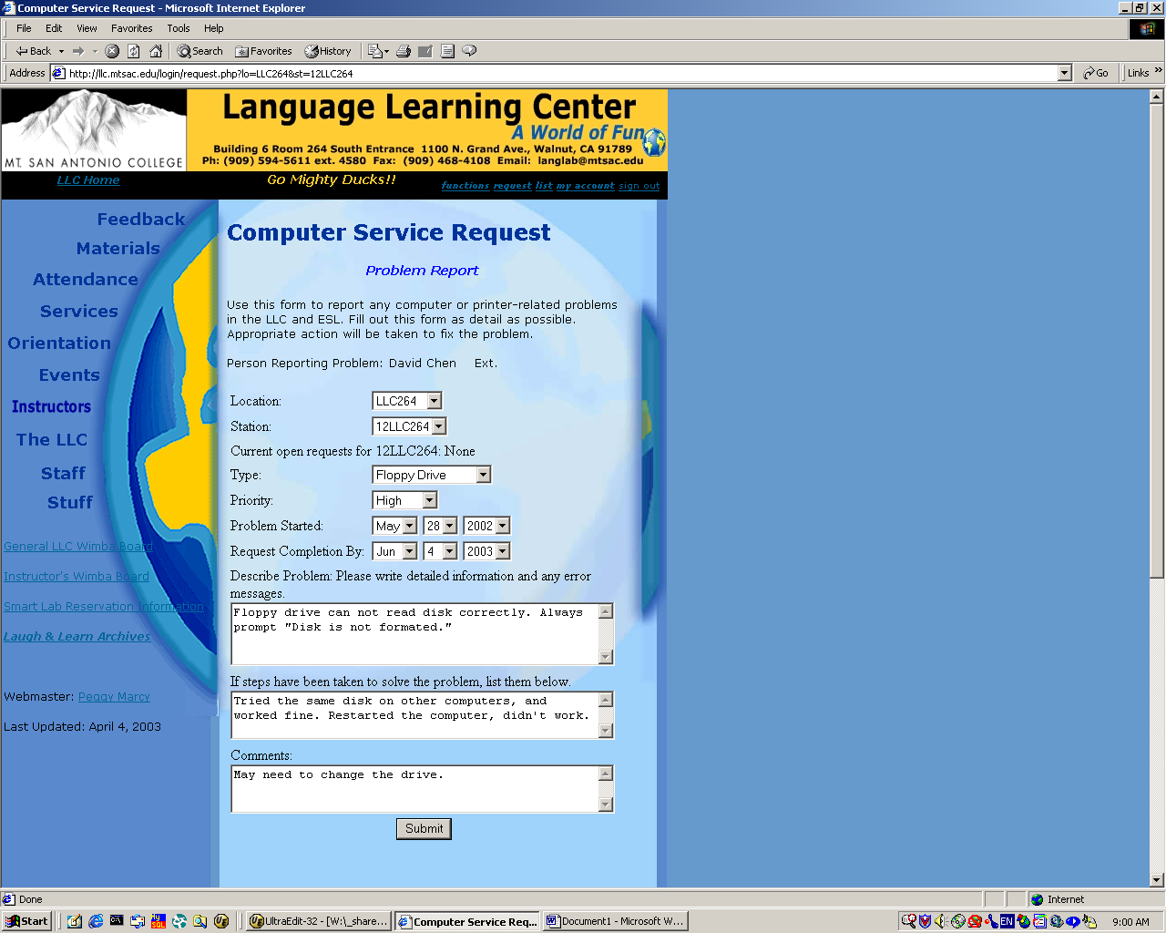

Location: LLC263, LLC264, LLC264A, LLC265, LLC266, or LLC267.

Current open requests for <Station No>:
If there is no open request, it will show “None”. Otherwise, open requests will be listed below with brief description.

Type: Software, Network, Headset, Operating System, Hard Drive, Floppy Drive, Zip Drive, CDRom, DVD Drive, Scanner Printer/Copier, TV/VCR/Satellite, Cassette Player, or Other.

Problem Started: Default value is the current date.
Request Completion By: Default value is 7 days later.
You can change these dates if needed.

You are required to type in detailed information and any error messages in the text area as well as steps been taken to solve the problem and comments.
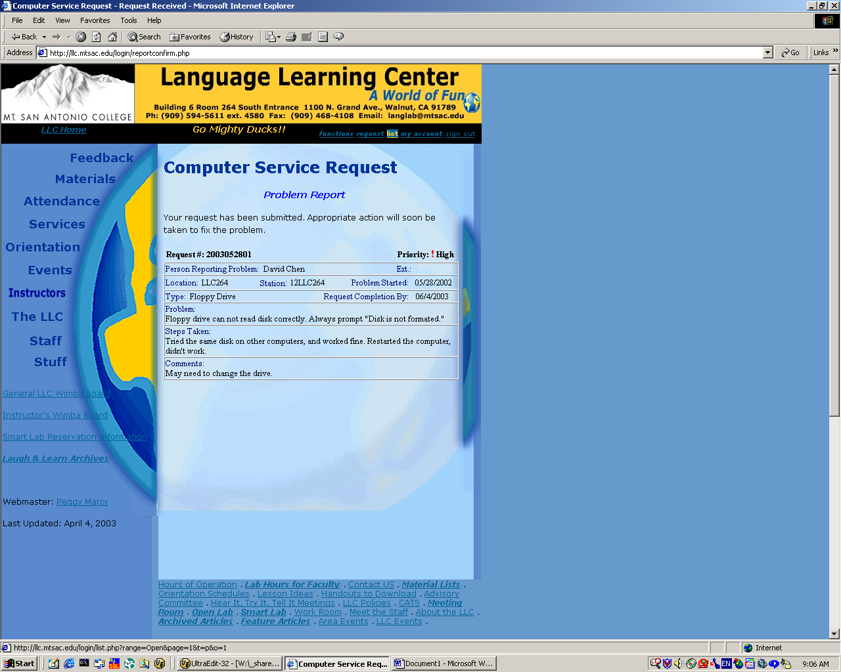

After you submit your request, it will show you a report. An email will be sent to LLC@mtsac.edu from which I believe everyone will get a copy.

List

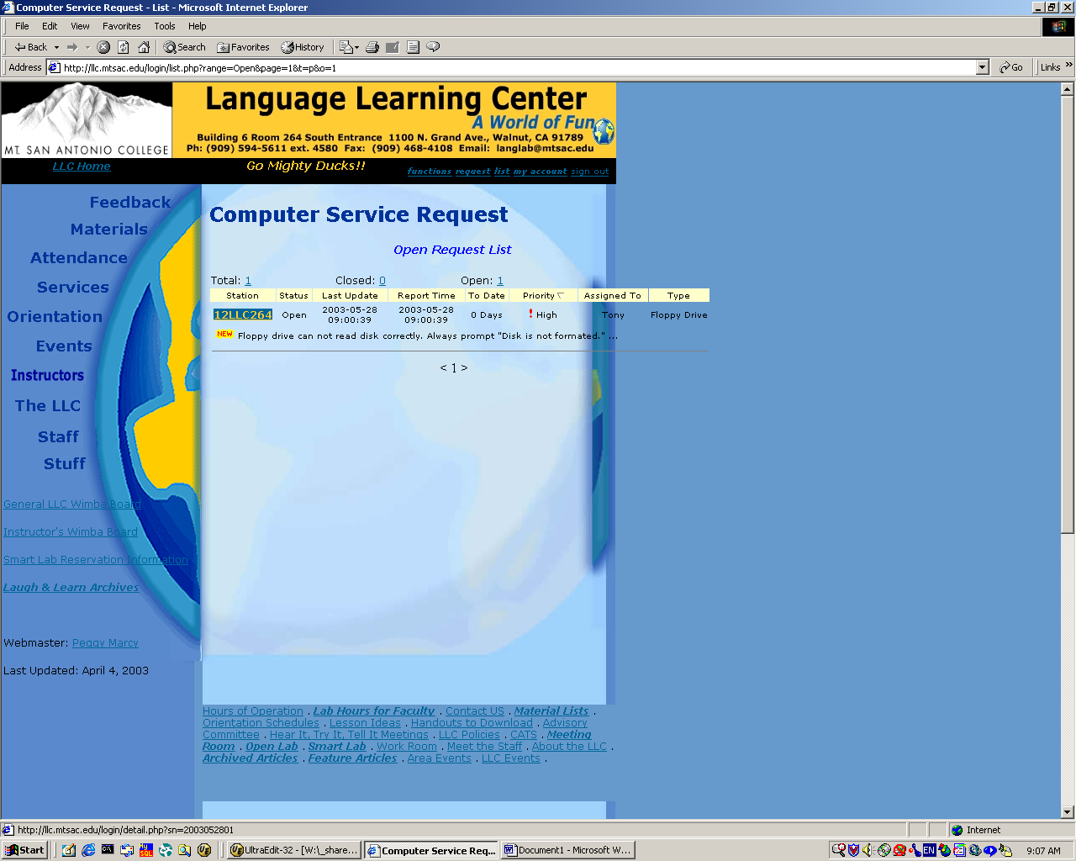

You can click Open Request List on function page or list on the menu bar to reach this page. This page gives you the current open requests. It’s ordered by Priority. You can click on the table item Priority, Last Update and Report Time to change the sorting in ascending or descending order.
To view the detail information of a request, you can click the station number, you will go to the next page.
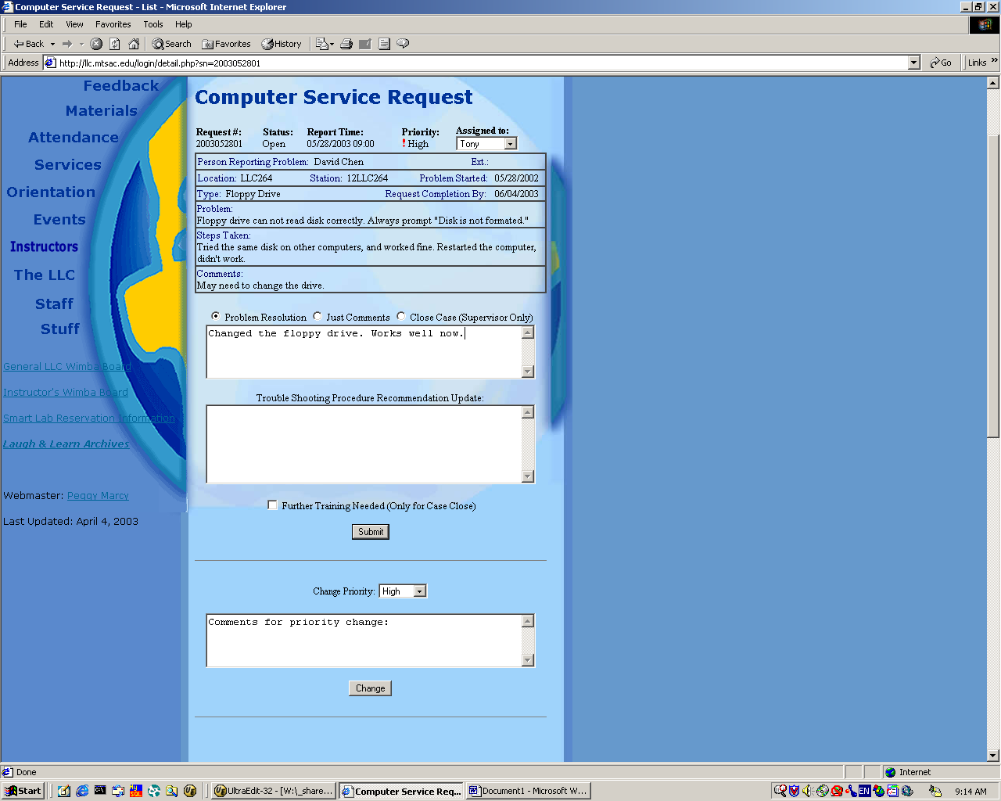

This page has two parts, the information part and the function part. Detail information is listed here including the original request and all updates. Functions include submitting comments, problem resolution and trouble shooting procedure. Supervisors can change the priority of an existing request, close a request, reopen a closed request, and recommend further training.

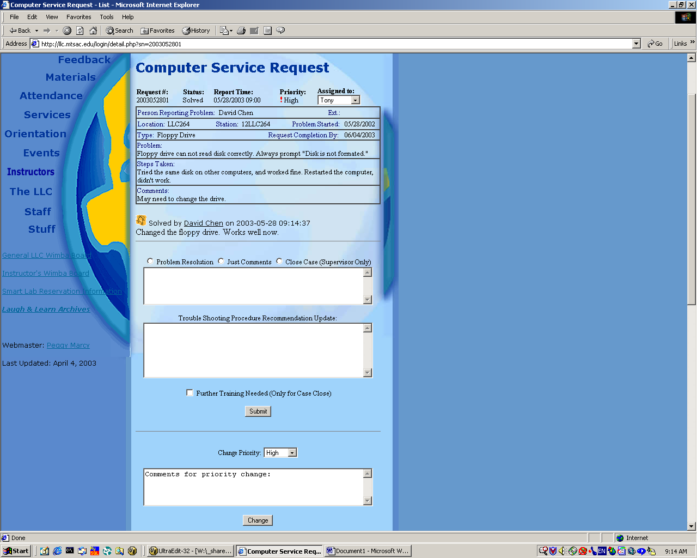

Once you submit your input, it will come back to this page with the newest update. For example, if you resolved the problem and submitted your resolution, the status will change from Open to Solved, and your resolution will be posted. This update will also be sent to LLC@mtsac.edu.
You can use the menu bar to go somewhere else or just sign out after this.
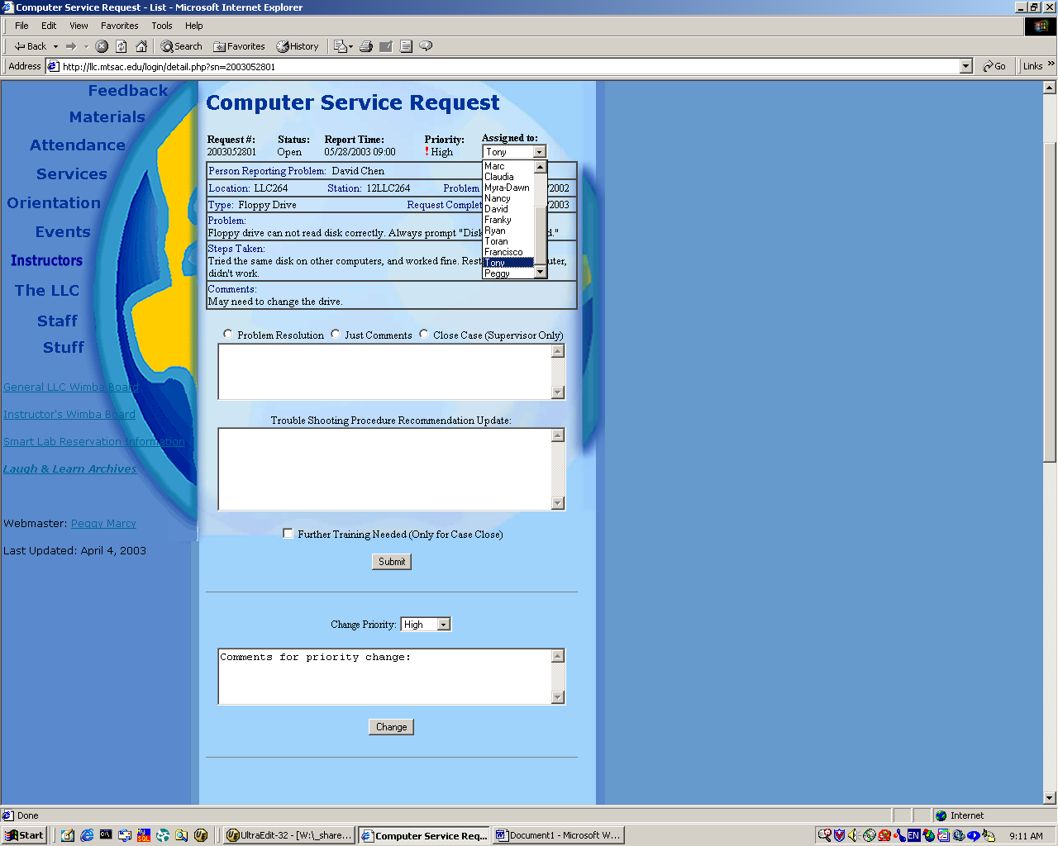

By default, all requests are assigned to Tony. Tony can assign service requests to other people afterwards.
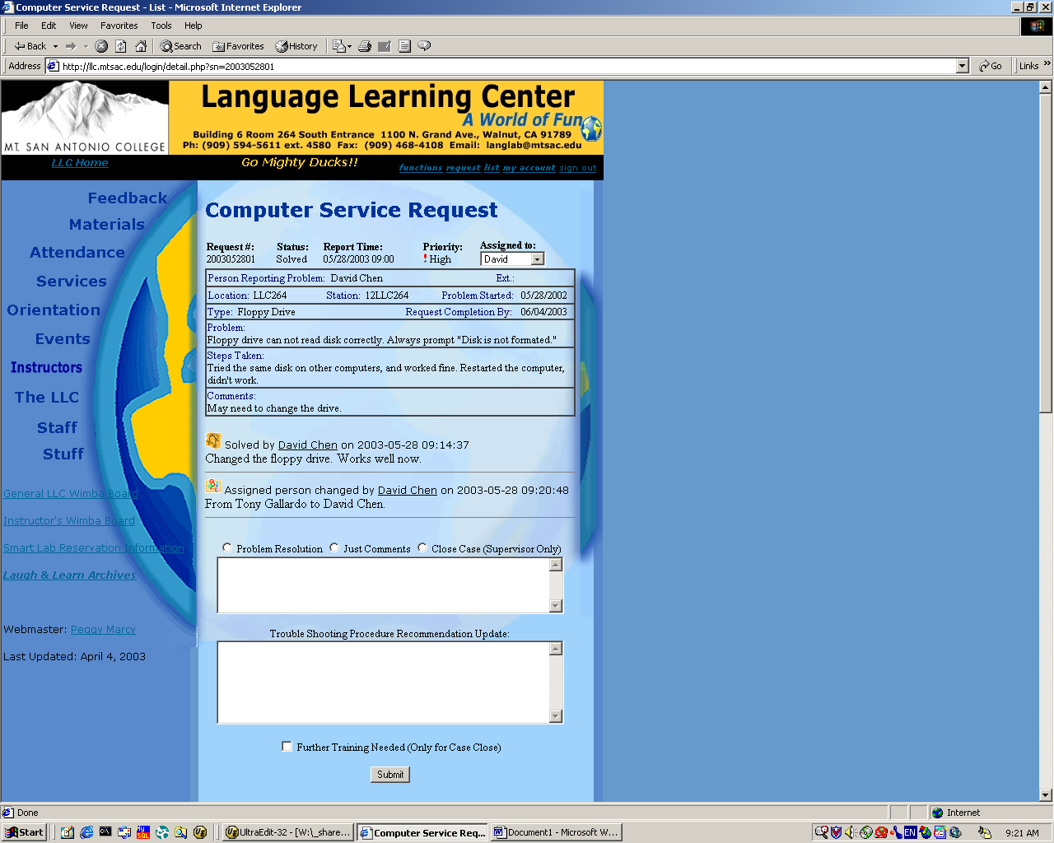

Besides the email sent to LLC@mtsac.edu, the assigned person will receive an email notice.

My Account

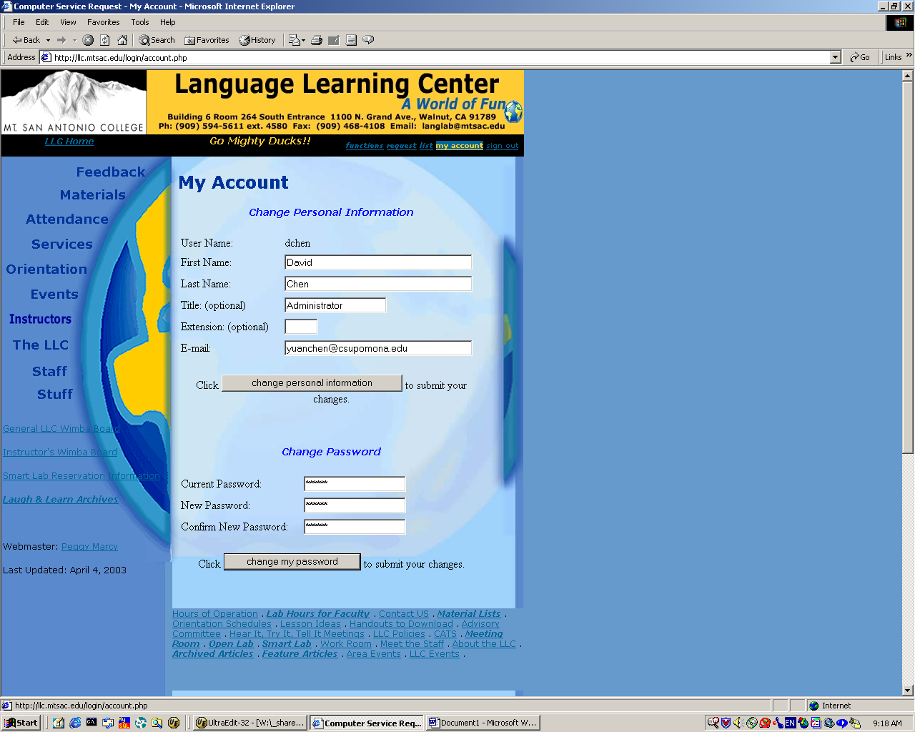

Under My Account, you can change your personal information including first name, last name, title, extension and email address. You also can change your password (you should change your password once you start using it since the default password is the same as your user name).
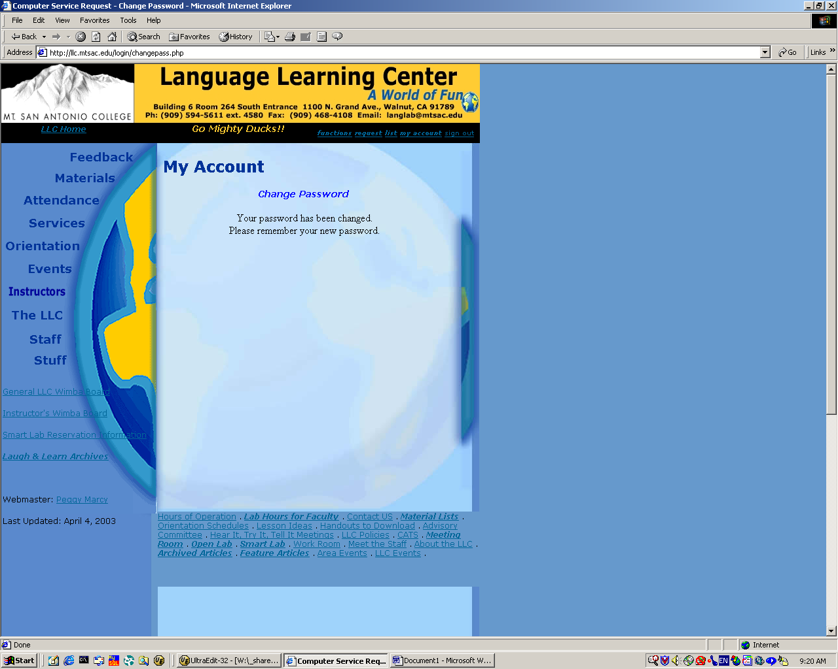

After you successfully changed your password, you will NOT be required to relogin right away. But you need to remember your new password for next login. We can only reset but not retrieve your password since all passwords are encrypted on the server. That also means no one will know your password even if someone has access on the database.

If you encounter any errors or problems, please contact me in person or by email to yuanchen@csupomona.edu.

Sign Out

To sign out, just simply click the menu item Sign Out. You will be directed to the LLC homepage. If your web browser remains inactive for long time, your session will expire. That means you will be signed out automatically. But you should sign out by yourself once you finish your work.

Admin

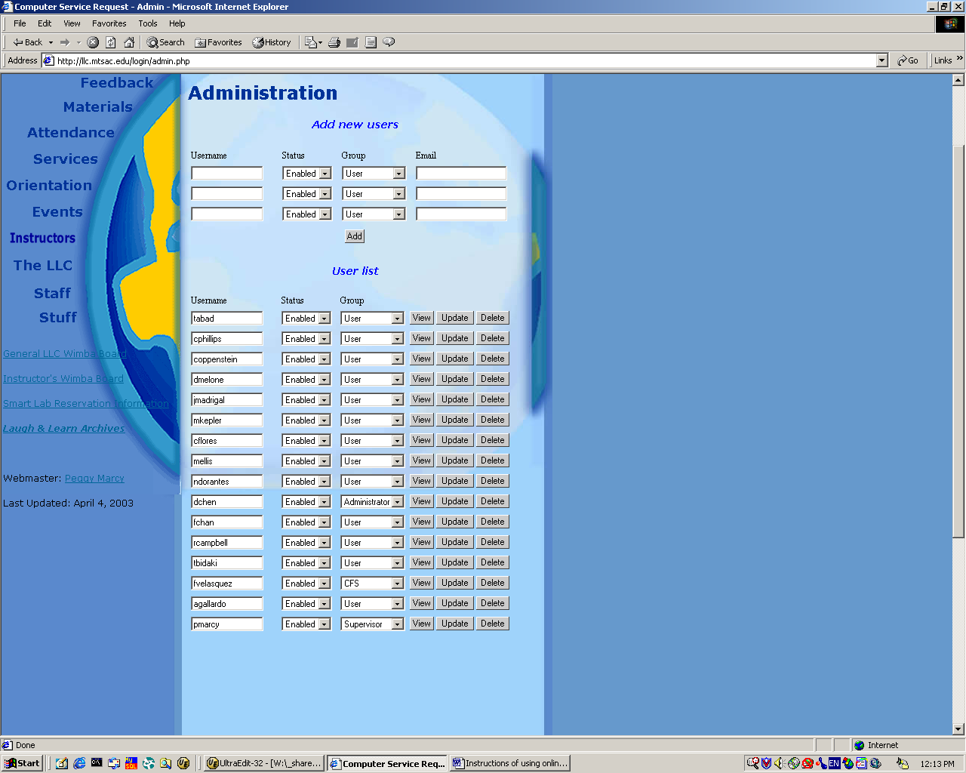

Administrator will have a option on the function page Admin. He/She can add new users, disable, enable or delete users, change user groups through this page.

