**SL3. Body Language**

Student Name: _________________________________ Student ID Number: ________________________

Instructor: _____________________________________ Level: ___________Date: ___________________

**IMPORTANT NOTE: Sections 1-4 in the SDLA must be completed before meeting with a tutor and receiving a stamp. Write/type all your answers on this handout.**

**After completing this SDLA, you will be able to:**

* Use body language to communicate meaning
* Recognize how personal space can affect the comfort level of others
* Identify the emotions conveyed through eye contact
* Illustrate emotions through universal facial expressions
* Read body language to understand the overall meaning of a conversation

**Sections 1-4 (approximately 45 minutes):** Read the information. Follow each step below to complete this SDLA. Be prepared to explain your answers when you meet with a tutor.

**Section 1: Introduction**

Have you ever played charades? Charades is an acting game in which one player *acts out* a word or phrase, and the other players guess the word or phrase. The goal is to use physical rather than verbal language to communicate meaning to the other players. Watch how the actors from the TV show *Modern Family* play charades. How do they use their bodies to communicate?

[**http://tinyurl.com/yegkq2k**](http://tinyurl.com/yegkq2k)[**http://tinyurl.com/68sbbpz**](http://tinyurl.com/68sbbpz)

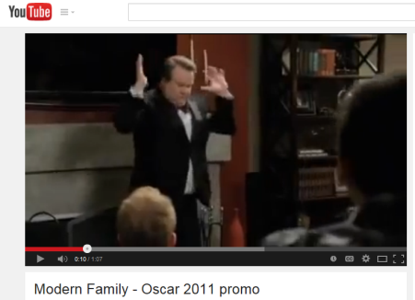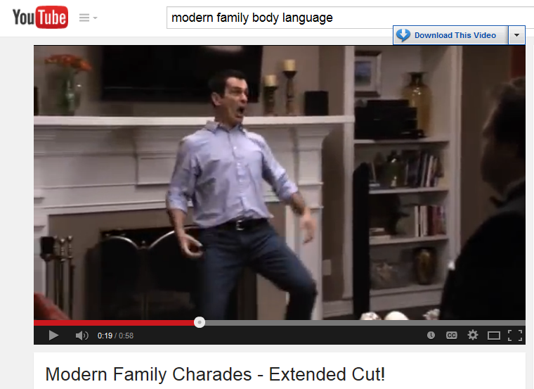

You may not realize it, but just like the actors in *Modern Family*, your body can communicate messages without even speaking. In fact, to be an effective communicator, it is important that you not only have good speaking skills, but it is also important that you use body language appropriately. Body language is sending messages to other people with the movements of your body. What are some ways that you can communicate with people other than talking? Write your ideas below:

___________________________________________________________________________________________________________________________________________________________________________________

**Did you know? – 60-80% of communication is non-verbal!!!**

There are many different messages that we can send a person with our body language. Some of the most important types of body language include:

1. Personal space
2. Eye contact
3. Facial expressions

Why do you think it is important to learn how to use appropriate body language in a conversation?

____________________________________________________________________________________________________________________________________________________________________________________

**Section 2: Types of Body Language**

**A. Personal Space**

Go to YouTube and watch the following video about personal space (the distance you maintain between yourself and the people around you): [**http://tinyurl.com/oc4autd**](http://tinyurl.com/oc4autd)**.**

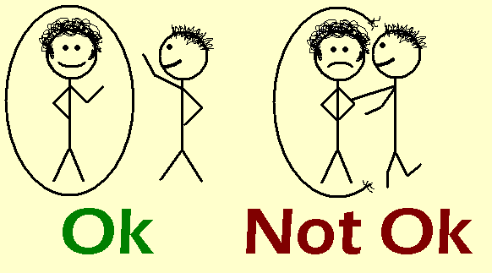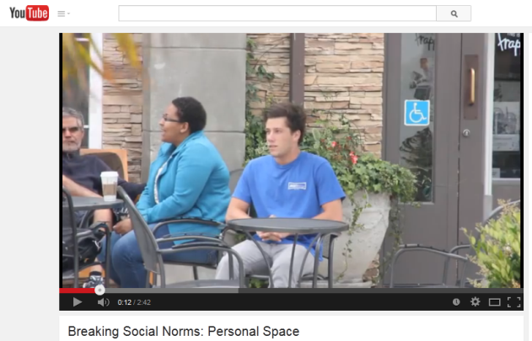

**Answer the following questions:**

1. What is happening in this video? How do the people in the video feel? Why?

____________________________________________________________________________________________________________________________________________________________________________________

1. Is personal space valued differently in your culture? How so?

____________________________________________________________________________________________________________________________________________________________________________________

It is important to remember that every culture uses different body language. You should remember that what is appropriate in the United States, might not be appropriate in your culture. For example, in the U.S., we value our personal space. As you saw in the video, it can make people very uncomfortable when someone they don’t know gets too close.

**B. Eye Contact**

Why do you think eye contact is important in the U.S.? Is eye contact important in your culture?

__________________________________________________________________________________________

__________________________________________________________________________________________

****Eye contact is important in North American culture because it shows that you are interested in what the other person is saying. It also shows that you respectand understand the other person. Eye contact can also be used to express affection, attraction, and anger. On the other hand, lack of eye contact may show boredom, low self-confidence, and deceit. What messages are their eyes communicating in these pictures? Write the message each picture below is sending (e.g., respect, interest, low-self-confidence, etc.)

[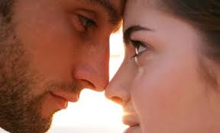](http://www.google.com/url?sa=i&rct=j&q=&esrc=s&frm=1&source=images&cd=&cad=rja&uact=8&ved=0CAcQjRw&url=http://womanfaq.ru/love/5760-ocharovyvat-i-byt-ocharovannoy-ili-kak-pervoy-pocelovat-parnya.html&ei=Eu4-VILsHYigigLIk4DoAw&bvm=bv.77648437,d.cGE&psig=AFQjCNFGkNf0U52A1TWcuC8PCKS5mfoN5Q&ust=1413496499721274)

1

4

3

2

|  |  |  |  |
| --- | --- | --- | --- |
| 1. *boredom* |  |  |  |

Images: Baunders, J. (2012). *Types of nonverbal communication and body language.*

**C. Facial Expressions**

The human face is extremely expressive, and it can express many emotions without saying a word. Unlike some forms of body language, facial expressions are universal. The facial expressions for happiness, sadness, anger, surprise, fear, and disgust are the same across cultures. Draw a facial expression in each box that matches each emotion below. The first one has been done as an example. Be as creative as you would like.

|  |  |  |
| --- | --- | --- |
| [https://encrypted-tbn1.gstatic.com/images?q=tbn:ANd9GcR5vB_XRxR7YfMBSh1XstYilICET_EhG8QmICcRpuRiPPheuoKFzg](http://www.google.com/url?sa=i&rct=j&q=&esrc=s&frm=1&source=images&cd=&cad=rja&uact=8&ved=0CAcQjRw&url=http://www.clipartpanda.com/categories/smiley-face-clipart-black-and-white&ei=WvM-VKWjN8i1iwKXsIDQAg&bvm=bv.77648437,d.cGE&psig=AFQjCNFMzJUrgAFbktdIG2S701aqQEwF0A&ust=1413498057180416)  **Happiness** | **Sadness** | **Anger** |
| **Surprise** | **Fear** | **Disgust** |

It is important to remember that you can use your face to communicate, and you can also pay attention to other people’s facial expressions to help you understand the conversation better. We call this “reading people” – instead of reading words, you are reading people’s facial expressions. “Reading people” is an extremely useful skill when learning a language.

**Section 3: Reading Body Language**

**Step 1:** Watch the following video from the TV show, *How I Met Your Mother* **http://tinyurl.com/ldcku4m**. The first time you watch it, play it with **NO** sound. Pay attention to the characters’ body language (personal space, eye contact, and facial expressions). Try to understand the overall meaning of the video based on the body language you see. Write down what you think the overall meaning of the video is in the box below. Then write down how the body language helped you understand the meaning.

|  |  |
| --- | --- |
| **Overall Meaning** | **How do you know?** |
|  | Personal space:  Eye contact:  Facial expressions: |

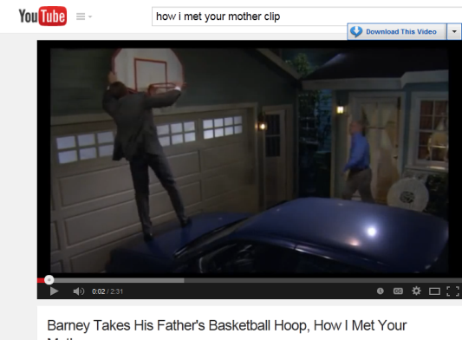

**Step 2:** Watch the video again. Play the video **with** sound. Write down the overall meaning of the video based on what the characters are saying.

|  |  |
| --- | --- |
| **Overall Meaning** | **How did the sound change your understanding?** |
|  |  |

**Section 4: Student Self-Assessment**

C:\Documents and Settings\wcuser1553\Local Settings\Temporary Internet Files\Content.IE5\Z02HHZPN\MC900072629[1].gif*Complete this self-assessment before meeting with a tutor.* **Now that you’ve completed sections 1 to 3, check the things you can do:**

* I can use body language to communicate meaning.
* I can recognize how personal space can affect the comfort level of others.
* I can identify the emotions conveyed through eye contact.
* I can illustrate emotions through universal facial expressions.
* I can read body language to understand the overall meaning of a conversation.

**DON’T FORGET! Write your name on the clipboard to work with a tutor. The tutor will call your name when he/she is ready.**

**Section 5: Practice with a tutor!**

After completing the self- assessment, meet with a tutor and give this completed SDLA to the tutor. To make sure you understand how to read body language, you will discuss the chart you completed in section 3 with the tutor. The tutor will give you recommendations for improvement below.

|  |  |  |  |
| --- | --- | --- | --- |
| **Area of Focus** | **1 Point** | **3 Points** | **5 Points** |
| **Content** | Not enough information provided about body language. | Sufficient information provided about body language. | All necessary information was provided about body language. |
| **Skill: Speaking** | Student’s speech is unclear and requires frequent listener effort. | Student’s speech is generally clear but requires occasional listener effort. | Student’s speech is clear and smooth and requires minimal listener effort. |
| **Oral Fluency** | Speaks in incomplete sentences that do not flow. | Speaks in complete sentences some of the time with frequent pauses. | Speaks in complete sentences with occasional pauses most of the time. |
|  |  |  | **Total points: /15** |

**\*Students must receive at least 10 points to move on.**

**Tutor Recommendations:**

|  |  |
| --- | --- |
| * **Congratulations! Move on**   *Student has successfully completed this SDLA and is ready to continue to the next.* | * **Repeat**   *Student hasn’t yet mastered this SDLA. It is recommended that the student complete it again.* |

**Tutor Signature: __________________________________________ Date: _______________________**