**SL31B. Song Lyrics**

Student Name: _________________________________ Student ID Number: ________________________

Instructor: _____________________________________ Level: ___________Date: ___________________

**IMPORTANT NOTE: Sections 1-5 in the SDLA must be completed before meeting with a tutor and receiving a stamp. Write/type all your answers on this handout.**

**After completing this SDLA, you will be able to:**

* Identify words related to singers and songs
* Listen for missing words in a song
* Interpret the meaning of song lyrics

**Sections 1-5 (approximately 45 minutes):** Read the information. Follow each step below to complete this SDLA. Be prepared to explain your answers when you meet with a tutor.

**Section 1: Meghan Trainor and John Legend**

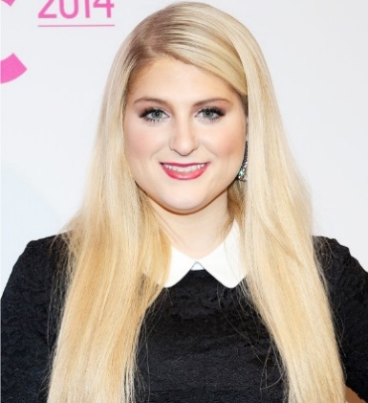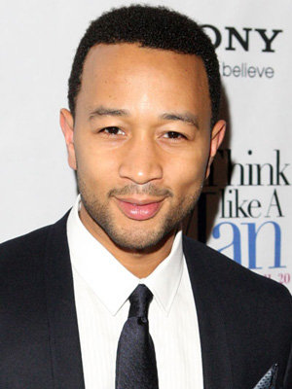Have you heard the song, “All About that Bass”? How about the song, “All of Me”? Meghan Trainor is the singer-songwriter behind “All about that Bass” [**http://tinyurl.com/n3lgtbb**](http://tinyurl.com/n3lgtbb)and John Legend is the singer-songwriter of the track, “All of Me” [**http://tinyurl.com/pjo6n62**](http://tinyurl.com/pjo6n62)**. T**hey are both very talented, successful music artists who teamed up to record a duet called, “Like I’m Gonna Lose You”. Based on the title of the song, what do you think the song is about? Write your **guess** on the lines below.

____________________________________________________________________________________________________________________________________________________________________________________

**Section 2: Words to Know**

In the paragraph above, some of the underlined words may be unfamiliar to you. Try to match the word on the left to the correct meaning on the right in the table below.

|  |  |
| --- | --- |
| Word | Meaning |
| 1. Singer-songwriter | ______ a performance by two people, especially singers, instrumentalists, or dancers |
| 1. Track | ______ to ​[join](http://dictionary.cambridge.org/us/dictionary/english/join) another ​[person](http://dictionary.cambridge.org/us/dictionary/english/person) or ​[group](http://dictionary.cambridge.org/us/dictionary/english/group), especially in ​[order](http://dictionary.cambridge.org/us/dictionary/english/order) to ​[work](http://dictionary.cambridge.org/us/dictionary/english/work) together to do something |
| 1. Duet | _______ one of several ​[songs](http://dictionary.cambridge.org/us/dictionary/english/song) on a ​[musical](http://dictionary.cambridge.org/us/dictionary/english/musical)​ [recording](http://dictionary.cambridge.org/us/dictionary/english/recording) |
| 1. Music Artist | _______ a [musician](https://en.wikipedia.org/wiki/Musician) who records and releases [music](https://en.wikipedia.org/wiki/Music), often professionally, through a [record label](https://en.wikipedia.org/wiki/Record_label) or independently |
| 1. Teamed up | _________ [musicians](https://en.wikipedia.org/wiki/Musician) who [write](https://en.wikipedia.org/wiki/Lyricist), [compose](https://en.wikipedia.org/wiki/Composer) and perform their own musical material including [lyrics](https://en.wikipedia.org/wiki/Lyrics) and [melodies](https://en.wikipedia.org/wiki/Melody) |

**Section 3: Lyrics Training**

Now you will practice your listening skills! Go to [**http://tinyurl.com/or5jdsl**](http://tinyurl.com/or5jdsl) and choose your level (beginner, intermediate, or advanced). Next, choose “Write Mode” or “Choice Mode” on the top right of the video screen. Then listen, type, and have fun! Be sure to write your scores below:

**My Lowest Score: ____________ My Highest Score: ____________**

**Section 4: Understanding the Song**

Read the song by Meghan Trainor and John Legend and then answer the questions that follow. Feel free to circle any words or phrases that you don’t know. When you meet with a tutor, you can ask the tutor about the meaning.

**Like I’m Gonna Lose You, by Meghan Trainor and John Legend**

I found myself dreaming in silver and gold

Like a scene from a movie that every broken heart knows

We were walking on moonlight and you pulled me close  
Split second and you disappeared and then I was all alone

I woke up in tears with you by my side  
A breath of relief and I realized  
No, we're not promised tomorrow

So I'm gonna love you like I'm gonna lose you  
And I'm gonna hold you like I'm saying goodbye  
Wherever we're standing, I won't take you for granted  
'Cause we'll never know when, when we'll run out of time

So I'm gonna love you like I'm gonna lose you  
I'm gonna love you like I'm gonna lose you

In the blink of an eye just a whisper of smoke  
You could lose everything. The truth is you never know

So I'll kiss you longer baby. Any chance that I get  
I'll make the most of the minutes and love with no regrets

Let's take our time to say what we want  
Here's what we got before it's all gone  
'Cause no, we're not promised tomorrow

So I'm gonna love you like I'm gonna lose you  
I'm gonna hold you like I'm saying goodbye  
Wherever we're standing, I won't take you for granted  
'Cause we'll never know when, when we'll run out of time

So I'm gonna love you like I'm gonna lose you  
I'm gonna love you like I'm gonna lose you

I'm gonna love you like I'm gonna lose you  
I'm gonna hold you like I'm saying goodbye  
Wherever we're standing, I won't take you for granted  
'Cause we'll never know when, when we'll run out of time

So I'm gonna love you like I'm gonna lose you  
I'm gonna love you like I'm gonna lose you

Write your answers to the questions about the song lyrics below and be prepared to discuss them with the tutor.

1. What do you think “split second” means?

______________________________________________________________________________________________________________________________________________________________________________

1. Why does she have a “breath of relief”?

______________________________________________________________________________________________________________________________________________________________________________

1. What can happen in the “blink of an eye”?

______________________________________________________________________________________________________________________________________________________________________________

1. What do they mean by “I’m gonna love you like I’m gonna lose you”?

______________________________________________________________________________________________________________________________________________________________________________

1. What is the moral or lesson that you learn from this song?

______________________________________________________________________________________________________________________________________________________________________________

**Section 5: Student Self-Assessment**

C:\Documents and Settings\wcuser1553\Local Settings\Temporary Internet Files\Content.IE5\Z02HHZPN\MC900072629[1].gif*Complete this self-assessment before meeting with a tutor.* **Now that you’ve completed sections 1 to 4, check the things you can do:**

* I can identify words related to singers and songs.
* I can listen for missing words in a song.
* I can interpret the meaning of song lyrics.

**DON’T FORGET! Write your name on the clipboard to work with a tutor. The tutor will call your name when he/she is ready.**

**Section 6: Practice with a Tutor!**

After completing the self- assessment, meet with a tutor and give this completed SDLA to the tutor. You will review this SDLA with the tutor and talk about the questions you answered in Section 4. The tutor will provide you with feedback in the following areas:

|  |  |  |  |
| --- | --- | --- | --- |
| **Area of Focus** | **1 Point** | **3 Points** | **5 Points** |
| **Content** | Student does not provide enough information in responses and does not use appropriate vocabulary. | Student provides sufficient information in responses and uses appropriate vocabulary some of the time. | Student provides all necessary information in responses and uses appropriate vocabulary most of the time. |
| **Skill: Speaking** | Student’s speech is unclear and requires frequent listener effort. | Student’s speech is generally clear but requires occasional listener effort. | Student’s speech is clear and smooth and requires minimal listener effort. |
| **Oral Fluency** | Speaks in incomplete sentences that do not flow. | Speaks in complete sentences some of the time with frequent pauses. | Speaks in complete sentences with occasional pauses most of the time. |
|  |  |  | **Total points: /15** |

**\*Students must receive at least 10 points to move on.**

**Tutor Recommendations:**

|  |  |
| --- | --- |
| * **Congratulations! Move on**   *Student has successfully completed this SDLA and is ready to continue to the next.* | * **Repeat**   *Student hasn’t yet mastered this SDLA. It is recommended that the student complete it again.* |

**Tutor Signature: __________________________________________ Date: _______________________**