**SL30. Food and Drink Preferences**

Student Name: _________________________________ Student ID Number: ________________________

Instructor: _____________________________________ Level: ___________Date: ___________________

**IMPORTANT NOTE: Sections 1-4 (approximately 45 minutes) in this SDLA must be completed to receive a stamp.**

**After completing this SDLA, you will be able to:**

* Express how you like your steak and eggs cooked
* Order coffee based on your preferences

**Section 1: Introduction**

When you go out to eat for breakfast, has your server ever asked you, “How do you want your eggs?” The server is asking you how you like your eggs cooked. There are actually many different ways that you can order your eggs. In this SDLA, you’ll learn about food and drink preferences. A preference is a greater liking for one alternative over another or others. You’ll learn how to order eggs, coffee, and steak the way you like it. To get started, you’ll need to open the “Food and Drink Preferences” PowerPoint presentation that goes with this SDLA. **Log in to the ESL tutoring website at** [**www.mtsac.edu/llc**](http://www.mtsac.edu/llc) **to view the PowerPoint. If you can’t find the PowerPoint, ask a tutor for help.**

**Section 2: Egg Preferences**

Use the PowerPoint to answer the following questions about eggs.

1. What are the three parts of an egg? (slide 3)

_______________________________________________________________________________________

1. What type of eggs do each of the following pictures show? (slide 4)

****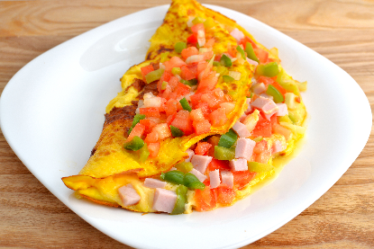

____________________ ____________________ _____________________

1. What does it mean when eggs are “runny”? Do you like your eggs runny? (slide 5)

____________________________________________________________________________________________________________________________________________________________________________________

1. After looking at all the different ways to order your eggs at restaurant, how do you think you will order your eggs the next time you go out to eat?

**__________________________________________________________________________________________________________________________________________________________**

**Section 3: Steak Preferences**

Use the PowerPoint to answer the following questions about your steak preferences.

**1**. What does it mean to sear a steak? What does it mean to broil a steak? (slide 6)

__________________________________________________________________________________________

**2**. In the chart below, label the different degrees of steak doneness. The first one has been done for you.

**3**. How do you like your steak cooked? ________________________________

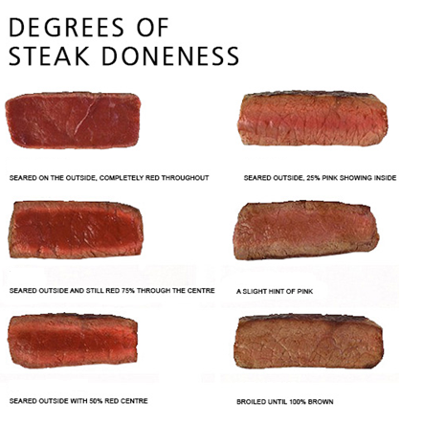

**Blue Rare**

_________________________________

_________________________________

_________________________________

_________________________________

_________________________________

**Section 4: Coffee Preferences**

Use the PowerPoint to answer the questions about coffee preferences.

1. What are the 4 things you should know when you order coffee? (slide 8)
   1. ____________________________________________
   2. ____________________________________________
   3. ____________________________________________
   4. ____________________________________________
2. What is decaf coffee? (slide 9)

__________________________________________________________________________________________

1. How do you ask for cold coffee? (slide 10)

__________________________________________________________________________________________

1. What is one example of the following (slide 11):
   1. Milk: _____________________________________
   2. Cream: ____________________________________
   3. Sugar: _____________________________________
2. How do you like your coffee?

__________________________________________________________________________________________

**Section 4: Self-Assessment**

C:\Documents and Settings\wcuser1553\Local Settings\Temporary Internet Files\Content.IE5\Z02HHZPN\MC900072629[1].gif*Complete this self-assessment after meeting with a tutor.* **Now that you’ve completed this SDLA, check the things you can do:**

* + I can express how I like my steak and eggs cooked.
  + I can order coffee based on my preferences.

**DON’T FORGET! Write your name on the clipboard to work with a tutor. The tutor will call your name when he/she is ready.**

**Section 5: Practice with a Tutor!**

After completing the self-assessment, meet with a tutor and give this completed SDLA to the tutor. Be prepared to talk about your answers in this SDLA. You will do a restaurant roleplay with the tutor to make sure you know how to order eggs, steak, and coffee the way you like them. The tutor will give you feedback in the chart below.

|  |  |  |  |
| --- | --- | --- | --- |
| **Area of Focus** | **1 Point** | 3 Points | **5 Points** |
| **Content** | Student does not provide enough accurate and relevant information in responses. | Student provides sufficient information in responses that is accurate and relevant some of the time. | Student answers all questions with accurate and relevant information most of the time. |
| **Skill: Speaking** | Student’s speech is unclear and requires frequent listener effort. | Student’s speech is generally clear but requires occasional listener effort. | Student’s speech is clear and smooth and requires minimal listener effort. |
| **Oral Fluency** | Speaks in incomplete sentences that do not flow. | Speaks in complete sentences some of the time with frequent pauses. | Speaks in complete sentences with occasional pauses most of the time. |
|  |  |  | **Total points: /15** |

**\*Students must receive at least 10 points to move on.**

**Tutor Recommendations:**

|  |  |
| --- | --- |
| * **Congratulations! Move on**   *Student has successfully completed this SDLA and is ready to continue to the next.* | * **Repeat**   *Student hasn’t yet mastered this SDLA. It is recommended that the student complete it again.* |

**Tutor Signature: __________________________________________ Date: _______________________**