**SL28C. Travel Part 3**

Student Name: _________________________________ Student ID Number: ________________________

Instructor: _____________________________________ Level: ___________Date: ___________________

**IMPORTANT NOTE: Sections 1-4 in the SDLA must be completed before meeting with a tutor and receiving a stamp. Write/type all your answers on this handout.**

**After completing this SDLA, you will be able to:**

* Search for a flight and hotel using a travel website
* Create a travel itinerary that follows a budget using travel websites

**Sections 1-4 (approximately 45 minutes):** Read the information. Follow each step below to complete this SDLA. Be prepared to explain your answers when you meet with a tutor.

**Section 1: Introduction**

In SDLAs 28A and 28B you learned about hotel accommodations, amenities, and attractions. These are all important factors to keep in mind when planning a trip. In this SDLA, you will use everything you have learned in the previous SDLAs to plan a trip to any place in the U.S. using travel websites. Here are the requirements for your trip:

* **Number of people:** 2 (you and one guest)
* **Budget:** $3,000.00
* **Length of trip**: 3 days and 2 nights
* **Flight/Hotel:** You MUST fly to your destination.

Are you having a difficult time deciding where to go? Look at this list of fun and interesting cities to get some ideas:

* Portland, Oregon
* New York City
* Chicago, Illinois
* Charleston, South Carolina
* Seattle, Washington
* Washington, D.C.
* Sedona, Arizona
* Honolulu, Hawaii
* Orlando, Florida
* Nashville, Tennessee
* Austin, Texas

**Section 2: Using Expedia**

People will often use travel websites to plan their vacations because it is easy to use and can offer you a good deal. You will use Expedia.com to plan your flight and hotel accommodations. Go to [www.expedia.com](http://www.expedia.com) to get started.

**Step 1:** Make sure the Flight/Hotel icon is blue.

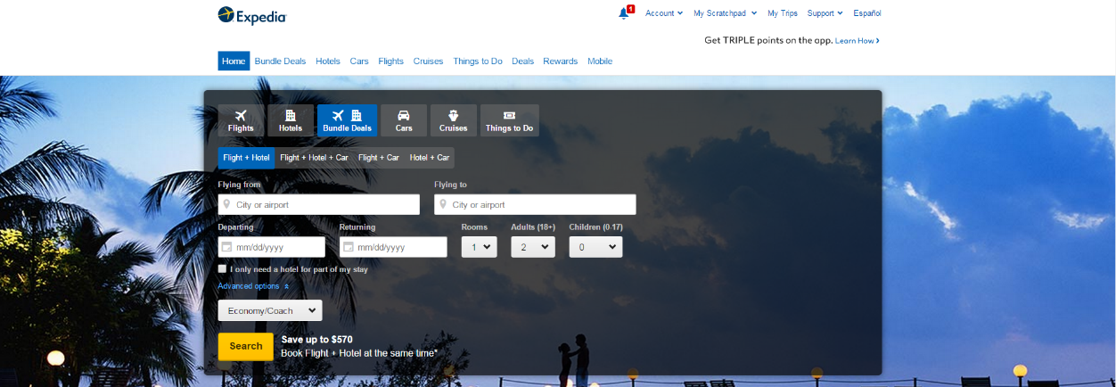

**Step 2**

**Step 1**

**Step 3**

**Step 2:** Fill in all of the boxes such as your airport information, departure date, returning date, and number of passengers.

**Step 3:** Click the yellow search button.

**Step 4:** Select a flight and hotel option within your budget. Remember you only have $3,000.00 for your entire trip. For your notes, you can write down your flight and hotel information below in addition to the price.

Flight Information: ______________________________________________________________________

Hotel Information: ______________________________________________________________________

Price: _________________________________________________________________________________

**Section 3: Planning your Trip**

Now that you have booked your flight and hotel, it is time to plan your trip! After you complete the itinerary on the following page with your flight and hotel information, go to tripadvisor.com to plan the rest of your trip (attractions and restaurants). You can also use yelp.com for restaurant information. Make sure you pay attention to prices; you have a $3,000budget for 2 people.

|  |  |  |
| --- | --- | --- |
| **Day 1** | Departed from: at (time) | |
| Arrived at: at (time) | |
| Attraction(s): | | Price $: |
| **Restaurants**  Breakfast:  Lunch:  Dinner: | | Price $: |
| Hotel: | | Price $: |
| **Day 2** |  | |
| Attraction(s): | | Price $: |
| **Restaurants**  Breakfast:  Lunch:  Dinner: | | Price $: |
| Hotel: | | Price $: |
| **Day 3** | Departed from: at (time) | |
| Arrived at: at (time) | |
| Attraction(s): | | Price $: |
| **Restaurants**  Breakfast:  Lunch:  Dinner: | | Price $: |
| **Total Price $ (Including flight):** | | |

**Section 4: Student Self-Assessment**

C:\Documents and Settings\wcuser1553\Local Settings\Temporary Internet Files\Content.IE5\Z02HHZPN\MC900072629[1].gif*Complete this self-assessment before meeting with a tutor.* **Now that you’ve completed sections 1 to 3, check the things you can do:**

* I can search for a flight and hotel using a travel website.
* I can create a travel itinerary that follows a budget using travel websites.

**DON’T FORGET! Write your name on the clipboard to work with a tutor. The tutor will call your name when he/she is ready.**

**Section 5: Practice with a Tutor!**

After completing the self- assessment, meet with a tutor and give this completed SDLA to the tutor. You will review this SDLA with the tutor and discuss your travel itinerary. The tutor will provide you with feedback in the following areas:

|  |  |  |  |
| --- | --- | --- | --- |
| **Area of Focus** | **1 Point** | **3 Points** | **5 Points** |
| **Content** | Student does not provide enough information in responses and does not use appropriate vocabulary. | Student provides sufficient information in responses and uses appropriate vocabulary some of the time. | Student provides all necessary information in responses and uses appropriate vocabulary most of the time. |
| **Skill: Speaking** | Student’s speech is unclear and requires frequent listener effort. | Student’s speech is generally clear but requires occasional listener effort. | Student’s speech is clear and smooth and requires minimal listener effort. |
| **Oral Fluency** | Speaks in incomplete sentences that do not flow. | Speaks in complete sentences some of the time with frequent pauses. | Speaks in complete sentences with occasional pauses most of the time. |
|  |  |  | **Total points: /15** |

**\*Students must receive at least 10 points to move on.**

**Tutor Recommendations:**

|  |  |
| --- | --- |
| * **Congratulations! Move on**   *Student has successfully completed this SDLA and is ready to continue to the next.* | * **Repeat**   *Student hasn’t yet mastered this SDLA. It is recommended that the student complete it again.* |

**Tutor Signature: __________________________________________ Date: _______________________**