**SL28B. Travel Part 2**

Student Name: _________________________________ Student ID Number: ________________________

Instructor: _____________________________________ Level: ___________Date: ___________________

**IMPORTANT NOTE: Sections 1-4 in the SDLA must be completed before meeting with a tutor and receiving a stamp. Write/type all your answers on this handout.**

**After completing this SDLA, you will be able to:**

* Listen for specific names of attractions
* Label different types of attractions
* Research different types of attractions using the Internet

**Sections 1-3 (approximately 45 minutes):** Read the information. Follow each step below to complete this SDLA. Be prepared to explain your answers when you meet with a tutor.

**Section 1: Introduction**

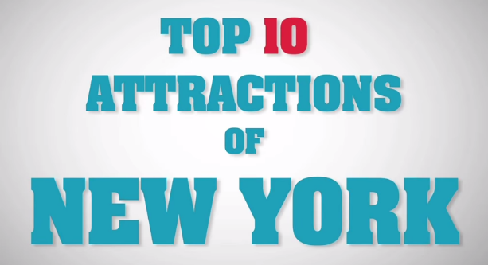Another important thing to consider when traveling is what you will see and do. We call these **attractions**. Attractions are sights, places, or things that are interesting or enjoyable that people want to visit, see, or do. Watch this video [**http://tinyurl.com/q8xmmjd**](http://tinyurl.com/q8xmmjd)about the top 10 attractions in New Your City. Write them in the chart below. Have you been to New York City? Do you agree?

|  |
| --- |
| **Top 10 Attractions of New York** |
| 10. |
| 9. |
| 8. |
| 7. |
| 6. |
| 5. |
| 4. |
| 3. |
| 2. |
| 1. |

**Section 2: Types of Attractions**

**Part 1:** There are many different types of attractions. Usually, attractions can fit into different categories. Read the list of attractions and use them to complete the chart below. Write the category of the attraction under the appropriate picture. Not all of the categories will be used.

**Attraction Categories**

* Outdoor Activities
* Shopping
* Museums
* Historical places
* Landmarks and Monuments
* Nature and Parks
* Ethnic Communities
* Tours
* Food and Dining
* Zoos and Aquariums
* Theme Parks

|  |  |  |
| --- | --- | --- |
| http://www.chinatourguide.com/china_photos/Hongkong/Attractions/big_bus_tour_on_road_t.jpg  **Tours** | https://upload.wikimedia.org/wikipedia/commons/f/fc/Yosemite_Valley_from_Wawona_Tunnel_view,_vista_point..JPG  **_____________________** | https://upload.wikimedia.org/wikipedia/commons/0/01/ChinatownGatePortland.jpg |
| https://upload.wikimedia.org/wikipedia/commons/1/10/Mount_Rushmore_National_Memorial.jpg  **______________________** | https://aromdoms.files.wordpress.com/2011/03/moa.jpg  **_______________________** | http://losangeles.diarystar.com/images/getty-museum12.jpg  **_______________________** |
| https://secure.parksandresorts.wdpromedia.com/resize/mwImage/1/640/360/90/wdpromedia.disney.go.com/media/wdpro-assets/dlr/gallery/destinations/disneyland-park/disneyland-gallery00.jpg?18042014104654  **______________________** | http://www.luckymountainhome.com/images/neighborhoods/breckenridge_rafting_colorado_whitewater.jpg  **_____________________** | http://blog.sandiego.org/wp-content/uploads/2012/02/Sandiego_wildanimalpark.jpg  **_____________________** |

**Part 2:** Think of one place you have visited. What attractions did you see? Write 5 attractions that you saw or visited, and then write the correct category of the attraction that you learned in Part 1. You will talk about your trip and the attractions you saw or visited with a tutor in Section 5.

**Trip location: ______________________________**

|  |  |
| --- | --- |
| **Attraction** | **Category** |
| ________________________________ | ________________________________ |
| ________________________________ | ________________________________ |
| ________________________________ | ________________________________ |
| ________________________________ | ________________________________ |
| ________________________________ | ________________________________ |

**Section 3: Using TripAdvisor to Research Attractions**

Have you ever wanted to know how to find attractions to see and do in a new place? You can use the TripAdvisor website to help you find possible attractions. Go to <http://www.tripadvisor.com/> and then follow the steps below.

**Step 1:** Type in any destination that you have NOT visited before in the box that says, “Where are you going?”

**Step 2:** In the box with the magnifying glass, select “Things to do in …”

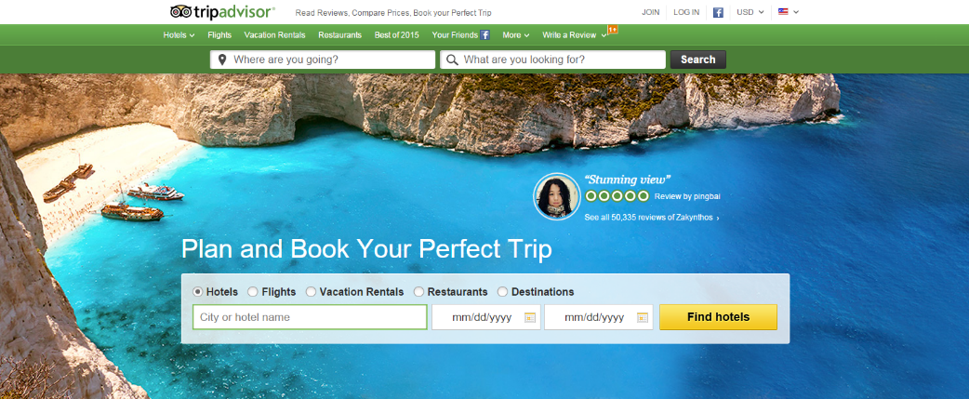

**Step 1**

**Step 2**

**Step 3:** Complete the chart below about the top 5 attractions of the destination you picked. Be prepared to talk about the information in the chart with a tutor in Section 5.

Destination: ________________________________________________________

|  |  |  |  |
| --- | --- | --- | --- |
| **Attraction Name** | **What category is the attraction?** | **How much does it cost?** | **What can you do or see there?** |
|  |  |  |  |
|  |  |  |  |
|  |  |  |  |
|  |  |  |  |
|  |  |  |  |

**Section 4: Student Self-Assessment**

C:\Documents and Settings\wcuser1553\Local Settings\Temporary Internet Files\Content.IE5\Z02HHZPN\MC900072629[1].gif*Complete this self-assessment before meeting with a tutor.* **Now that you’ve completed sections 1 to 3, check the things you can do:**

* I can listen for specific names of attractions.
* I can label different types of attractions.
* I can research different types of attractions using the Internet.

**DON’T FORGET! Write your name on the clipboard to work with a tutor. The tutor will call your name when he/she is ready.**

**Section 5: Practice with a Tutor!**

After completing the self- assessment, meet with a tutor and give this completed SDLA to the tutor. You will review this SDLA with the tutor and discuss the different attractions you saw, visited, and researched. The tutor will provide you with feedback in the following areas:

|  |  |  |  |
| --- | --- | --- | --- |
| **Area of Focus** | **1 Point** | **3 Points** | **5 Points** |
| **Content** | Student does not provide enough information in responses and does not use appropriate vocabulary. | Student provides sufficient information in responses and uses appropriate vocabulary some of the time. | Student provides all necessary information in responses and uses appropriate vocabulary most of the time. |
| **Skill: Speaking** | Student’s speech is unclear and requires frequent listener effort. | Student’s speech is generally clear but requires occasional listener effort. | Student’s speech is clear and smooth and requires minimal listener effort. |
| **Oral Fluency** | Speaks in incomplete sentences that do not flow. | Speaks in complete sentences some of the time with frequent pauses. | Speaks in complete sentences with occasional pauses most of the time. |
|  |  |  | **Total points: /15** |

**\*Students must receive at least 10 points to move on.**

**Tutor Recommendations:**

|  |  |
| --- | --- |
| * **Congratulations! Move on**   *Student has successfully completed this SDLA and is ready to continue to the next.* | * **Repeat**   *Student hasn’t yet mastered this SDLA. It is recommended that the student complete it again.* |

**Tutor Signature: __________________________________________ Date: _______________________**