**SL21. Viral Videos**

Student Name: _________________________________ Student ID Number: ________________________

Instructor: _____________________________________ Level: ___________Date: ___________________

**IMPORTANT NOTE: Sections 1-6 in the SDLA must be completed before meeting with a tutor and receiving a stamp. Write/type all your answers on this handout.**

**After completing this SDLA, you will be able to:**

* Define vocabulary words related to viral videos
* Identify the reasons why videos go viral
* Analyze videos that have gone viral
* Find viral videos on the Internet

**Sections 1-6 (approximately 45 minutes):** Read the information. Follow each step below to complete this SDLA. Be prepared to explain your answers when you meet with a tutor.

**Section 1: Introduction**

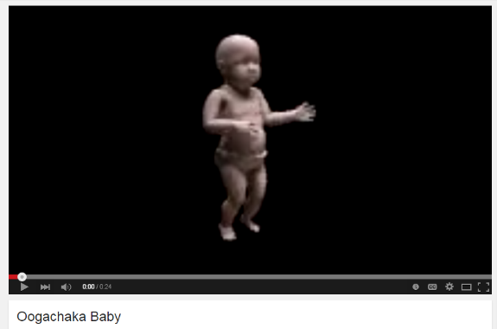As you learned in *SL19: Current Events*, current events are a great topic of conversation. In today’s society, another popular topic of conversation is a viral video. A viral video is any clip of animation or film that is spread rapidly through **online sharing**. In the past, a video went viral once it hit one million **views**. Today, a video **goes viral** once it gets more than five million views in a 3-7 day period. Viral videos can receive millions of views as they are shared on **social media sites**, reposted to blogs, sent in emails, and so on. In order to become an **overnight sensation**, viral videos need to be short (10-120 seconds long), shareable, and rely on humor and **hooks** or **catchphrases** to get the viewer’s attention. Watch one of the first viral videos, “The Dancing Baby”: [**http://tinyurl.com/3d2nr4m**](http://tinyurl.com/3d2nr4m) **.** Why do you think this video went viral? Write your thoughts below.

________________________________________________________________________________________________________________________________________________________________________________________________________________________________________________________________________________________________________________________________________________________________________

Source: http://www.techopedia.com/definition/26863/viral-video

**Section 2: Vocabulary**

When you talk about viral videos, there are certain words and phrases that you can use to talk about them. Below is a list of the words and phrases on the left. Write the letter of each definition next to the appropriate word on the left.

|  |  |
| --- | --- |
| **Word** | **Definition** |
| 1. _____ Online sharing 2. _____ Social media 3. _____ Views 4. _____ Overnight sensation 5. _____ Hook 6. _____ Catchphrase 7. _____ Go viral 8. _____ Parody 9. _____ Tastemakers 10. ____ Unexpectedness | 1. a person whose judgments about what is good, fashionable, etc. are accepted and followed by many people 2. websites and applications that allow users to create and share content or to participate in social networking, e.g. Facebook, Wikipedia, LinkedIn, Pinterest 3. the act of watching or looking at a video, image, or link on the Internet 4. something that attracts people’s attention 5. something that becomes interesting and exciting to people very quickly 6. when an image, video, or link has been spread quickly to many people on the Internet 7. a word or phrase that is easy to remember and is commonly used 8. when things happen without warning 9. sending information (images, videos, links) to other people via the Internet 10. a piece of writing, music, etc. that imitates the style of someone or something in a funny way |

**Section 3: Why do some Videos go Viral?**

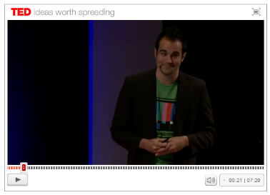There are over 48 hours of new videos uploaded to YouTube every minute. That’s a lot of YouTube videos you can watch! So with all of these new videos being uploaded, why do some videos go viral while others do not? Listen and watch this video [**http://tinyurl.com/m7zsv5v**](http://tinyurl.com/m7zsv5v)about why some YouTube Videos go viral. There is also a transcript of the speech available. In order to read as you listen, select “View Interactive Transcript” and then play the video. Please ask a tutor for help if needed. Listen for the 3 reasons why videos go viral according to the speaker and write them below.

**Reason 1: ________________________________________**

**Reason 2: ________________________________________**

**Reason 3: ________________________________________**

**\*Bonus Question:** What famous singer was discovered on YouTube?

________________________________________________________

**Section 4: Examples of Recent Viral Videos**

Below you’ll find two recent viral videos. Watch them and answer the questions about the videos.

**Viral Video 1:** [**http://tinyurl.com/lk4845o**](http://tinyurl.com/lk4845o)

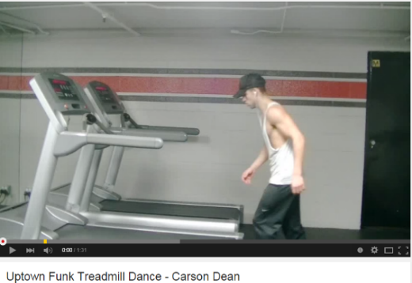

1. What happened in this video?
2. How many views does it have?
3. Why do think it went viral?

**Viral Video 2:** [**http://tinyurl.com/p9yg6q3**](http://tinyurl.com/p9yg6q3)

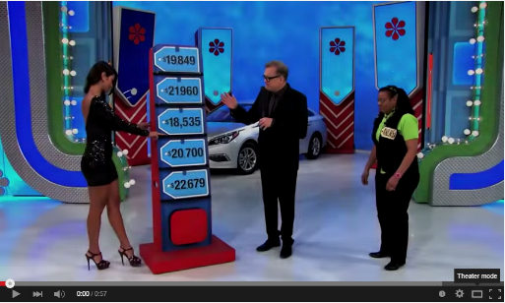

1. What happened in this video?

2. How many views does it have?

3. Why do think it went viral?

**Section 5: Student Examples of Viral Videos**

Now it’s your turn. Find 2 examples of viral videos on the Internet. You can search youtube.com or google.com for “viral videos”. The videos should have at least one million views. Fill out the chart about your videos. You will show them to the tutor in Section 5 and have a conversation about them with the tutor.

|  |  |  |  |
| --- | --- | --- | --- |
| **Title of Video** | **Number of Views** | **What happened in the video?** | **Why do you think it went viral?** |
|  |  |  |  |
|  |  |  |  |

**Section 6: Student Self-Assessment**

C:\Documents and Settings\wcuser1553\Local Settings\Temporary Internet Files\Content.IE5\Z02HHZPN\MC900072629[1].gif*Complete this self-assessment before meeting with a tutor.* **Now that you’ve completed sections 1 to 5, check the things you can do:**

* I can define vocabulary words related to viral videos.
* I can identify the reasons why videos go viral.
* I can analyze videos that have gone viral.
* I can find viral videos on the Internet.

**DON’T FORGET! Write your name on the clipboard to work with a tutor. The tutor will call your name when he/she is ready.**

**Section 7: Practice with a Tutor!**

After completing the self- assessment, meet with a tutor and give this completed SDLA to the tutor. You will watch the videos and have a conversation with the tutor about the viral videos you selected in Section 5. The tutor will provide you with feedback in the following areas:

|  |  |  |  |
| --- | --- | --- | --- |
| **Area of Focus** | **1 Point** | **3 Points** | **5 Points** |
| **Content** | Student does not provide enough information in responses and does not use appropriate vocabulary. | Student provides sufficient information in responses and uses appropriate vocabulary some of the time. | Student provides all necessary information in responses and uses appropriate vocabulary most of the time. |
| **Skill: Speaking** | Student’s speech is unclear and requires frequent listener effort. | Student’s speech is generally clear but requires occasional listener effort. | Student’s speech is clear and smooth and requires minimal listener effort. |
| **Oral Fluency** | Speaks in incomplete sentences that do not flow. | Speaks in complete sentences some of the time with frequent pauses. | Speaks in complete sentences with occasional pauses most of the time. |
|  |  |  | **Total points: /15** |

**\*Students must receive at least 10 points to move on.**

**Tutor Recommendations:**

|  |  |
| --- | --- |
| * **Congratulations! Move on**   *Student has successfully completed this SDLA and is ready to continue to the next.* | * **Repeat**   *Student hasn’t yet mastered this SDLA. It is recommended that the student complete it again.* |

**Tutor Signature: __________________________________________ Date: _______________________**