**SL20. Current Events**

Student Name: _________________________________ Student ID Number: ________________________

Instructor: _____________________________________ Level: ___________Date: ___________________

**IMPORTANT NOTE: Sections 1-4 in the SDLA must be completed before meeting with a tutor and receiving a stamp. Write/type all your answers on this handout.**

**After completing this SDLA, you will be able to:**

* Find information about current events using the Internet
* Separate the facts from opinions in a current event article
* Have a conversation about a current event

**Sections 1-4 (approximately 45 minutes):** Read the information. Follow each step below to complete this SDLA. Be prepared to explain your answers when you meet with a tutor.

**Section 1: Introduction**

When you’re having a conversation with someone, a common topic to talk about is current events**.** Current events are important events that are happening in the world in the present time. You can find information about current events from many different sources such as newspapers, magazines, the TV news, and of course, the Internet. The Internet provides you with access to many news websites such as Fox News, NBC News, and CNN.

**Section 2: Voice of America: Learning English**

Another great website to find information about current events is Voice of America: Learning English. Every day, the website features current event stories that are happening around the world.

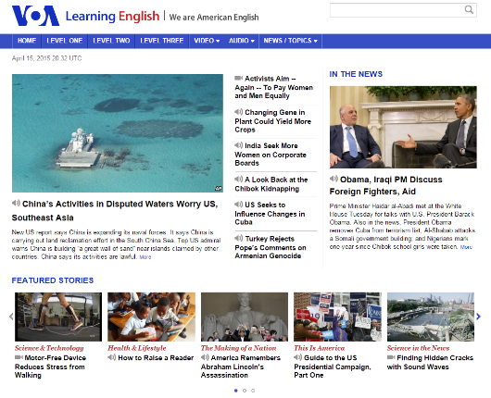Go to <http://learningenglish.voanews.com/> and choose one of the current events of the day. Here is an example of what you will see:

Once you’ve chosen a current event, read and/or listen to the story about the current event. You can listen to the current event by clicking play on the recording (see example). After you’ve read and/or listened to the story about the current event, answer the questions below.

**EXAMPLE**



To listen to the recording, click play

1. **What** is the title of the current event?
2. **Where** is the current event taking place?
3. **Who** is involved in the current event?
4. **What** are three facts about the current event?
5. **What** is your opinion of the current event? – How do you feel about this event? How does this event affect you?
6. **How** does this event affect the world?
7. Write down three new vocabulary words and their definitions in the following table. Go to [www.learnersdictionary.com](http://www.learnersdictionary.com) to find the definition and pronunciation of each word.

|  |  |
| --- | --- |
| Vocabulary Word | Definition |
|  |  |
|  |  |
|  |  |

**Section 3: Facts vs. Opinions**

In Section 2, you were asked to write down some of the facts from the article and some of your opinions. Do you know what the difference between facts and opinions is? A fact is a statement that is indisputably true. It can be proven, or supported by observation. For example, "The sky is blue" is a fact. So is "birds have wings," "Oslo is the capital of Norway," and "The Civil War lasted from 1861 to 1865." Opinions, on the other hand, are influenced by the beliefs and values of people and the societies in which they live. An opinion can’t be proven true, but informed opinions are often supported by facts. Below is a list of statements. Write on the line whether each statement is a fact (F) or opinion (O). You can check your answers at the bottom of this page.

1. _________ We need to eat food in order to survive.

2. _________ Foods with fat in them are bad.

3. _________ Fruits and vegetables are an important part of the human diet.

4. _________ Too many fats can make you sick.

5. _________ A healthy diet is important for general health.

6. _________ Hot dogs taste better than hamburgers.

It is important to know some of the facts about the current event and your opinion about the current event because it will keep the conversation going. You don’t have to spend hours researching the current event or memorize every detail, but it would be beneficial to know the main idea or gist of the article in addition to facts concerning who, what, where, when, why, and how. Having this information will help you to have a solid conversation because each new piece of information you bring up will help the conversation to continue. Also, having an opinion about the current event is a good idea. Not only should you share your opinion, but you should allow the other person to share his or her opinion. Some ways that you can encourage the other person to share his or her opinion is to ask the following questions:

* What’s your opinion about…?
* What do you think about …?
* Do you agree that ….?
* Do you disagree that …?
* Why do feel that way about …?

If you share the same opinion with the person you’re talking to, you’ve made an instant connection with the person. This will allow you to continue the conversation very easily because you share similar beliefs and ideas. If you have a different opinion with the person you’re talking to, that’s okay. It might lead to an interesting debate, or maybe you’ll be able to discuss your differences and come to a mutual understanding of or agreement about the current event. Either way, be prepared for both situations.

Source:www.abcteach.com/free/f**/fact**or**opinion_food**.pdf

1. F 2. O (“bad” is an opinion word) 3. F 4. F 5. F 6. O

**Section 4: Student Self-Assessment**

C:\Documents and Settings\wcuser1553\Local Settings\Temporary Internet Files\Content.IE5\Z02HHZPN\MC900072629[1].gif*Complete this self-assessment before meeting with a tutor.* **Now that you’ve completed sections 1 to 3, check the things you can do:**

* I can find information about current events using the Internet.
* I can separate the facts from opinions in a current event article.
* I can have a conversation about a current event.

**DON’T FORGET! Write your name on the clipboard to work with a tutor. The tutor will call your name when he/she is ready.**

**Section 5: Practice with a Tutor!**

After completing the self- assessment, meet with a tutor and give this completed SDLA to the tutor. You will have a conversation with the tutor about the current event you learned about. Make sure to provide the tutor with background information about the event, some facts about the event, and make sure to discuss both of your opinions. The tutor will provide you with feedback in the following areas:

|  |  |  |  |
| --- | --- | --- | --- |
| **Area of Focus** | **1 Point** | **3 Points** | **5 Points** |
| **Content** | Student does not provide enough information in responses and does not use appropriate vocabulary. | Student provides sufficient information in responses and uses appropriate vocabulary some of the time. | Student provides all necessary information in responses and uses appropriate vocabulary most of the time. |
| **Skill: Speaking** | Student’s speech is unclear and requires frequent listener effort. | Student’s speech is generally clear but requires occasional listener effort. | Student’s speech is clear and smooth and requires minimal listener effort. |
| **Oral Fluency** | Speaks in incomplete sentences that do not flow. | Speaks in complete sentences some of the time with frequent pauses. | Speaks in complete sentences with occasional pauses most of the time. |
|  |  |  | **Total points: /15** |

**\*Students must receive at least 10 points to move on.**

**Tutor Recommendations:**

|  |  |
| --- | --- |
| * **Congratulations! Move on**   *Student has successfully completed this SDLA and is ready to continue to the next.* | * **Repeat**   *Student hasn’t yet mastered this SDLA. It is recommended that the student complete it again.* |

**Tutor Signature: __________________________________________ Date: _______________________**