**SL18. Traffic Accident**

**Part 1**

Student Name: _________________________________ Student ID Number: ________________________

Instructor: _____________________________________ Level: ___________Date: ___________________

**IMPORTANT NOTE: Sections 1-4 in the SDLA must be completed before meeting with a tutor and receiving a stamp. Write/type all your answers on this handout.**

**After completing this SDLA, you will be able to:**

* Take notes based on a news report
* Recognize the important information to include in a police report
* Identify the necessary steps to take after a car accident

**Sections 1-4 (approximately 45 minutes):** Read the information. Follow each step below to complete this SDLA. Be prepared to explain your answers when you meet with a tutor.

**Section 1: Introduction**

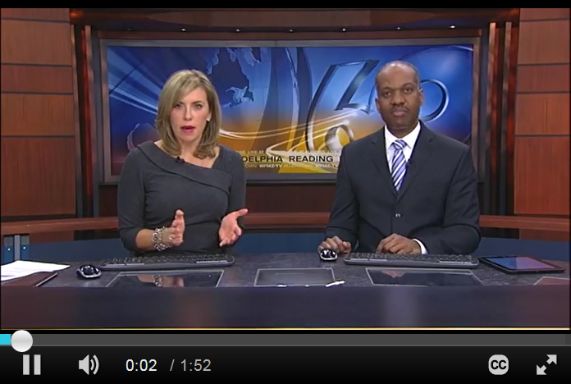Have you ever been in a car accident? If so, you are definitely not alone. Statistics show over the course of a lifetime, the average driver will have three or four car accidents (Werteen, 2015). It can be very scary being in a car accident, especially if you don’t know what to do or how to describe what happened. This SDLA will help you be prepared if you are ever involved in a car accident.

**Do you know what you should do if you are in a car accident?**

**Listen** to the news report about what to do in a car accident. After you finish listening, complete the list below with the steps you should take when in a car accident. [**http://tinyurl.com/lowysnd**](http://tinyurl.com/lowysnd)

**What to do in a car accident:**

1. Assess ____________________. You can ask yourself questions such as:

_______________________________________________________________________________________

1. Get your car _________________________________________________________________________
2. If you cannot move the vehicle, __________________________________________________________
3. Don’t ______________________________________________________________________________
4. Exchange ___________________________________________________________________________
5. Get information ______________________________________________________________________
6. Notify ______________________________________________________________________________
7. Call the police **if** ______________________________________________________________________
8. Take _______________________________________________________________________________

**Section 2: Police Report**

**Why should I file a report?**

It is extremely important to file a police report after a car accident. The police report can provide valuable information for your car insurance company, and it can help protect you in the event of an accident-related lawsuit.

**What should I include in my report?**

You want to make your police report as detailed and accurate as possible. You should take notes and photos of the scene, your vehicle, and your injuries to gather information and help you remember. Include as much of the following information as you can:

* Description of what happened
* Number of passengers in the other driver’s car
* Driver’s name and insurance information
* Names of witnesses -- if possible, record their description of the accident using your cell phone
* Damages to your vehicles
* Injuries to yourself or your passengers

**What should I do if no police come to the accident?**

The police don’t always make it to the scene of a car accident. They might not come because the accident did not cause injuries, or because the damage to the vehicles was too small. If a police officer does not come to the scene of the accident, you can go to the police department to file your report. You can often do this online or at the police station. You can also file an accident report with the DMV.

Adapted from: www.dmv.org

**Section 3: An Accident**

**Read the short story** below about Johnathan’s car accident. As you read, think about the following questions: What did Johnathan do correctly? What did he not do, or what did he not do correctly? Write the answers to these questions in the chart below.

Johnathan was driving alone when he got in a car accident on the freeway yesterday. It was a minor accident, so he immediately stopped, grabbed his insurance information, phone, and paper and a pen. When he got out of his car, he first looked at the front of his car, and there was a pretty big dent and some missing paint. He then walked over to the other car in the accident. Remaining calm, he said, “Hi, I’m so sorry about this. I should have stopped sooner. It really ruined my day, and I’m sure it ruined yours as well. Let’s just exchange information and move on.” Johnathan then gave his insurance card to the other driver. Johnathan wrote down the other driver’s name and phone number. They shook hands, and Johnathan got back in his car and drove away. He called his insurance company as soon as he got home.

|  |  |
| --- | --- |
| **What did he do correctly?** | **What did he not do, or not do correctly?** |
|  |  |

**Discussion Questions:** You will talk about the questions below with a tutor. Be sure to read the questions in advance so you are more prepared to talk with the tutor.

1. Have you ever been in a car accident? What happened? How did you feel?
2. What should you do if you are in a car accident?
3. Do you handle car accidents in your native country the same way we handle them here?
4. What are some activities you should avoid when driving because they increase the possibility of getting in an accident?

**Section 4: Student Self-Assessment**

C:\Documents and Settings\wcuser1553\Local Settings\Temporary Internet Files\Content.IE5\Z02HHZPN\MC900072629[1].gif*Complete this self-assessment before meeting with a tutor.* **Now that you’ve completed sections 1 to 3, check the things you can do:**

* I can take notes based on a news report.
* I can recognize the important information to include in a police report.
* I can identify the necessary steps to take after a car accident.

**DON’T FORGET! Write your name on the clipboard to work with a tutor. The tutor will call your name when he/she is ready.**

**Section 5: Practice with a Tutor!**

After completing the self-assessment, meet with a tutor and give this completed SDLA to the tutor. To make sure you understand the information in this SDLA, you will have a discussion about the questions in Section 3. After you’ve finished talking about the questions, the tutor will provide you with feedback in the following areas:

|  |  |  |  |
| --- | --- | --- | --- |
| **Area of Focus** | **1 Point** | **3 Points** | **5 Points** |
| **Content** | Student does not provide enough information in responses and does not use appropriate vocabulary. | Student provides sufficient information in responses and uses appropriate vocabulary some of the time. | Student provides all necessary information in responses and uses appropriate vocabulary most of the time. |
| **Skill: Speaking** | Student’s speech is unclear and requires frequent listener effort. | Student’s speech is generally clear but requires occasional listener effort. | Student’s speech is clear and smooth and requires minimal listener effort. |
| **Oral Fluency** | Speaks in incomplete sentences that do not flow. | Speaks in complete sentences some of the time with frequent pauses. | Speaks in complete sentences with occasional pauses most of the time. |
|  |  |  | **Total points: /15** |

**\*Students must receive at least 10 points to move on.**

**Tutor Recommendations:**

|  |  |
| --- | --- |
| * **Congratulations! Move on**   *Student has successfully completed this SDLA and is ready to continue to the next.* | * **Repeat**   *Student hasn’t yet mastered this SDLA. It is recommended that the student complete it again.* |

**Tutor Signature: __________________________________________ Date: _______________________**