**SL17. Post-It: A Short Film**

Student Name: _________________________________ Student ID Number: ________________________

Instructor: _____________________________________ Level: ___________Date: ___________________

**IMPORTANT NOTE: Sections 1-4 in the SDLA must be completed before meeting with a tutor and receiving a stamp. Write/type all your answers on this handout.**

**After completing this SDLA, you will be able to:**

* Recognize the necessary vocabulary and phrases featured in a short film
* Predict what will happen in a short film based on pictures
* Listen for missing words in a conversation
* Comprehend the meaning of a short film

**Sections 1-3 (approximately 45 minutes):** Read the information. Follow each step below to complete this SDLA. Be prepared to explain your answers when you meet with a tutor.

**Section 1: Necessary Vocabulary**

In this SDLA, all of the activities are about the short film *Post-It*. Before you watch the short film, you should know the following vocabulary words and phrases. Match the definitions to each of the vocabulary words. The first one has been done for you.

|  |  |
| --- | --- |
| **Vocabulary Words** | **Definitions** |
| 1. Post-it (n.) | 1. ___  to make (someone) afraid |
| 1. Ridiculous (adj.) | 1. ___ an amount of time or a situation in which something can be done |
| 1. Intimidating (adj.) | 1. A a small, colored slip of paper with a sticky edge |
| 1. Intrigued (v.) | 1. ___ wanting to know about other people's lives, problems, etc. |
| 1. Can’t stand people/person | 1. ___thoroughly dislike; be unable to put up   with someone. |
| 1. Opportunity (n.) | 1. ___ to make (someone) want to know more about something **:** to cause (someone) to become interested |
| 1. Nosy (adj.) | 1. ___  extremely silly or unreasonable |

Now, write 1 sentence for each of the vocabulary words from above.

|  |  |
| --- | --- |
| **Vocabulary Words** | **Sentences** |
| Post-it (n.) |  |
| Ridiculous (adj.) |  |
| Intimidating (adj.) |  |
| Intrigued (v.) |  |
| Can’t stand people/person |  |
| Opportunity (n.) |  |
| Nosy (adj.) |  |

|  |  |
| --- | --- |
| **1** | **2** |
| **3** | **4** |
| **5** | **6** |

**Section 2: Plot Prediction**

Below are photos taken from the short film you are going to watch. Before you watch the film, look at the photos below and guess what will happen in the film. Write your predictions in the boxes.

**Now watch the film to see if your predictions were correct! Watch the film at** [**http://tinyurl.com/k3efyls**](http://tinyurl.com/k3efyls)**.**

**Section 3: Fill-in the Blanks Conversation**

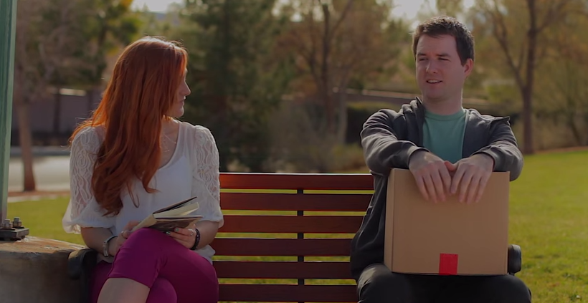

Watch the film again. For the first 2 minutes of the short film, listen to the conversation between Claire and Elroy. There is a transcription of their conversation below, but some of the words have been taken out. As you listen, fill in the blank spaces with the missing words that you hear.

**Claire:** I think it’s kind of ridiculous you’re not __________________ down.

**Elroy:** Oh, I don’t . . . I don’t ______________ standing.

**Claire:** Well, there’s plenty of room. And I’m not ____________________ .

**Elroy:** Uh. . . yeah. That’s true.

**Claire:** I have to ask . . . what’s in the ____________?

**Elroy:** It’s umm. . . It’s, it’s ______________________.

**Claire:** Well you carry it like it’s ___________________. (long pause) Sorry. It’s none of my __________________. I guess I was just ________________________.

**Elroy:** Uh, it’s . . . picture frames, a _______________, paper clips, pens, and a stack of ___________________.

**Claire:** Not a ____________________ head then.

**Elroy:** (laughs) Uh, no. It’s not a ______________________ head.

**Claire:** I’m Claire by the way.

**Elroy:** Hi.

**Claire:** Hi.

**Elroy:** Oh, sorry. Uh, I’m Elroy.

**Claire:** Elroy…So Elroy, sorry you ________________ your job.

**Elroy:** What? No. Oh, because of the _____________? No, I didn’t … I didn’t _______________ my job.

**Claire:** Oh. Well. ___________________________, then.

**Elroy:** Why?

**Claire:** For not _______________________ your job.

**Elroy:** Oh. Okay. Right. Thanks.

**Section 4: Comprehension Questions**

After you’ve watched the film, answer the questions below. Please write your answers in complete sentences.

1. Who does the stuff in the box belong to? Why does he have the box?

________________________________________________________________________________________________________________________________________________________________________

1. What did Elroy’s mother use to leave him when he was in high school?

________________________________________________________________________________________________________________________________________________________________________

1. How are Elroy and his mother different from each other?

________________________________________________________________________________________________________________________________________________________________________

1. What nice things do Claire and Elroy say about the man who sits between them on the bench?

________________________________________________________________________________________________________________________________________________________________________

1. What do Elroy and Claire do together the rest of the day?

________________________________________________________________________________________________________________________________________________________________________

1. In the last scene of the film, what does Elroy write on the post-it he gives to Claire? Why?

________________________________________________________________________________________________________________________________________________________________________

**Section 5: Student Self-Assessment**

C:\Documents and Settings\wcuser1553\Local Settings\Temporary Internet Files\Content.IE5\Z02HHZPN\MC900072629[1].gif*Complete this self-assessment before meeting with a tutor.* **Now that you’ve completed sections 1 to 4, check the things you can do:**

* I can recognize the necessary vocabulary and phrases featured in a short film.
* I can make predictions about a short film based on pictures.
* I can listen for missing words in a conversation.
* I can comprehend the meaning of a short film.

**DON’T FORGET! Write your name on the clipboard to work with a tutor. The tutor will call your name when he/she is ready.**

**Section 6: Practice with a Tutor!**

After completing the self- assessment, meet with a tutor and give this completed SDLA to the tutor. To make sure you understand the information in this SDLA, you will review all of the sections with a tutor. Then the tutor will show you a few pictures, and just like in the movie, you will need to think of something nice to say about each person or animal in each picture.

The tutor will provide you with feedback in the following areas:

|  |  |  |  |
| --- | --- | --- | --- |
| **Area of Focus** | **1 Point** | **3 Points** | **5 Points** |
| **Content** | Student does not provide enough information in responses and does not use appropriate vocabulary. | Student provides sufficient information in responses and uses appropriate vocabulary some of the time. | Student provides all necessary information in responses and uses appropriate vocabulary most of the time. |
| **Skill: Speaking** | Student’s speech is unclear and requires frequent listener effort. | Student’s speech is generally clear but requires occasional listener effort. | Student’s speech is clear and smooth and requires minimal listener effort. |
| **Oral Fluency** | Speaks in incomplete sentences that do not flow. | Speaks in complete sentences some of the time with frequent pauses. | Speaks in complete sentences with occasional pauses most of the time. |
|  |  |  | **Total points: /15** |

**\*Students must receive at least 10 points to move on.**

**Tutor Recommendations:**

|  |  |
| --- | --- |
| * **Congratulations! Move on**   *Student has successfully completed this SDLA and is ready to continue to the next.* | * **Repeat**   *Student hasn’t yet mastered this SDLA. It is recommended that the student complete it again.* |

**Tutor Signature: __________________________________________ Date: _______________________**