**RW9. Text Messages**

Student Name: _________________________________ Student ID Number: ________________________

Instructor: _____________________________________ Level: ___________Date: ___________________

**IMPORTANT NOTE: Sections 1-5 in the SDLA must be completed before meeting with a tutor and receiving a stamp. Write/type all your answers on this handout.**

**After completing this SDLA, you will be able to:**

* List the advantages and disadvantages of text messaging
* Identify appropriate situations for talking and texting
* Translate text language into formal English
* Use texting language to create text messages

**Sections 1-5 (approximately 45 minutes):** Read the information. Follow each step below to complete this SDLA. Be prepared to explain your answers when you meet with a tutor.

**Section 1: Introduction**

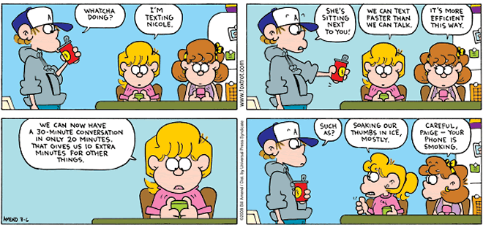

The comic above is supposed to be funny, but it is actually not far from the truth. Texting is a very popular and preferred method of conversation, but it is not always the best. Write your ideas below about the pros and cons of text messaging.

|  |  |
| --- | --- |
| **Text Messaging** | |
| Pros (+) | Cons (-) |
|  |  |

**Section 3: Using Text Messages**

Statistics show that many people with cell phones prefer texting over talking on the phone or face to face. It’s not always young people, although the data shows that the younger you are, the more likely you are to prefer texting. And this is creating a communication divide – the talkers vs. the texters. Some people argue that *how* we communicate is not important; what’s important is that we continue to communicate. But many experts say the most successful communicators will, of course, have the ability to do both: talk and text. Experts also say successful communicators will also know the most appropriate times to use talking skills or texting skills.

*Decide if the situations below are more appropriate for talking (talk) or texting (text). The first one has been done as an example.*

______ 1. You want to confirm the restaurant you are meeting friends for lunch at today.

______ 2. You want to say goodbye to your friend before he or she moves out of the country.

______ 3. You want to ask someone to marry you.

_______4. You want to know what time someone in your family will be home for dinner.

Text adapted from: Irvine, M. (2012). *Text messaging: Is texting ruining the art of conversation?* Huffington Post.

**Section 3: Reading and Writing Text Messages**

**Part 1:** Texting can sometimes seem like a completely different language. They are usually short and use a lot of abbreviations. It is helpful to understand some common text messages so you are never left with a text that you don’t understand. Match the text message language below with the correct English word or phrase.

|  |  |
| --- | --- |
| **Text Language** | **Formal English** |
| 1. l8r | 1. before |
| 1. c u | 1. later |
| 1. btw | 1. as soon as possible |
| 1. 2 | 1. are you . . . |
| 1. xoxo | 1. hugs and kisses |
| 1. lol | 1. see you |
| 1. ur | 1. laughing out loud |
| 1. b4 | 1. estimated time of arrival |
| 1. r u | 1. your |
| 1. ASAP | 1. to |
| 1. ETA | 1. on my way |
| 1. omw | 1. by the way |

**Part 2:** Rewrite the following messages in correct English. Use correct grammar, punctuation, and capitalization.

1. C u l8r ______________________________________
2. ill b there b4 8 ______________________________________
3. Btw, you 4got ur coat ______________________________________
4. im w8ing 4 u outside ______________________________________
5. can u pick me up? 8 ok? ______________________________________
6. call me ASAP ______________________________________
7. Omw, ETA is 5pm ______________________________________

**Part 3:** In the phone below, write a conversation between two friends, classmates, or family members. Try to use appropriate abbreviations and texting language.

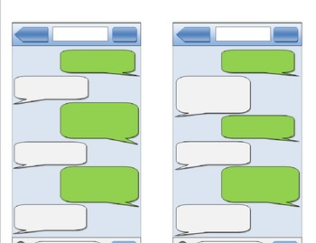

Adapted from: onestopenglish.com, Macmillan Publishers (2003).

**Section 5: Student Self-Assessment**

C:\Documents and Settings\wcuser1553\Local Settings\Temporary Internet Files\Content.IE5\Z02HHZPN\MC900072629[1].gif*Complete this self-assessment before meeting with a tutor.* **Now that you’ve completed sections 1 to 4, check the things you can do:**

* + I can list the advantages and disadvantages of text messaging.
  + I can identify appropriate situations for talking and texting.
  + I can translate text language into formal English.
  + I can use texting language to create text messages.

**DON’T FORGET! Write your name on the clipboard to work with a tutor. The tutor will call your name when he/she is ready.**

**Section 6: Practice with a Tutor!**

After completing the self- assessment, meet with a tutor and give this completed SDLA to the tutor. The tutor will review your work with you. Also, you will translate a text message passage.

|  |  |  |  |
| --- | --- | --- | --- |
| **Area of Focus** | **1 Point** | **3 Points** | **5 Points** |
| **Content** | Student does not provide enough information in responses and does not use appropriate vocabulary. | Student provides sufficient information in responses and uses appropriate vocabulary some of the time. | Student provides all necessary information in responses and uses appropriate vocabulary most of the time. |
| **Skill: Speaking** | Student’s speech is unclear and requires frequent listener effort. | Student’s speech is generally clear but requires occasional listener effort. | Student’s speech is clear and smooth and requires minimal listener effort. |
| **Oral Fluency** | Speaks in incomplete sentences that do not flow. | Speaks in complete sentences some of the time with frequent pauses. | Speaks in complete sentences with occasional pauses most of the time. |
|  |  |  | **Total points: /15** |

**\*Students must receive at least 10 points to move on.**

**Tutor Recommendations:**

|  |  |
| --- | --- |
| * **Congratulations! Move on**   *Student has successfully completed this SDLA and is ready to continue to the next.* | * **Repeat**   *Student hasn’t yet mastered this SDLA. It is recommended that the student complete it again.* |

**Tutor Signature: __________________________________________ Date: _______________________**