**RW5. Job Résumé**

Student Name: _________________________________ Student ID Number: ________________________

Instructor: _____________________________________ Level: ___________Date: ___________________

**IMPORTANT NOTE: Sections 1-4 must be completed before meeting with a tutor and receiving a stamp. Write/type all your answers on this handout.**

**After completing this SDLA, you will be able to:**

* Identify the important parts of a good résumé
* Identify effective power words in a résumé
* Identify and critique a poor résumé

**Sections 1-4 (approximately 45 minutes):** Read the information. Follow each step below to complete this SDLA. Be prepared to explain your answers when you meet with a tutor.

**Section 1: Introduction**

**A. What is a Résumé?**

A résumé is a typed document that summarizes your skills, experience, and accomplishments. It is a quick advertisement of who you are. Your résumé lets the potential employer know who you are in a very short amount of time. Because the employer only spends a short amount of time looking at your résumé, it is important that it has no mistakes. You want to read, proofread, and edit your résumé many times to make sure it is perfect! Watch this short video clip from the TV show *Friends* to see what happens when you don’t proofread your résumé: **http://tinyurl.com/lnq49sb**

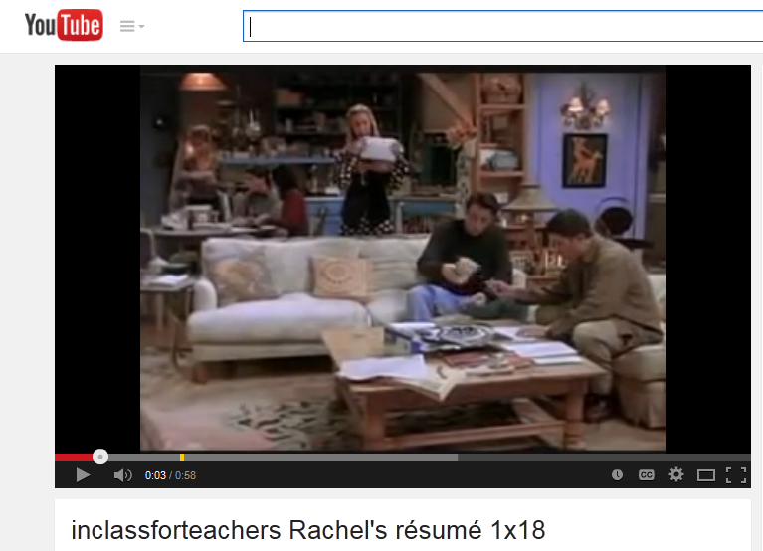**How much time does an employer usually spend reviewing a résumé?**

1. 1 minute
2. 6 seconds
3. 3 minutes

If you chose B, you are correct! An employer usually looks at each résumé for about 5-7 seconds before deciding to see that person for an interview. This shows how important it is to have an excellent résumé.

**Did you know?**

* 76% of résumés are discarded for an unprofessional email address.
* 88% throw away your résumé when you include a photo.
* 1 spelling or grammar mistake and the employer will throw your résumé in the trash.

Adapted from: Buckland, M. (2014). *25 Fun Facts about Resumes, Interviews & Social Recruitment.* http://www.business2community.com

**Section 2: Helpful Tips**

**Tip 1: Include important sections**

Not all résumés are the same, but there are some common sections that they all should include. The important sections are:

**Heading:** This should include your formal name, address, telephone number, and email address. Make sure email address is appropriate.

**Objective:** Employers often say this is the most important part of a résumé. It is a 2-3 sentence explanation of your experience and the job you are looking for.

**Education**: This should include dates, name of school(s), degrees, licenses, credentials and certificates. Include the subject you are currently studying.

**Experience**: In this section, you should include previous employers, their locations, your dates of employment, and your job title. You should include at least two one-line descriptions of what your job duties and responsibilities were. Use **power words** to start each of these descriptions. **Do not use “I”** in descriptions.

**Additional Skills and Information**: This section should highlight any technical or specialized skills you have that are applicable to the position.

**References:** You should have 2-3 people who have observed your work habits (employers, teachers, coaches, etc.). Make sure you have asked their permission to include them as references. Create a separate list of references including their names, addresses, employers, job titles, and phone numbers.

**Answer the Question:** Does the résumé on page 3 include all of the sections? If not, which sections are missing?

__________________________________________________________________________________________

__________________________________________________________________________________________

**Tip 2: Use power words**

To make your résumé more noticeable to the employer, use power words that match the position you want. The most powerful words are verbs. And the most powerful verbs are action verbs. **As a result, you should use**

**plenty of action verbs to describe your previous job responsibilities and current skills.**

Adapted from: *Resume Writing.* http://www.ccd.me.edu/careerprep/CareerPrepCurriculum_LP-4.pdf

**Example Power Words**

|  |  |  |
| --- | --- | --- |
| **Creative skills** | **Financial skills** | **Teaching skills** |
| create  illustrate  integrate  invent  perform | administer  allocate  analyze  budget  calculate | advise  clarify  enable  encourage  facilitate |

**Read** the résumé below. Circle the power words in the résumé that help to make it more noticeable to the employer.

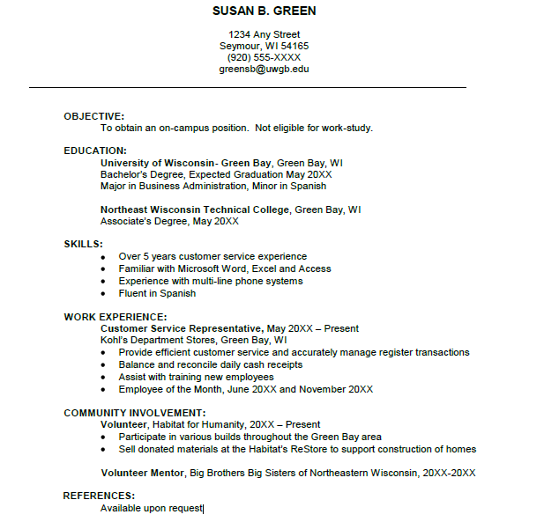

Source: On-Campus Student Employment Resumes, http://www.uwgb.edu/careers/skills/resume-samples/OnCampus_Resume.pdf

**Tip 3: Be Honest and Relevant**

**Watch another scene from *Friends* and answer the questions below.** [**http://tinyurl.com/qgyl9zv**](http://tinyurl.com/qgyl9zv)

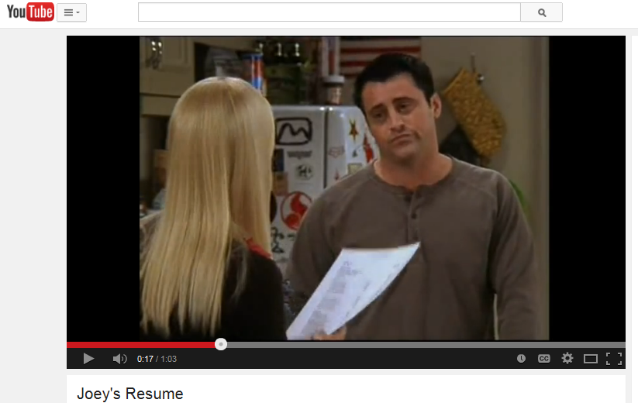**What are three skills that Joey lied about on his résumé?**

1. **______________________________________________**
2. **______________________________________________**
3. **______________________________________________**

When seeking out employment at any type of company, it is important that you are honest with the information that you are presenting in your résumé. As you saw in the scene, Joey lied about some of his skills in hopes of gaining attention from potential employers. The problem with lying is that you are completely getting off on the wrong foot with these potential employers. Not only that, but you also run the risk of being fired from the company which you are applying to. If a company discovers that you have been dishonest in the way that you presented yourself in your résumé, they are legally able to fire you.

**What was one skill that Joey can do?**

Another important tip is to tailor your résumé to the job you’re applying for. Make sure that the information you provide on your résumé is relevant for the job. For example, Joey could drink a gallon of milk in 10 seconds, but is it really relevant to being a good actor? Remember, each job you apply for will have a unique set of requirements. Unlike Joey, you should create a résumé so that your skills and experience will align with the specific responsibilities of the job you’re applying for.

**Section 3: Résumé Critique**

Look at the résumé on the next page. This is an example of a résumé that has not been edited or proofread. Each of the arrows points to a problem area in the résumé. Identify the problem and explain how it could be fixed or improved. Write your recommendations in the boxes provided. You will discuss your answers with a tutor when you’re finished.

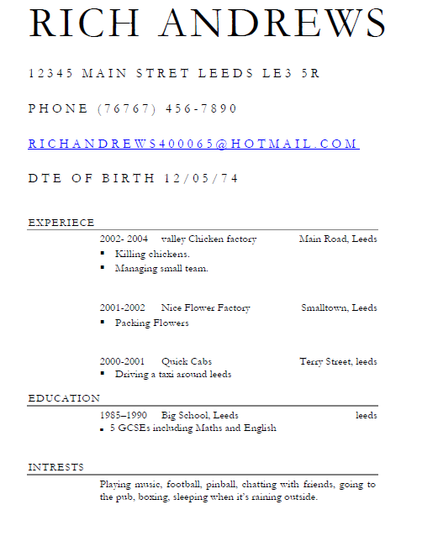

Source: Macmillan Publishers Ltd 2004. Downloaded fromthe ESOLsection in www.onestopenglish.com

**Section 4: Student Self-Assessment**

C:\Documents and Settings\wcuser1553\Local Settings\Temporary Internet Files\Content.IE5\Z02HHZPN\MC900072629[1].gif*Complete this self-assessment before meeting with a tutor.* **Now that you’ve completed sections 1 to 3, check the things you can do:**

* + - * Identify the important parts of a good résumé.
      * Identify effective power words in a résumé.
      * Identify and critique a poor résumé.

**DON’T FORGET! Write your name on the clipboard to work with a tutor. The tutor will call your name when he/she is ready.**

**Section 5: Practice with a Tutor!**

After completing the self- assessment, meet with a tutor and give this completed SDLA to the tutor. You will talk about the résumés in this SDLA with the tutor. Be prepared to explain your critique of the résumé in Section 3. You may also ask the tutor any questions that you might have.

|  |  |  |  |
| --- | --- | --- | --- |
| **Area of Focus** | **1 Point** | **3 Points** | **5 Points** |
| **Content** | Not enough information discussed in the résumé critique and student does not refer to tips or specific vocabulary. | Sufficient information discussed in the résumé critique and student refers to tips and specific vocabulary to support their opinion some of the time. | All necessary information discussed in the résumé critique and student refers to tips and specific vocabulary to support their opinion most of the time. |
| **Skill: Speaking** | Student’s speech is unclear and requires frequent listener effort. | Student’s speech is generally clear but requires occasional listener effort. | Student’s speech is clear and smooth and requires minimal listener effort. |
| **Oral Fluency** | Speaks in incomplete sentences that do not flow. | Speaks in complete sentences some of the time with frequent pauses. | Speaks in complete sentences with occasional pauses most of the time. |
|  |  |  | **Total Points: /15** |

**\*Students must receive at least 10 points to move on.**

**Tutor Recommendations:**

|  |  |
| --- | --- |
| * **Congratulations! Move on**   *Student has successfully completed this SDLA and is ready to continue to the next.* | * **Repeat**   *Student hasn’t yet mastered this SDLA. It is recommended that the student complete it again.* |

**Tutor Signature: __________________________________________ Date: _______________________**