**RW1. Developing an Opinion**

Student Name: _________________________________ Student ID Number: ________________________

Instructor: _____________________________________ Level: ___________Date: ___________________

**IMPORTANT NOTE: Sections 1-4 in the SDLA must be completed before meeting with a tutor and receiving a stamp. Write/type all your answers on this handout.**

**After completing this SDLA, you will be able to:**

* Perform a Yelp search
* Use Yelp to search for specific information about a place
* Read and summarize reviews from Yelp
* Use the results of a Yelp search to develop an opinion about a place
* Discuss an opinion about a search result from Yelp

**Sections 1-4 (approximately 45 minutes):** Read the information. Follow each step below to complete this SDLA. Be prepared to explain your answers when you meet with a tutor.

**Section 1: Agree or Disagree**

Have you ever wanted to eat out at a restaurant, but you couldn’t decide where to go? This happens to most people when they want to go out to eat, especially if you are trying to decide with a group. The next time you have this problem, you can go to www.yelp.com. Yelp is a website that gives you other people’s opinions about different restaurants, bars, coffeehouses, home services, and the list goes on. When people write their opinion about something, it is often called a “Review.” Read the review below from Yelp about the Applebee’s restaurant on North Grand Avenue in Walnut, California.

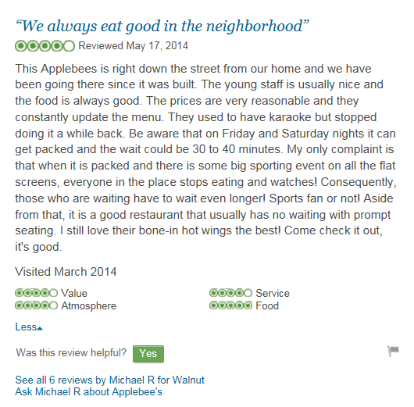**After reading this restaurant review, would you eat at this restaurant? Why or why not?**

______________________________________________________________________________________________________________________________________________________________________________________________________________________________________________________________________________________________________________________

**Section 2: Finding Reviews**

**Part A:** Below are step-by-step instructions on how to search for places on Yelp. Read through the steps before completing Part B.

**Magnifying**

**Glass (Search)**

**How to Search on Yelp**

**Find**

**Near**

1. 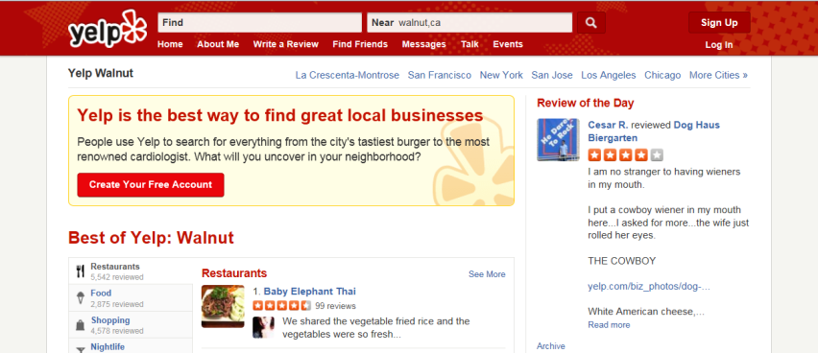**Go to** [**www.yelp.com**](http://www.yelp.com)
2. In the *Find* box at the top of the webpage, type *coffee* in it.
3. In the *Near* box next to the *Find* box, type *Walnut, CA* in it. The *Near* box may already have *Walnut, CA* typed in it. Change it to *Walnut, CA* if it does not.
4. Once you have the *Find* and *Near* boxes filled, click on the *magnifying glass* next to the *Near* box. This will start your search.

**Understanding your Search Results**

1. After you click the *magnifying glass*, your search results will appear.
   1. 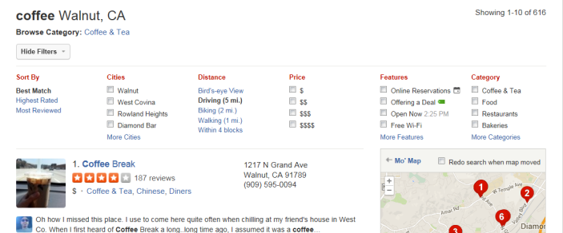**OPTIONAL:** You can filter your results based on cities, distance, price, features, and category by clicking on any of the boxes under each one. This will narrow your search, so you can get more specific results.
2. Each search result will display the following:
   1. Name of the restaurant, bar, coffeehouse, home service, etc.
   2. Stars – five stars (the highest rating) to one star (the lowest rating)
   3. The total number of reviews
   4. Dollar sign(s) – four dollar signs (very expensive) to one dollar sign (inexpensive)
   5. The type of food or service provided
   6. The address

**Note:** People usually use the information provided with each search result to help them decide which reviews to read. For example, some people will only read about restaurants that have at least 4 stars while others will only read about restaurants that are close by in distance.

**Part B:** You will now search for a new place to get coffee in Walnut, CA. Use the steps above to help search for a places that serves coffee. After your search results appear, choose one coffeehouse to complete the table below.

|  |  |  |  |  |  |
| --- | --- | --- | --- | --- | --- |
| **Name of Coffeehouse** | **Number of Stars** | **Number of Reviews** | **Number of Dollar Signs** | **Type of Food** | **The Address** |
|  |  |  |  |  |  |

**Section 3: Reading Reviews**

After you have looked at your search results and picked a place,you’ll see a page that includes more information about it including reviews from Yelpers (people who write Yelp reviews). You can browse the reviews and read those that interest you.

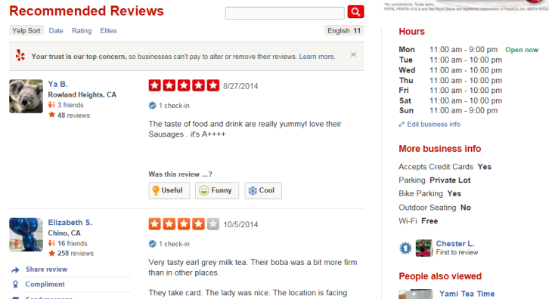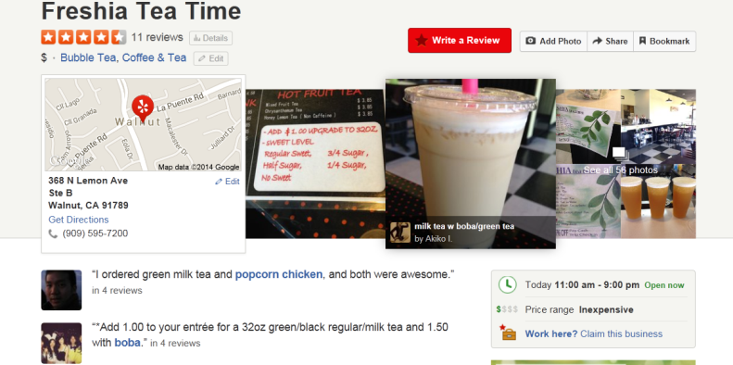

Now it’s your turn to read some Yelp reviews!

1. Decide which category you want to search: restaurants, shopping, home services, etc.
2. Find **ONE** place that looks interesting to you using the search results you learned about in section 2.
3. Read **THREE** reviews about your selected place. Complete the table below using the information from the three reviews. Use only the information in the reviews**.** Do **NOT** include your own opinions.

**Note:** Reviews can be very helpful to read when trying to make a decision. In order to make a good decision about something, you can’t believe EVERYTHING you read, and you want to read many reviews before you decide to go to the place.

|  |  |  |  |
| --- | --- | --- | --- |
| **Name of Place:** | **Likes**  What does the reviewer like about this place? | **Dislikes**  What does the reviewer dislike about this place? | **Overall Opinion**  Does the reviewer recommend this place to others? |
| **Review 1** |  |  |  |
| **Review 2** |  |  |  |
| **Review 3** |  |  |  |

After reading the three reviews, what is **YOUR** overall opinion of this place? Will you go there in the future? Explain.

__________________________________________________________________________________________

__________________________________________________________________________________________

____________________________________________________________________________________________________________________________________________________________________________________

**Section 4: Student Self-Assessment**

*Complete this self-assessment before meeting with a tutor.* **Now that you’ve completed sections 1 to 3, check**

C:\Documents and Settings\wcuser1553\Local Settings\Temporary Internet Files\Content.IE5\Z02HHZPN\MC900072629[1].gif **the things you can do:**

* I can perform a Yelp search.
* I can use Yelp to search for specific information about a place.
* I can read and summarize reviews from Yelp.
* I can use the results of a Yelp search to develop an opinion about a place.
* I can discuss my opinion about a search result from Yelp.

**DON’T FORGET! Write your name on the clipboard to work with a tutor. The tutor will call your name when he/she is ready.**

**Section 5: Practice with a Tutor!**

After completing the self- assessment, meet with a tutor and give this completed SDLA to the tutor. You will talk about the reviews that you read in Section 3. Be prepared to discuss your overall opinion about the place. You may also ask the tutor any questions that you might have.

|  |  |  |  |
| --- | --- | --- | --- |
| **Area of Focus** | **1 Point** | **3 Points** | **5 Points** |
| **Content** | Based on restaurant reviews, student develops an unfocused opinion with no support. | Based on restaurant reviews, student develops an opinion with little support. | Based on restaurant reviews, student develops a focused and well-supported opinion. |
| **Skill: Speaking** | Student’s speech is unclear and requires frequent listener effort. | Student’s speech is generally clear but requires occasional listener effort. | Student’s speech is clear and smooth and requires minimal listener effort. |
| **Oral Fluency** | Speaks in incomplete sentences that do not flow. | Speaks in complete sentences some of the time with frequent pauses. | Speaks in complete sentences with occasional pauses most of the time. |
|  |  |  | **Total points: /15** |

**\*Students must receive at least 10 points to move on.**

**Tutor Recommendations:**

|  |  |
| --- | --- |
| * **Congratulations! Move on**   *Student has successfully completed this SDLA and is ready to continue to the next.* | * **Repeat**   *Student hasn’t yet mastered this SDLA. It is recommended that the student complete it again.* |

**Tutor Signature: __________________________________________ Date: _______________________**