Communication Guides
Mt. San Antonio College
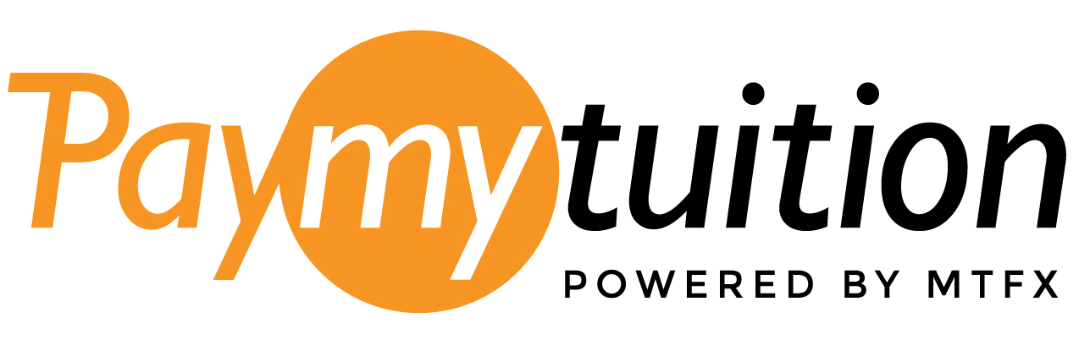

Table of Contents

Welcome to PayMyTuition 1
Communication Guidelines & Templates 2
Student Invoices 3
Internal Communication 4
External Communication 5
Wire Transfer Student Redirect 6

Welcome to PayMyTuition

Thank you for choosing PayMyTuition as your preferred solution for international tuition collections. We are excited to have your educational institution join our growing network of partner schools. At MTFX, we want to ensure that your experience and those of your students and colleagues is nothing short of exceptional. Welcome aboard our growing network of partner schools.

PayMyTuition was created to ensure that international students can settle tuition payments in their home currency, while taking advantage of low exchange rates, convenient payment tracking options and awesome multilingual customer support.

Our dedicated account managers are here to help develop awareness of our new partnership within the entire school community. Our goal with your implementation is to make the process as easy and seamless as possible. We have created a marketing checklist as well as several communication templates that are meant to help promote the new PayMyTuition solution.

Please note that our communication guidelines are meant to be used as a guide and should be tailored to meet the specific requirements of your educational institution. We encourage you to modify the content as you see fit. We hope you find the communication guidelines helpful and that they will save you time in the implementation process!

Thank you for partnering with PayMyTuition. We look forward to working with you and your team to provide international students an easy, safe and seamless online payment solution geared toward saving them money.

Communication Guidelines & Templates

The checklist below outlines some of the communication templates our partner schools use to build awareness of PayMyTuition within the school community. These communication templates are meant to help reduce your workload while introducing PayMyTuition to your international students. Please feel free to contact us should you require any additional information.

Communication Template | Notes & Comments
Student Bills & Invoices | Include a copy of your school’s unique and custom URL to electronic PDF bills or paper bills sent to your international students.
Internal Communication | This template is used to introduce PayMyTuition to internal stakeholders within your school. The internal communication template is especially important for any colleagues and staff that advise/support international students.
External Communication | This communication is designed to introduce and announce the PayMyTuition partnership as a new payment option to your international students and their families.
Admissions | Include the PayMyTuition student “how to” material in your welcome packet to international students.
International Student Events | Are there any events that are specific to international students that we should be speaking at to help promote the PayMyTuition services to international students?

Student Invoices

Communication: | Student invoices and bills for international students.
Purpose: | Introduce international students and families to the PayMyTuition payment method.

For international payments, Mt. San Antonio College has partnered up with PayMyTuition. PayMyTuition is an easy-to-use, safe and seamless solution that allows international students to pay their tuition and fees in their local currency from any bank, in any country, in any currency at better than bank exchange rates.
Students can now efficiently make a payment with PayMyTuition to fund all their invoices and tuition-related fees. To complete a payment:
Visit www.paymytuition.com
Select Mt. San Antonio College, and
Complete the secured online payment request.

Students can track their payments online, and it is recommended to send payments at least 72 business hours before the due date.
For additional information on PayMyTuition visit www.paymytuition.com.

Internal Communication

Communication: | Communication to internal stakeholders, staff and colleagues.
Purpose: | Introduce various departments within your educational institution to the benefits of PayMyTuition to both international students and your school.

Dear (Insert audience)

We are pleased to announce the partnership between Mt. San Antonio College and PayMyTuition, which offers a secure payment platform for our international students to fund their tuition and school-related fees. PayMyTuition has been developed by a leading Financial Technology Firm – MTFX – specifically for educational institutions and with the school’s administration and reconciliation processes in mind.

Teaming up with PayMyTuition is another way we are adding value to our international students attending Mt. San Antonio College, by creating an effective and seamless solution to accept international payments. International students will also benefit from the flexibility PayMyTuition offers, such as:

- Tuition and fees can be funded in the student’s local currency in 100+ currencies from anywhere in the world.
- Students receive the best exchange rate, increasing their savings.
- Payments can be initiated, funded and tracked online by students.
- Funds are received within 24-72 hours of sent payments.
- Offers an easy-to-use, secure online platform, available anytime.
- Multilingual customer service support is provided for students and parents 24/7.

Mt. San Antonio College is happy to have our students benefit from this FREE solution, as PayMyTuition provides numerous online dashboards, expansive reporting modules, and opportunities to integrate payments directly into our administrative processes, easing the burden of reconciliation and administration for international tuition payments.

I encourage you to introduce PayMyTuition to our school’s community so that we can better support our international student population. You can find the link to the PayMyTuition portal on our website or by visiting www.paymytuition.com. Please feel free to connect with me should you have any questions.

(Insert school contact)

External Communication

Communication: | Student and family letter introducing PayMyTuition.
Purpose: | Introduce international students to the PayMyTuition payment portal as the preferred payment method for international students.

EMAIL TO SEND TO STUDENTS/PARENTS:

Subject: New payment method announcement for Mt. San Antonio College students

Dear (Insert student’s name)

I am pleased to announce that Mt. San Antonio College has partnered with PayMyTuition for international tuition payments. With PayMyTuition, you can pay your tuition payments from any bank, in any country in any currency at better than bank exchange rates.

PayMyTuition allows you to choose from several payment options and currencies including wire transfers, e-wallet payments, bill payments and credit card payments. You can pay your tuition payments in your home currency at better than bank exchange rates. PayMyTuition is fast, simple and cost effective.
Did you know the cost of a typical education increases by 3-6% when banks process your international tuition payments? PayMyTuition protects students and families from inflated retail exchange rates which can save you thousands of dollars.
Benefits of using PayMyTuition:
- Don’t overpay your bank on currency exchange. PayMyTuition will save you money.
- PayMyTuition is fast, secure and easy to use.
- Create, fund and track your payments from start to finish using PayMyTuition’s online dashboard.
- Access multilingual customer support available any time.
- Opening an account is easy and only takes a few minutes.

CREATE YOUR ACCOUNT

To get started with your payment, visit www.paymytuition.com, select our school from the dropdown menu and complete the online steps.

• For questions about making a payment with PayMyTuition, email support@paymytuition.com.
• For questions about your student account, email (insert school email address if desired).

Sincerely

(Insert school contact)

Wire Transfer Student Redirect

Communication: | Communication for students that have used traditional bank transfers in the past.
Purpose: | Direct international students and families to PayMyTuition to make a bank transfer payment.

Subject: Important information on your international tuition payment

Dear (Insert student’s name)

I am pleased to announce that Mt. San Antonio College has partnered with PayMyTuition for international tuition payments. With PayMyTuition, you can pay your tuition payments from any bank, in any country in any currency at better than bank exchange rates.

Based on our records, we noticed that your last tuition payment to Mt. San Antonio College was not through PayMyTuition. We wanted to make sure that you took advantage of PayMyTuition’s great currency exchange rates and benefits.

PayMyTuition allows you to choose from several payment options and currencies including wire transfers, e-wallet payments, bill payments and credit card payments. You can pay in your home currency at better than bank exchange rates.

PayMyTuition is fast, simple and cost-effective and is Mt. San Antonio College’s preferred method of secure transfers.

Opening an account is easy and only takes a few minutes.
To get started with your payment, visit www.paymytuition.com, select our school and complete the online steps.

Sincerely,

(Insert school contact)

