Mt. San Antonio College COVID Policies Q&A

Question | Answer
When will students be required to start submitting vaccination proof? | To be determined. The college is working on setting up a process. Stay tuned!
When will students be required to start taking weekly COVID tests? | To be determined. The college is working on setting up a process. Stay tuned!
Will there be a cost for the COVID testing? | NO
What type of COVID testing will be required? | To be determined. Most likely the PCR test (nasal swab).
Can students go to in person classes until notified about how to submit vaccination proof or until testing is set up? | YES but all students must wear a mask while indoors in classes or buildings.
Do students have to switch to online classes? | Only if the student does not want to be vaccinated and does not want to submit proof OR does not want to be tested weekly.
What happens if students can’t find open seats in online classes? | Students should continually search for online courses and directly contact instructors via their email addresses. More online courses may be added during the first week. Additionally, courses for the 2nd 8 week session beginning in October will also be added.
What happens I can’t continue in my in-person/on campus classes? | Students should DROP any course they do not want or won’t be able to continue. There is a specific date for each course by which students should drop courses. Check #11 on the Student Self-Service in your student portal for the specific drop dates for each course.
Can students still drop a course with an EW any time during the semester? | The EW policy has changed: students must submit a Petition for Exceptional Action to the Admissions office if they want to drop with an “EW” – an “Excused Withdrawal”.
What happens if a student feels sick or has a positive COVID test? | Students feeling sick should NOT come to school and if sick on campus, should immediately return home.  Students should immediately complete an online form at https://www.mtsac.edu/health/covidscreen.html/  Someone representing the college will contact the student to provide further direction.
What happens if a student is exposed to COVID but has no symptoms? | It is still an exposure. Students who have an active exposure should be tested immediately, self-quarantine and complete the online student health check form https://www.mtsac.edu/health/covidscreen.html/  before coming to campus. A “contact tracer” from the college will be in contact with the student to explain when they can come to campus. Students should also contact their instructors to let them know about missing class. Even vaccinated students who are exposed should be tested.
If a student is experiencing anxiety, depression, or other emotions, where can they go for help? | The Student Health Center has two locations at Bldg. 9E and 67B with mental health counselors available. Contact them at (909) 274-4400.
What happens if a student does not want to wear a mask? | Students with a medical condition may request an accommodation to the mask requirement through the ACCESS at (909) 274-4290 or through Student Health Services at (909) 274-4400. Medical verification may be required. Students who can’t wear a mask due to medical reasons will be asked to wear a face shield. Students who are not excused or exempt from wearing a mask and refuse to wear a mask will be reported for student discipline as mandatory mask-wearing is college policy.

Mt. San Antonio College
Safe Practices for All of Us
Welcome back, Mounties! We hope you’re doing well and excited to be here. Our campus looks different for many reasons, but most importantly because students, faculty, and staff are all working together to keep our College community, ourselves, and our families safe and healthy. We ask that you stay informed and follow the guidelines.

Keep reading below for critical information that applies to all of us while we’re on campus, and stay tuned to all of Mt. SAC’s news and updates via our website, Facebook and Instagram posts, and emails and text messages.

- Sick? Do not come to campus.
Stay home, even if symptoms are mild, or if you have COVID-19.
- Cough
- Fever
- Sore throat
- Shortness of breath
- Sneezing
- Stomach issues
- Complete the student health check so that a Mt. SAC contact tracer can reach out to you: https://www.mtsac.edu/health/covidscreen.html
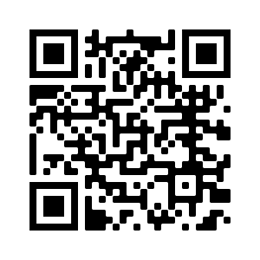

- Wear face coverings.
Masks prevent the transmission of illness and work best when everybody wears one.
- All indoor locations
- Regardless of vaccination status
- Make sure to cover your nose and mouth

- Get vaccinated.
COVID-19 vaccines help our bodies develop immunity to the virus that causes COVID-19 without us having to get the illness.
- Mt. SAC has partnered with East Valley Community Health Center to offer free COVID-19 vaccines to the community on select Thursdays
- Go to one of the websites below to register for a free vaccination at any participating site, including Mt. SAC

- https://myturn.ca.gov/

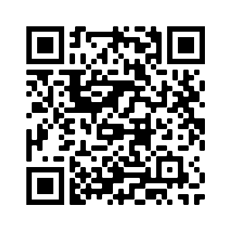
- http://www.publichealth.lacounty.gov/media/Coronavirus/vaccine/index.htm

- The COVID-19 vaccine is free.
- Vaccines are available for everyone age 12 and over.
- You will not be asked about your immigration status when you get a vaccine.
- Walk-ins welcome; no appointment is needed at many locations.
- Get tested.
COVID-19 testing is recommended if you develop symptoms or have been exposed to a confirmed COVID-19 case. It helps identify if you have COVID-19 and need to isolate and if you need to notify close contacts to quarantine.
- LA County COVID-19 Testing Sites
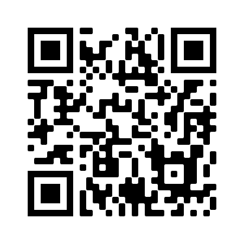
https://covid19.lacounty.gov/testing/

- Curative
https://curative.com/


- Pomona Fairplex
https://fairplex.com/aboutus/coronavirus-quarantine-center-information
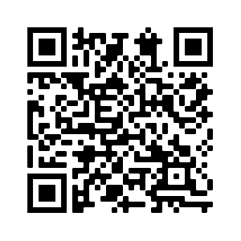

- Continue healthy practices.
Protect yourself from all illnesses.
- Cover Your Cough
- Wash Your Hands
- Don’t Touch Your Face

- How do I get help?
The Student Health Services is one of your primary resources on campus.
- Medical appointments with a physician, nurse practitioner, or registered nurse
- Mental health appointments with a psychologist or licensed clinical social worker
- Health education events and resources
- Fall 2021 Hours: Monday - Thursday 8:00am – 6:00pm, Friday 8:00am – 4:30pm
- Call: (909) 274-4400 to speak with our staff
- Online: https://www.mtsac.edu/healthcenter/


- Seek medical attention and additional instruction from your healthcare provider.
- Find out more at Learn About Symptoms and What To Do If You Are Sick
- If you develop any life-threatening symptoms such as chest pain, trouble breathing, bluish lips or face, then call 911 or go to the nearest hospital emergency room immediately.

Information as of 8.20.21 430pm

