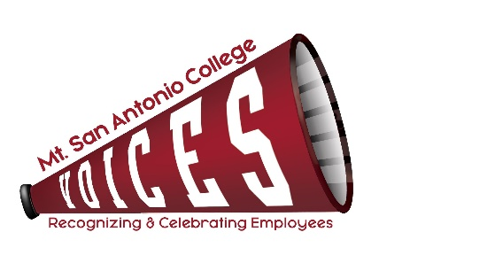
Agenda for July 12, 2022
12:30 to 1:30 p.m., Zoom Meeting

VOICES
X | Loralyn Isomura – Appointed by CSEA 262 | X | Ann Walker – Appointed by Faculty Association
X | Caitlin Rodriguez – Appointed by Classified Senate |  | Ignacio Flores – Appointed by CSEA 651(Co-chair)
X | Lizette Henderson – Acting Assistant Director, POD | X | Melissa Cone – Appointed by Confidentials (Co-chair)
X | Maribel Gonzalez – Appointed by Academic Senate | X | Desiree Marquez – Appointed by Management Steering
 | Julie Laverty – Appointed by the President
 |  |  | Guest:

ITEM | DISCUSSION | OUTCOME
Committee Membership | Welcome to Ignacio Flores, representing CSEA651! | Held for next meeting.
Minutes | Review May minutes | Minutes approved.
Employee Engagement for 2022 | “Friday Feel Good” – Employee appreciation Recap (Maribel, Ann, Caitlin, Melissa) | Employee Engagement for 2022
Way to Go, Joe! | Event Services to Nominate next department by Friday, July 15 (Loralyn) | Loralyn will follow up with Event Services for them to select the next recipient or VOICES Committee will vote.
May Shout Outs | Certificates to be created and sent | Desiree to create certificates, Melissa will email out.
Committee Goals and Progress Report | Review and submit outcomes/accomplishments for 2021-22 Progress Report (all, Melissa) | Outcomes/accomplishments were reviewed and approved to be reported.  Melissa will send to the President’s Office for PAC review.
College Champion Awards | Nominations open 6/16 – 7/14  Number of nominations received  Next steps:  Preparing certificates for nominees not selected with nomination details. | - 47 nominations received in total.  - Compiling nominations for Dr. Scroggins review.  - Preparing slides for President’s Office/Flex Day (due to Brigitte Hebert 8/5).  - Inviting winners to President’s Breakfast on August 19 and provide headcount to Carol Nelson for BOT Meeting on September 14.  - Order name plates and provide trophies to skilled craft. Need to be completed prior to September 14, 2022 board meeting.
VOICES Committee Member Projects & Events Timeline | Review and assign duties  Discuss new opportunities for employee recognition and engagement | Reviewed.
Website Update | Minutes  Shout Outs | Needs to be assigned.
2022-23 Meeting Dates & Times | Discuss Meeting Schedule and location (zoom or in-person) | Continue with zoom meetings due to committee preference and convenience.
Next Meeting | TENTATIVELY: Tuesday, August 9, 2022 – 12:30-1:30 pm – Zoom Meeting

TOPICS FOR FUTURE MEETINGS
Website
Repository
Award listing – descriptions of each award to be added
Use of Mt. SAC Social Media, Marquee, and tv screens across campus as additional outreach

