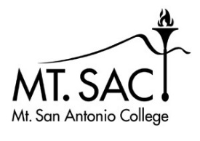 | Textbook & Instructional Materials Committee Meeting  Agenda, Oct, 21, 2021  (3:00 PM – 4:30PM, Zoom)

 | (Faculty) Kristina Allende |  | (Co-chair) Allie Frickert |  | (Co-chair) Romelia Salinas
 | (Faculty) Ellen Caldwell |  | (Faculty) Jenny Leung |  | (Student Services) Gabi Quiroz
 | (Faculty) Monika Chavez |  | (Bookstore) Suzanne Luetjen |  | (Student rep)  Susan Ramuco-Elicerio
 | Replacement for Tony Rivas? |  | (EOPS)Julie Marquez |  | (Student rep)  Chen Yu

Time Allotted | Item | Leader | Action Needed (discussion, decision, etc.)
5 min | Review minutes | AF | Approval of Minutes
15 min | SPEAC report (and inclusive access ”First Day” issue) | MC | Discussion
Remaining? | Finalize Goals  Vote to approve Mission and Goals | RS | Discussion and votes
Time permitting (10 min) | Bookstore info videos  The first is a General Demo video that is 3.30 min  https://www.youtube.com/watch?v=rTnuv7X63y8  The second focuses on how to adopt a textbook and its about 3 min  https://www.youtube.com/watch?v=d94J73pcoPs | AF | Record any questions for next meeting

