Headcount of full-time students at Mt. SAC
 | Male | Female | Total*
Fall 2019 | 5190 | 5199 | 10,524
Fall 2020 | 4470 | 5245 | 9,844
Fall 2021 | 4160 | 4394 | 8,678
*Note: Headcounts in the total column include students who have “unknown” or “other” as their gender status, therefore summing female and male headcounts will not equal the total headcounts.
Looking at the full-time student headcount data for the past three fall terms reveals two trends:
- The largest decline in full-time enrollment for males was from fall 2019 to fall 2020. There were 720 less full-time males in fall 2020 compared to fall 2019. For female students, there was an actual increase in full-time headcount for fall 2020 compared to fall 2019.
- When comparing fall 2021 to fall 2020, the largest decline in full-time headcount is for female students. There are 851 less full-time female students in fall 2021 compared to fall 2020. During this time, male full-time headcount also declined however not to the degree that it did for female students. In fact, the loss of full-time female students is greater in fall 2021 than the loss of full-time male students in fall 2020.
Decline in community college enrollment, particularly for male students, is a national and state trend, one that has been exacerbated by the pandemic.
- Nationwide, male enrollment in 2020 declined by nearly 7%. This decline was sharper for men of color (Black = 19.2% and Hispanic = 16.6%).
Sources:
  - https://nscresearchcenter.org/wp-content/uploads/CTEE_Report_Fall_2020.pdf
  - https://www.communitycollegereview.com/blog/declining-enrollment-and-the-widening-gender-gap)
  - https://www.latimes.com/california/story/2021-04-12/california-community-college-enrollment-plummets-amid-covid
  - https://www.the74million.org/article/new-data-sharp-declines-in-community-college-enrollment-are-being-driven-by-disappearing-male-students/
  - https://www.chronicle.com/article/the-missing-men
The decline in male enrollment at Mt. SAC in fall 2020 has followed state and national trends. There are several theories as to why the pandemic has disproportionately impacted men compared to women. These include:
- Gender and cultural roles - male students forced to take on jobs to help the family during the pandemic. The work of J. Luke Wood and Frank Harris has explored the issue of masculinity and being a college student.
- Males had a harder time transition from on-campus classes to online classes – less access to technology, and less willing to take online classes.
- Gender make up of certain fields of study could have also impacted enrollment during the pandemic. Are the majority of students in programs like, Aeronautics, Air Conditioning & Welding, Aircraft Maintenance Tech, Electronics & Computer Tech, and Public Safety programs, etc. male? If so, the transition of these programs to remote learning could have impacted students’ decision to stay enrolled, especially if there is a propensity for not wanting to take online courses.
- Source: http://laschoolreport.com/new-data-sharp-declines-in-community-college-enrollment-are-being-driven-by-disappearing-male-students/

There is very little empirical evidence on this topic, and the possible reasons listed above are theories and or anecdotal. There was one small national survey that went out to current, former, and would-be community college students in December 2020. In the post below (linked), the authors took a deeper look at men who were enrolled in community college in spring 2020 but did not enroll in fall 2020.

Source: https://www.newamerica.org/education-policy/edcentral/where-did-all-the-community-college-students-go-2/

Results showed that a higher proportion of men compared to women reported having to work, feared the safety of taking classes in person, didn’t want to take classes online, and didn’t have access to internet or technology to take online classes.
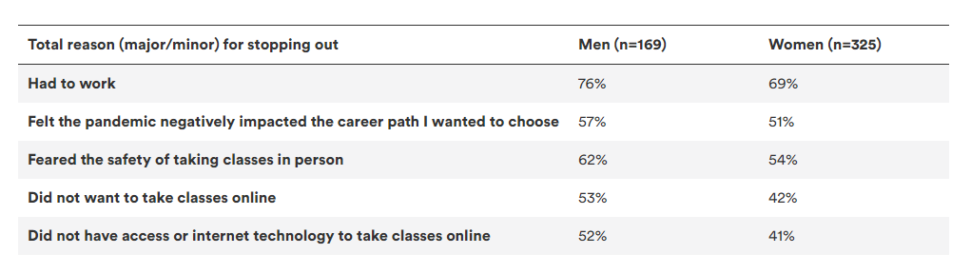

A higher proportion of men of color reported having to work compared to White men, had greater overall uncertainty due to the pandemic, greater health issues, and fewer wanted to take online courses.

