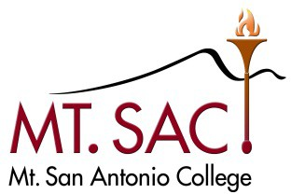

DATE: September 22, 2021

TO: College Committees and Selected College Programs FROM: Bill Scroggins, Ph.D., President/CEO
SUBJECT: PLANNING FOR 2021-22

The President’s Advisory Council (PAC) seeks to maintain a systematic mechanism for documenting and reviewing the important work taking place at committee and program levels. We want to reflect this work in our reporting of institutional effectiveness. As a result, we are asking that each committee consider how the work of the council/committee contributes to moving us towards reaching college-wide goals. As a college we are making particular efforts this year to examine all of our work with an equity lens and to make commitments to address issues that will increase equity. Therefore, in addition to connecting the work of your council/committee to college goals you are asked to speak how the council/committee will address equity in the work of the committee. Each council/committee is required to complete the following:

- Purpose and Function Statement. Your committee’s latest PAC-approved Purpose and Function Statement is attached to this email. Please make changes directly to this file using strikethrough for deletions and bold and underlined for additions. DO NOT use track changes. The purpose, function, and membership of council/committees which report to PAC cannot be changed without approval. If your council/committee believes that changes are warranted, they need to be recommended during this annual review process. Committees which report to Senate must get Senate approval to change your purpose and function statement or add/delete members to your committee.
- Committee Goals and Progress Report. Use the attached template to document the goals and accomplishments that your committee/program worked on this year. [In fall you are asked to set goals for the year, and in late spring you will be asked to reflect on these goals and report your accomplishments.] You will note the first Goal has been completed for you. To comply with Accreditation Standards, your College committee website needs to be maintained and kept up-to-date. PAC encourages your group to be thoughtful with its goals. The College continues to use its goals and College mission, vision, and core values https://www.mtsac.edu/about/mission-and-goals.html to drive planning. The attached goals have been reviewed and approved by the Institutional Effectiveness Committee (IEC), PAC, the College President, and the Board of Trustees. Also, if you have received recommendations from PAC to revise or add other goals, please do so on this form.

Please submit your completed documents to Brigitte Hebert (bhebert3@mtsac.edu) and the manager responsible for the program or respective council using the attached templates. Please see the due dates below.

Form | Due Date
Purpose and Function Statement Review | November 5, 2021
Committee Goals and Progress Report – Columns 1 and 2 | November 5, 2021
Committee Goals and Progress Report – Column 3 | June 3, 2022

Strategic Plan Goals

- Advance and foster an equitable, diverse, inclusive, just, and anti-racist campus culture that empowers our community to make positive change in society.
- Further develop, facilitate, and maintain a physically and emotionally safe and accessible campus environment.

- Develop and expand strategies for and communication about opportunities for students that support retention, persistence, and success.

- Effectively coordinate human, physical, technology, and financial resources to improve student accessibility, growth, and academic success.

- Embed environmental, social, and economic sustainability into the work and decision-making processes of all areas of campus.

- Ensure open and authentic communication and coordination among stakeholders to support achievement of all college goals.

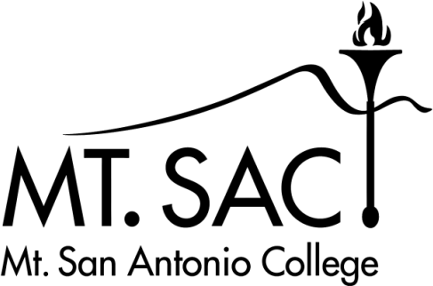
Committee Goals and Progress Report 2021-22

Committee name: Assessment & Matriculation

Name of person completing the report: George Bradshaw
Instructions: Due by November 5, 2021: Columns 1 and 2
Due by June 3, 2022: Column 3
Please enter your committee’s outcomes and accomplishments in Column 3 and submit electronically to bhebert3@mtsac.edu (on behalf of the President’s Advisory Council).
(EXPAND AS NECESSARY)

Committee Goal |  | Link to College Goal # | Completed Outcomes/Accomplishments (descriptive bullet list)
GOAL # 1: | Keep committee website up- to-date | 6 | Committee website was last updated 5/11/22.  - In addition to general information, new and continuing committee member have easy access to the previous minutes, current agendas and other documents.
GOAL #2: Review College practices to ensure that state policies and guidelines regarding assessment and matriculation are being followed. |  | 1, 4, 6 | - The Committee reviewed the current legislation related to AB 705 and AB 1705 as well as statewide best practices related to equitable placement and responded in the following ways:  - Editing AQ website to include more positive and encouraging language.  - Committee members attended CCCCO webinars for updates related to AB 705 throughout the academic year.  - Committee edited the AQ and appropriate campus websites to reflect the new mandates eliminating non-transfer level math and English coursework.  - Committee reviewed draft language developed by Instruction and Student Services related to Equitable Placement and Completion: English and Math Validation of Practices and Improvement Plans.  - ESL Adoption Plan submitted to the CCCCO (Credit ESL/AMLA).
GOAL #3: Recommend refinements to the assessment and placement processes, including special populations, such as special admit students, English Language Learners, students with disabilities, and students with high school equivalencies. |  | 1, 3, 4, 6 | - Added AMLA 1A to the Assessment Questionnaire.  - Modified AQ admin form to collect AMLA recommendations.  - Improve the AQ documentation making it accurate and relevant for continuing as well as incoming student populations.
GOAL #4: Review internal and external research related to assessment and matriculation. |  | 1, 3 | - Developed, collected and summarized the campus wide AB-705 survey and widely distribute across the campus community.
GOAL #5: Submit research requests related to assessment and matriculation, with a focus on equity. |  | 1, 3 | - Continue to review and consider data related to grade distribution and completion rates disaggregated by ethnicity and gender. Provide input where appropriate.  - Submitted research request to find out throughput for our students and their success in English 1A and English 1C, how successful AMLA students are, how many AMLA are getting through the sequence, regardless of delivery mode, how many are taking our reading classes, and if these classes lead to increased chances of success.  - Reviewed the number of students took recommended courses (recommendation from AQ and GSP facilitator).  - A subgroup was formed to work on retroactively giving students eligibility for AMLA 1A, if they took the AQ prior to October 12, 2021 (when AMLA 1A placements were added to the AQ).
GOAL #6: Review updates regarding orientation, educational planning, counseling, and follow-up. |  | 2, 3, 4, 6 | - Reviewed other college websites for model practices related to matriculation guidance that is engaging and informative.  - In conjunction with Counseling provided input to new online Orientation that features an interactive approach to providing information to matriculating students.
GOAL #7: Review and provide input on Chancellor’s Office forms and reports regarding assessment and matriculation. |  | 6 | - The Committee reviewed the draft version of “Equitable Placement and Completion Improvement Plan” and was in support of the draft version.
GOAL #8: Review and provide feedback about College’s Student Equity Plan and other initiatives as they relate to assessment and matriculation. |  | 1, 3, 4 | - Provided feedback to the campus’ leadership about the 1 year throughput model that the CCCCO uses to assess student success with regard to transfer level completion of ENGL and math. Many of our “at-risk” student populations were adversely affected by COVID-19 and thereby found it difficult to stay on the 1 year completion track.  - Provide quarterly updates related to the AB-705 implementation to the campus leadership.

