  Mt. San Antonio College  Outcomes Committee  Minutes | September 3, 2024  2:00 pm -3:30pm – Zoom

Membership
X | Kelly Coreas, Co-Chair  Professor, Respiratory Therapy | X | Chris Jackson, Co-Chair  Professor, Kinesiology |  |  | Michelle Sampat, Co-Chair  Dean, Arts |  | X | Annel Medina Tagarao  Edu Research Assessment Analyst
 | Fawaz Al-Malood  Associate Dean, Business | X | Aida Cuenza-Uvas  Director, AANAPISI |  |  | Jared Burton  Professor, Library Science |  | X | Christina Cammayo  Professor, Nutrition & Food
X | Landry Chaplot  Professor, Adult Basic Education | X | Amy Nakamura  Professor, Dance |  |  | Daniel Ozan  Professor, Kinesiology |  |  | Vacant  At-Large Faculty
 | Vacant  At-Large Faculty |  | Vacant  At-Large Faculty |  |  | Vacant  At-Large Faculty |  |  | Vacant  Associated Students
X | Tiffany Kuo - Guest | X | Tania Anders – Guest
 | Topic |  | Updates/Discussion |  |  |  | Outcome/Action
 | Welcome and Introductions |  | - All members were welcomed back to the group  - Members and guests introduced themselves to the group |  |  |  | - New members will be approved in Senate on Thursday
 | Review of agenda |  | - Agenda was reviewed |  |  |  | - Approved
 | Review of May 21, 2024 Minutes |  | - Minutes were reviewed |  |  |  | - Approved
 | Review of June 4, 2024 Minutes |  | - Minutes were reviewed |  |  |  | - Approved
 | President’s Award |  | - Student and Academic Support – Title V Team  - Career and Technical Education – Tech Ed Resource Center  - Skill Development – Sign Language and Interpreting Department  - Personal, Social, Civic, and Environmental Responsibility – Grounds Team |  |  |  | - Awardee information will be updated on website  - ILO focus for 24-25 will be Critical Thinking
 | Purpose and Function Update |  | - 23-24 Purpose and Function Statement  - The Academic Senate has asked that we add elements of the California Community Colleges Vision 2030 into our Purpose and Function statement  - Review and discuss next meeting |  |  |  | - Committee members will review this information in preparation for the next meeting
 | 24-25 Goals |  | - 23-24 Goals  - 24-25 ILO Focus: Critical Thinking  - Review and discuss next meeting |  |  |  | - Committee members will review this information in preparation for the next meeting
 | Membership for 24-25 |  | - Committee appointments for 24-25 were reviewed and confirmed as correct
 | Canvas/ Nuventive Integration |  | - Pilot fall 2024 to allow for disaggregation of outcomes data at the assessment level. This is an easy way to identify equity gaps and spark discussions and action within departments.  - Goal: start with a small sample of courses. 20 sections with direct and indirect assessment on Canvas. At least 5 different courses  - Timeline:  - Pull demographic data after drop date  - Develop indirect assessments for use on Canvas and determine pilot participants by the end of the last week of September  - Participants to add the assessment by last week of October  - Participants to assess by last week of November  - Committee members were asked to participate  - Aida updated the committee regarding disparities of disaggregation of data within Asian groups |  |  |  | - Committee members who want to participate in the pilot are:  - Kelly and Tiffany  - Co-Chairs are scheduling meetings with Nuventive soon
 | Development of indirect assessments for use on Canvas |  | - Committee members were asked to think of indirect assessments that can be used in Canvas |  |  |  | - Committee members will be prepared to discuss this at our next meeting
 | SLO worksheet |  | - Microsoft Forms version  - Practice survey just for fun!  - 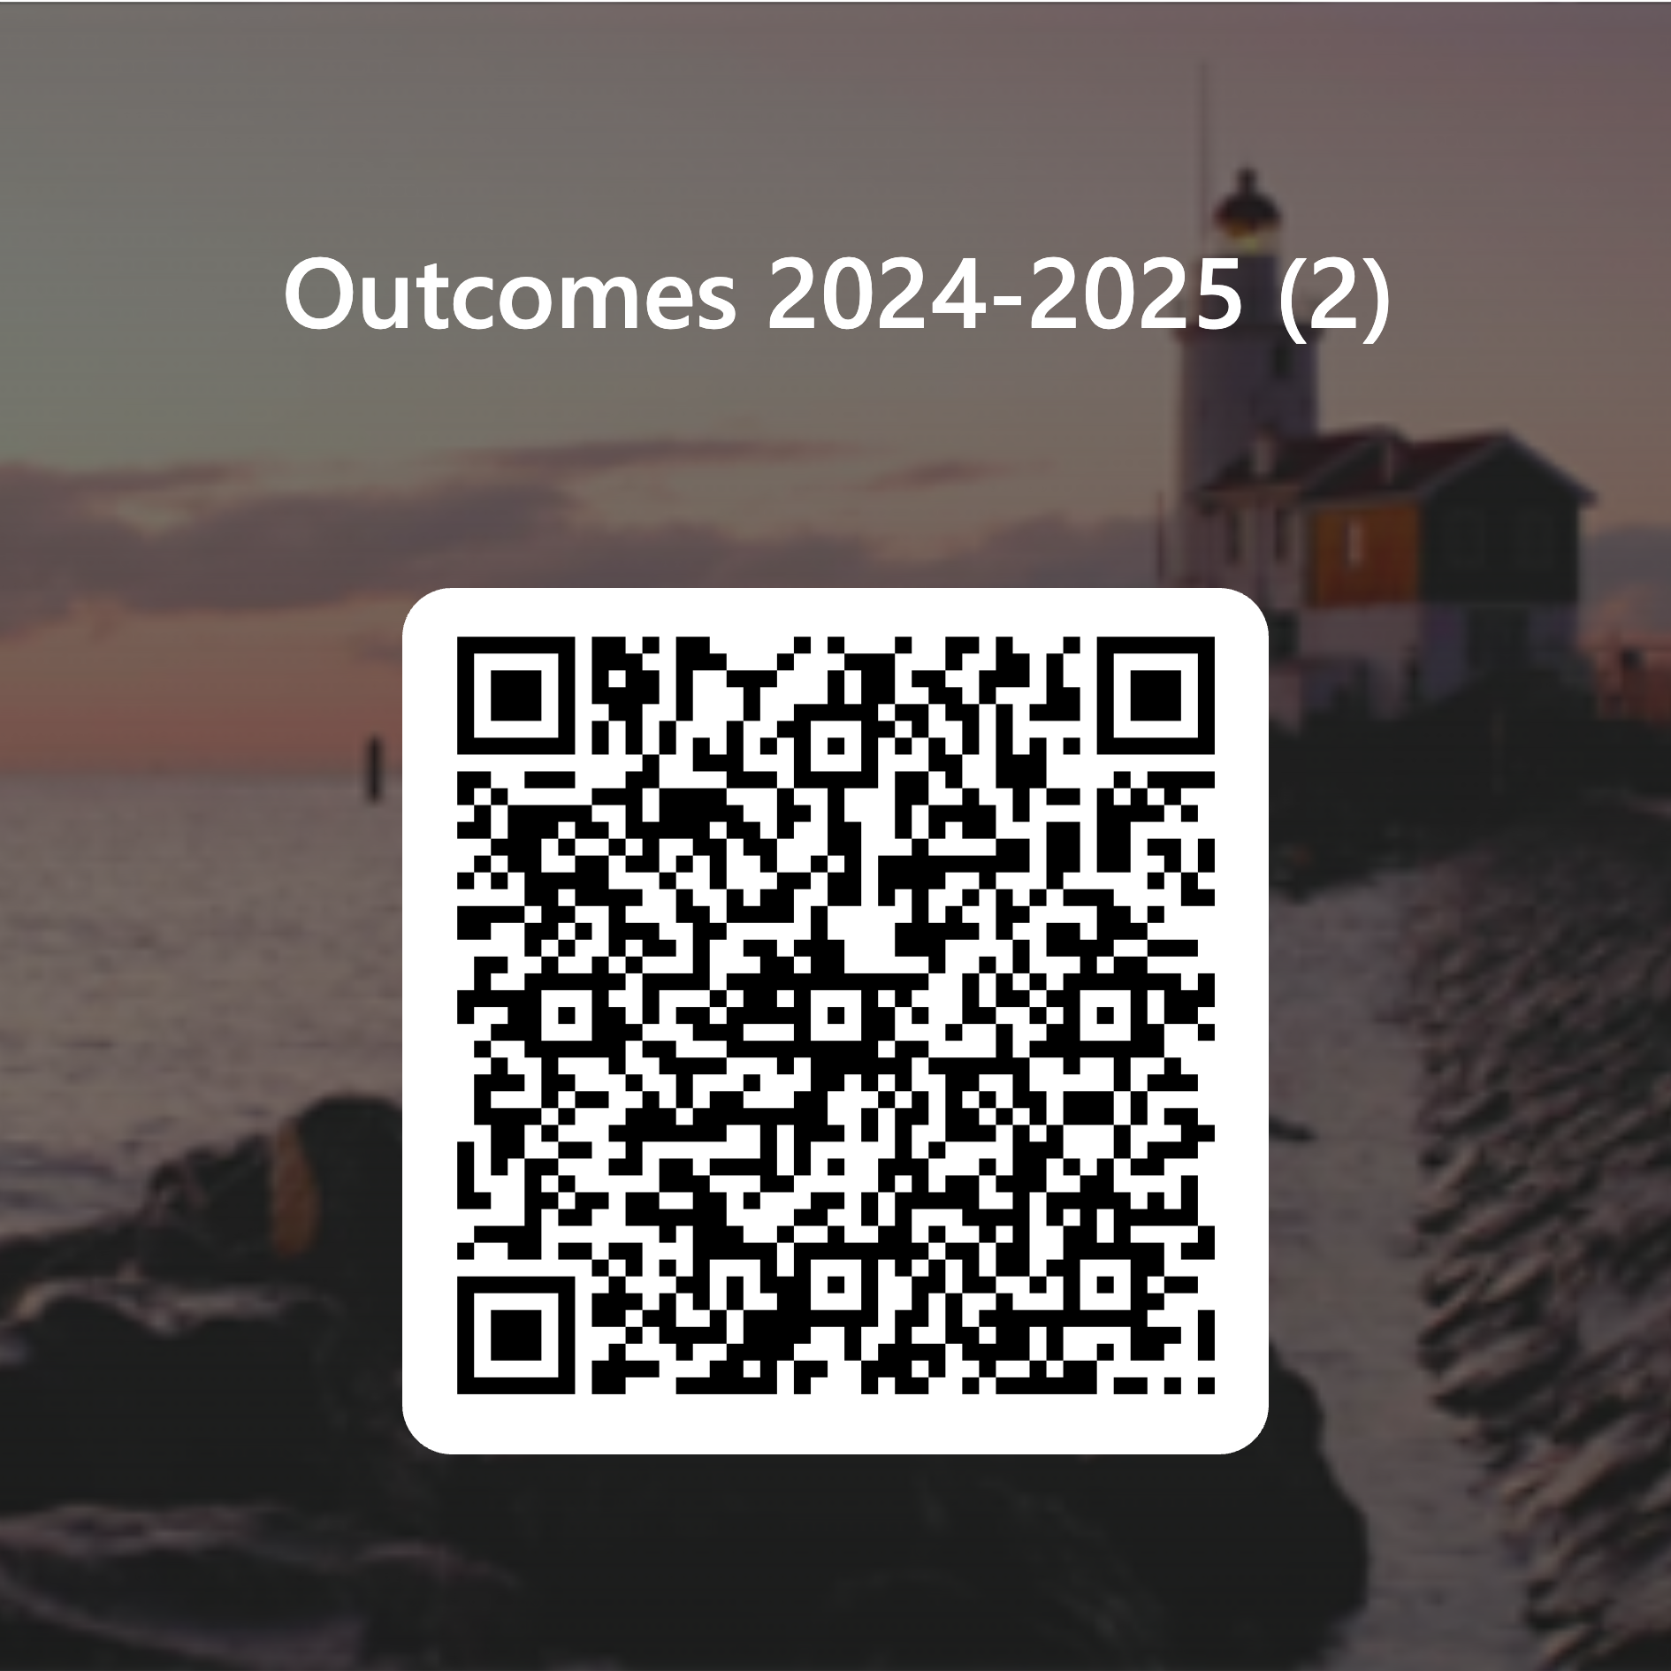  - Can we use Qualtrics?  - Smartsheet requires access  - No google forms |  |  |  | - Annel will create a Qualtrics option for this worksheet
 | PLO Update |  | - What assessment methods should be included?  - Summary of SLO results  - Student survey  - Standardized test  - Portfolio  - Project  - Other  - Employer survey  - Board exam results  - Job placement  - Transfer  - Capstone project (examples in parenthesis)  - Certificate completed (# of completers)  - Mostly higher level assessments – with a section where they could add more specific information  - Can we ask IT what assessment methods are being used for PLOs?  - AB 928 – more students on a degree path – how do we assess all of these students?  - How do programs that do not have cohorts assess data?  - What are the requirements for PLO? They can be assessed every year (ideally at least every two years since this is a two year institution). Requirement is every 6 years. |  |  |  | - Co-chairs will follow up with IT
 | Unit Outcome Update |  | - What is considered a unit? Anything that does not have a SLO,PLO, ILO |  |  |  | - Plan to schedule a meeting soon
 | Fall 2024 Committee Book Club |  | - From Equity Walk to Equity Walk: Expanding Practitioner Knowledge for Racial Justice in Higher Education by Tia Brown McNair, Estela Mara Bensimon and Lindsey Malcom-Piqueux |  |  |  | - Still waiting to receive books
 | Thank You and Homework |  | - Please be prepared to discuss the following at our next meeting:  - Purpose and Function Statement  - 24-25 goals at our next meeting  - Indirect assessments on Canvas
 | Parking Lot/Upcoming Topics: |  | - Future Meetings:  Fall 2024 – 1st & 3rd Tuesday 2 – 3:30 pm  September 17th  October 1st  October 15th  November 5th  November 19th  December 3rd |  |  |  | Important Dates:  - COACHes Friday SLO Talks  - Schedule  - Registration  - COACHes SLO Symposium Jan 24 & 25, 2025  - Online
Standing Information:
Outcomes Website
Outcomes Email
Outcomes Help Request
Zoom Office Hours
- Mon 1:00 pm – 2:00 pm
- Tues 9:00 am – 10:00 am

