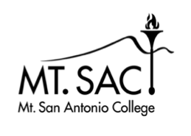

Committee Goals and Progress Report
2019-20

Committee name: Curriculum and Instruction Council

Name of person completing the report: Kristina Allende

Instructions: Due by October 1, 2019: Columns 1 and 2
Due by June 1, 2020: Column 3
Please enter your committee’s outcomes and accomplishments in Column 3 and submit electronically to bhebert3@mtsac.edu (on behalf of the President’s Advisory Council).

(EXPAND AS NECESSARY)

Committee Goal |  | Link to College Goal # | Completed Outcomes/Accomplishments  (descriptive bullet list)
GOAL # 1: | Committee website up-to-date | 6, 11, 14 | Committee website is up to date.
GOAL #2: | Review and recommend changes to APs and BPs related to curriculum and instruction. | 1 | Reviewed AP 4020 and AP 4051
GOAL #3: | Review processes and guidelines and make recommendations regarding program and course development and approval. | 1 | Recommended to Academic Senate a change to the curriculum review process. The proposal is to move to a 5-year course and program review process.
GOAL #4: | Monitor and evaluate the curriculum reporting structure coding of courses and programs. | 14 | Reviewed EDC minutes relating the results of the code alignment project for courses and programs.
 | GOAL #5: Integrate sustainability, equity, and consideration of Guided Pathways into committee discussion about curriculum. | 9 | Integrated Guided Pathways mapping tool into WebCMS 10.0.  Discussed sustainability in the approval of the Geotech program and courses.

