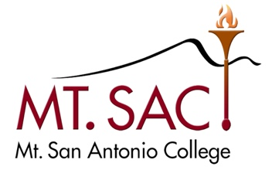

CURRICULUM & INSTRUCTION COUNCIL
November 27, 2018 Agenda
Building 4-2440
3:30 P.M. – 5:00P.M.

Kristina Allende, Co-Chair
Madelyn Arballo, Continuing Education
George Bradshaw, Admission & Records
Jamaika Fowler, Articulation Officer
Carol Impara, D.L. Coordinator
Joumana McGowan, Assoc. VP Instruction
Dana Miho, Faculty
Martin Ramey, Academic Senate President
Dianne Rowley, Assist. Curriculum Liaison
Michelle Sampat, Co-Chair
Om Tripathi, Faculty
Chesa Uyeki, Senate VP
Emily Woolery, Outcomes Coordinator
Vacant, Student Representative

Meeting Agenda | Outcomes
- Approval Minutes
November 13, 2018
- Public Comments
- Information
- Acceptance of Minutes
- Distance Learning Committee Minutes
- October 23, 2018
- Educational Design Committee Minutes
- November 13, 2018
- November 20, 2018
- November 27, 2018
- Equivalency Committee Minutes
- Outcomes Committee Minutes
- October 16, 2018
- November 6, 2018
- Transfer and General Education
Subcommittee Minutes
- Content Review Committee Minutes
- New or Substantive Program Changes
- New Courses
- KORE 1 Elementary Korean – Part of World Language and Global Studies AA
- GERM 60 German Culture through Cinema - Part of World Language and Global Studies AA
- SPAN 50 Spanish of the Barrio: A Socio-linguistic Prespective - Part of World Language and Global Studies AA
- New Stand-alone courses
- Course Disciplines
- Course Unit change Report
- Items for Discussion or Action
- On Hold Items

2018-19 Meetings  3:30-5:00  2nd & 4th Tuesdays | Fall 2018  September 11 & 25  October 9, 23 | November 13 & 27  December 11, | Spring 2019  March 12 & 26 | April 9 & 23  May 14 & 28 | June 11

