g
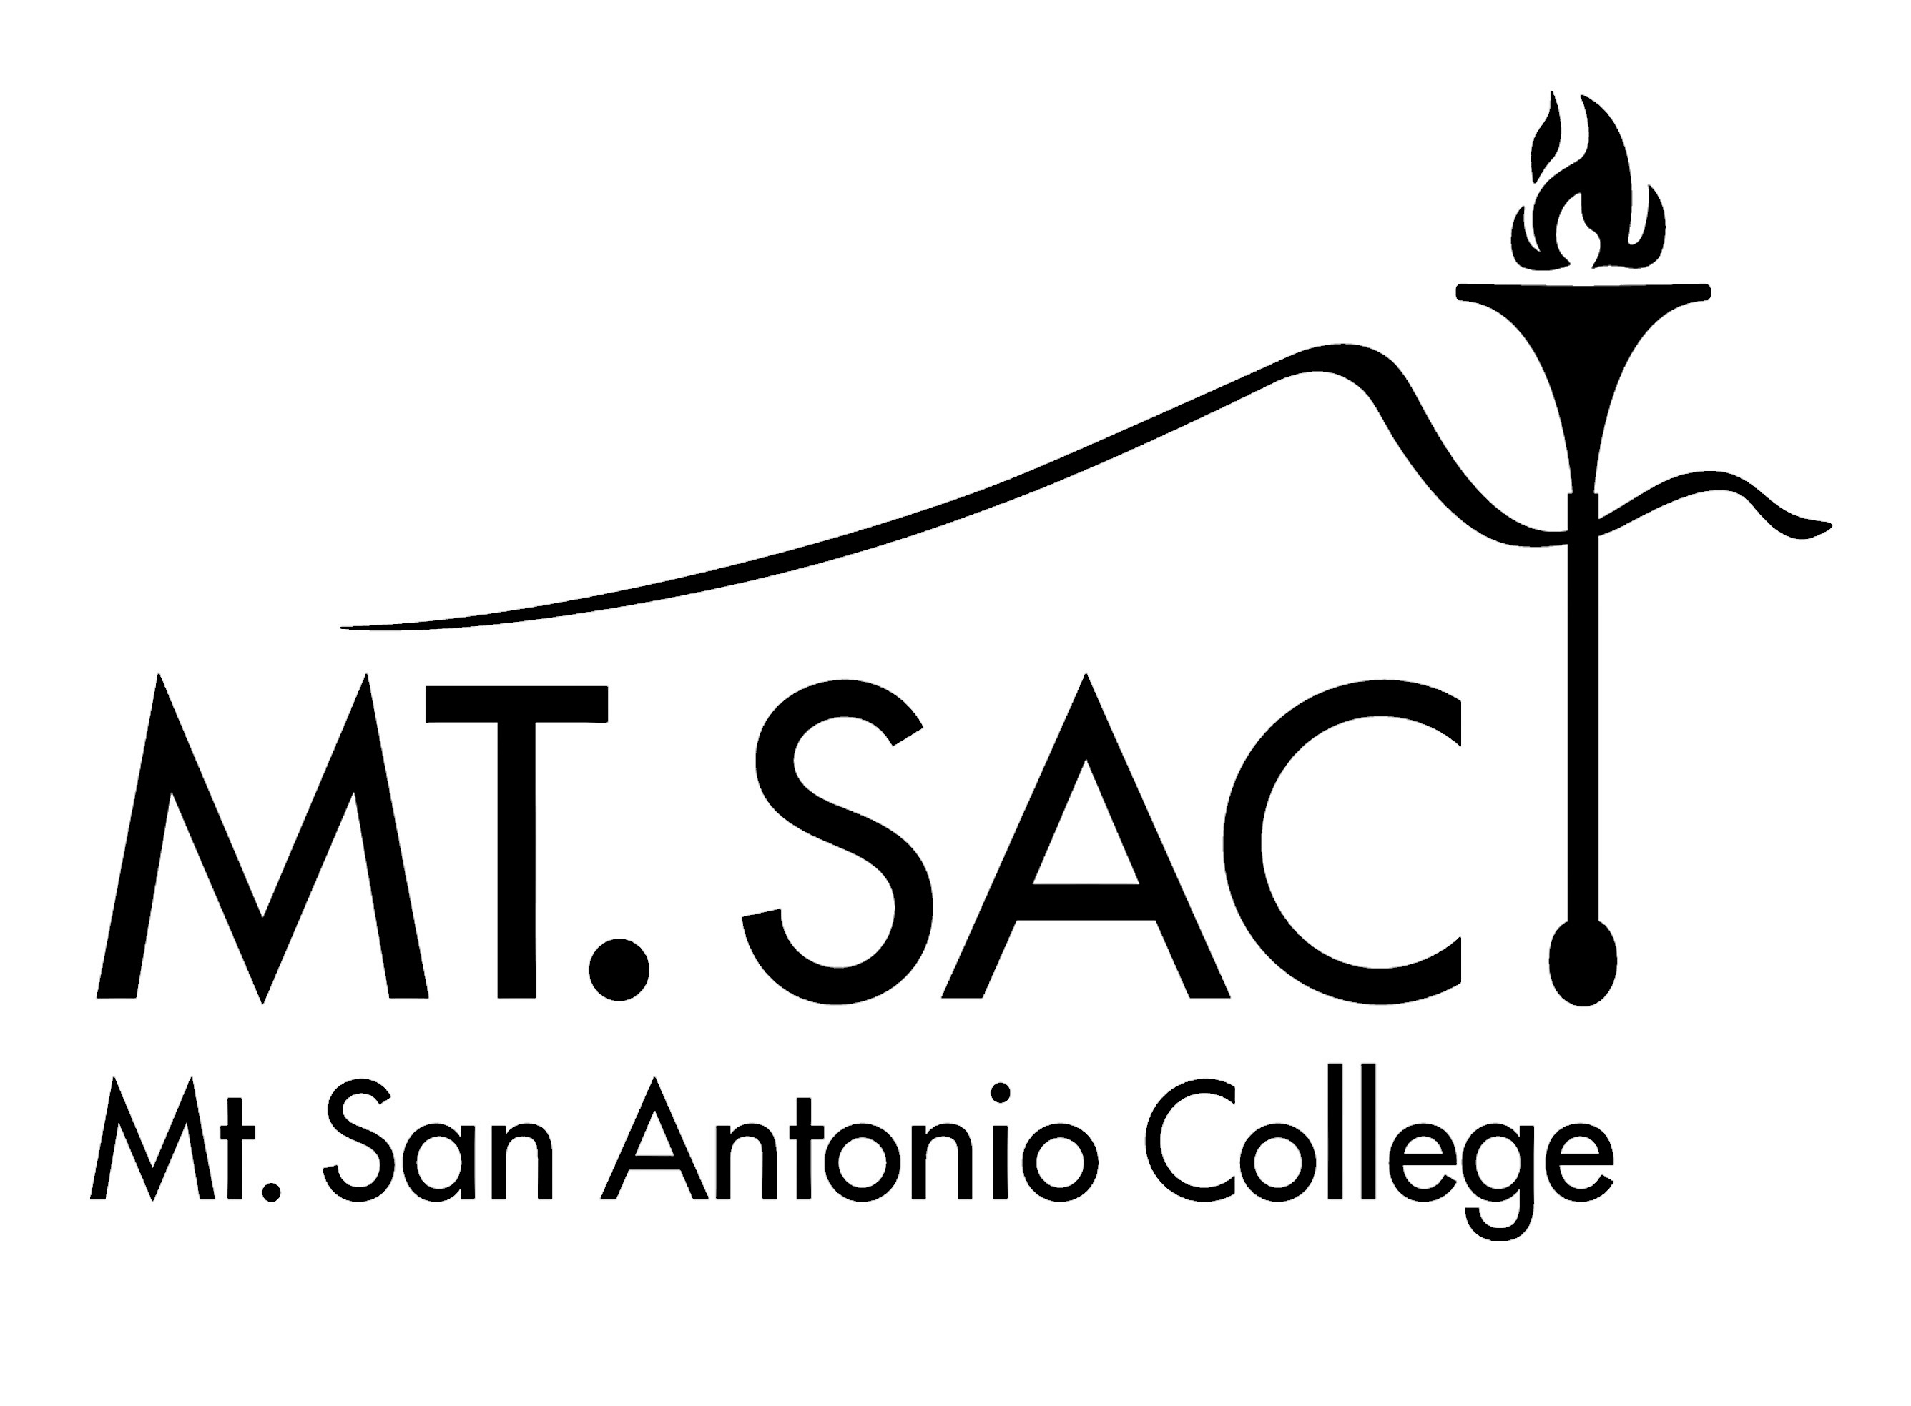
Academic Senate
http://academicsenate.mtsac.edu
(909) 594-5611 Ext. 5433

Minutes
Academic Senate Meeting
December 8, 2011

Present: Barry Andrews, Jeffrey Archibald, Janna Brink, Glenda Bro, Holly Cannon, Kate Cannon, Michael Dowdle, Ralph Eastman, Tom Edson, Tim Engle, Edwin Estes, Kelly Ford, Jennifer Galbraith, LeAnn Garrett, Jennifer Garwick, Kamran Golestaneh, Barbara Gonzales, Michelle Grimes-Hillman, Scott Guth, Dirk Hagner, Laurie Hartman, Lance Heard, Alina Hernandez, Luisa Howell, Jonathan Hymer, Bonnie Jeffers, Eric Kaljumagi, Akram Khan, Paul Kittle, Erica Ledezma, Max Lizarraga, Richard McGowan, Beta Meyer, Amy Nakamura, Monique Neel, Jennifer Peiten, Sarah Plesetz, Liesel Reinhart, Michelle Sampat, Hector Sanchez, Michael Sanetrick, Dan Smith, April Tellez, Antoine Thomas, Rebecca Walker, Liz Ward, Kathy Watanabe, Kisha Williamson, Paula Young Tina Ziolkowski.

Absent: Ema Burman, Jason Chevalier, Kelly Coreas, Marlene Gallarde, Vicki Greco, Tamara Karn, Martin Mason, Sam Nassar, Charlie Newman, Robert Rogus, James Stone, Lance Wilcher.

Guests:

- Call to Order: The meeting was called to order at 11:35am.
  - The C & I Report was pulled from the Consent Agenda.
- Consent Agenda: A Motion to Approve the Consent Agenda as amended was made, seconded and approved unanimously.
  - Approval of Minutes – November 17, 2011
  - Approval of C & I Report – November 17, 2011 – Pulled from Consent Agenda; see Action item A.
  - Variances and Course Substitution Task Force Appointments: Will Daland, Terri Faraone, Jamaika Fowler (chair), Robert Ho, Jennifer MacDonald, Tuan Vo
  - Behavioral Intervention Teams Task Force Appointments: Lane Braver, Gina Carlson, Tim Engle (chair), Alina Hernandez, Nancy Meggelin, Karen Schnurbusch, Kisha Williamson
  - AA Degree in Liberal Arts and Sciences with an Emphasis in Kinesiology and Wellness Task Force Appointments: Jamaika Fowler, LeAnn Garrett, Ron Kamaka, Jean Metter, Shane Poulter, Doug Todd (chair), Nan Shea
- Public Comment: Paul Killte noted that the Elearn server will be retired from service at the end of the month. All faculty with material stored on the server should remove it before December 31.
- Officer Reports
  - President:
    - Academic Mutual Agreement Council:
      - AMAC met on 14 and 28 November. On the 14th we provided the district with Resolutions 11-11 (Foundation Support for Campus Programs), 11-12 (Economic and Transfer Impact of PE and Arts) and 11-13 (Process to Adopt C-ID Numbering). All of these resolutions have been referred to President’s Cabinet for discussion. We also presented the Catalog Task Force recommendations on the 14th, which were then accepted by the College on the 28th. Thus, we are expecting a mid-year online addendum to the College Catalog.
      - In addition, we discussed the EEO Plan, catalog quality control issues, program discontinuance protocols, the reassignment of credit courses to fee-based noncredit, our enrollment management plan, and proposed changes to the Use of Facilities policy. AMAC will next meet on 12 December.
    - President’s Advisory Council: PAC met on 7 December. Details of this meeting will be in my next report.
    - Institutional Effectiveness Committee: IEC met on 23 November and completed its work summarizing the Planning for Institutional Effectiveness (PIE) materials for inclusion in the campus’s Strategic Plan. These documents have been forwarded to PAC for consideration at its 7 December meeting. IEC also met with the Outcomes Committee on 29 November to discuss a potential new College goal. Much of the meeting was spent discussing the extent to which SLO planning should affect unit funding and support requests, and the potential “carrots” or “sticks” that may become necessary. The College timeline requires that at least 75% of all programs and courses have completed at least one SLO assessment cycle (including “use of results”). Further, Accreditation Standard II requires us to be “proficient” at using SLOs in a number of ways by the end of this academic year.
    - Equivalency Committee: The Equivalency Committee met on 28 November and recommended a new Board Policy on equivalencies. We also recommended an equivalency for Respiratory Technologies to C & I. Proposals from Photography, Art, Emergency Medical Technologies, and Interdisciplinary Studies were returned. The Equivalency Committee will next meet on 26 March.
    - Coordinator Positions Available: The Academic Senate is in the process of seeking coordinators for Fall 2012. The only available position this year is Study Abroad Coordinator. Letters-of-interest are due to the Academic Senate President by 12 December 2011.
    - Hayward Award for Excellence in Education: Information regarding the State Academic Senate’s Hayward Award for Excellence in Education was sent to all faculty via email on 14 November. No one from Mt. SAC applied this year.
    - Faculty Hiring: Dr. Scroggins has announced that a minimum of thirteen positions will be authorized for faculty recruitment, although not all of these recruitments will begin right away. Faculty are reminded that all retirements announced by the end of the fall semester will be considered for replacement. This is not guaranteed for retirements announced later in the year.
  - Vice President: There was no report.
- Legislative Liaison: (ASCCC Delegate): Student Success Task Force Recommendations: The final meeting of the SSTF was held yesterday. The recommendations will go to the Board of Governors in January, and submitted to the state legislature in March. While several changes requested by faculty are reflected in the latest document, recommendation 8.3 still seems to allow for performance-based funding. This is opposed by faculty.
- Faculty Association:
  - Faculty Association Newsletter: The first issue of the FA Newsletter was sent to all faculty via email and put in all faculty mailboxes on November 30. Several faculty have contacted the Faculty Association indicating that they liked the newsletter. It is the intention to send a newsletter at the beginning and end of each primary term.
  - Reopener Negotiation Survey: The Faculty Association did the negotiations survey via the faculty portal this year. All faculty sould have been able to access the survey via the portal. The return rate was approximately 19%. The results have been sent to the Executive Board for them to discuss at their next meeting, and then give direction to the FA Negotiations Team.
  - FA Negotiations Team: The FA is going to have a three-person negotiations team during reopener negotiations. This year President Galbraith appointed Paul Sharpe, Michelle Grimes-Hillman and herself to the negotiations team. The Executive Board approved of these appointments at their last meeting.
  - Cameras on Campus: At the last Representative Council meeting the Representatives approved a position paper that states that the Faculty Association believes that the District funds could be better spent and does not support the installation of cameras into old or new buildings on the campus. The Representatives also approved a motion that directs President Galbraith to make the Board of Trustees aware that important decisions about what occurs on campus are being made without going through any type of shared governance procedure.
  - Overload and Intersession Pay Dates: The Representatives voted to have the overload and intersession pay dates stay with the pay dates that are used for full-time faculty. Therefore, full-time faculty will continue to receive on pay check that includes both regular and overload pay.
  - Appendix E Reassigned Positions: Vice President Burley and Jennifer Galbraith will be sending out a letter to all coordinators, department chairs, and deans that announces the retirements for review of Appendix E positions. The requests for new and the review of existing positions will be sent next week, and will require the return of information by the end of the third week of the Spring semester for negotiations this year.
  - Board of Trustees Redistricting: A survey recommending electing members from defined districts rather than At-Large was completed. The survey also examined whether to have a five or seven-member Board.
- Associated Students:
  - Associated Students met on November 29. Among the most controversial topics was the possible adoption of a system-wide enrollment procedure, which concerned students because it affects their registration dates.
  - The November 30 Holiday Event was a great success, with 200 students attending.
  - The A.S. decided to leave the Student Senate of California Community Colleges, due to various actions carried out by that body.
- Council/Committee Reports
  - Curriculum and Instruction:
    - Committees
      - Distance Learning: Minutes: October 25, 2011.
      - Educational Design: Minutes: October 25, November 1 and November 8, 2011.
      - Educational Design Sub-committee for General Education and Transfer Issues: No report.
      - Equivalencies: No report.
      - Outcomes: Minutes: October 18 and November 1, 2011.
    - Information
      - New fee-based course offerings – Winter/Spring 2012 (a handout was distributed)
      - SLO Report 2010-11 (a handout was distributed)
      - SLO Update (a handout was distributed)
    - Consent:
      - Distance Learning 2011-12 Goals (a handout was distributed)
      - EDC 2011-12 Goals (a handout was distributed)
      - Noncredit Tutor Training Certificate (a handout was distributed)
      - Disciplines List – SOC and ANIM (a handout was distributed)
    - Action:
      - ANIM 167 Visual Development for Animation (3 units): Development of visual concepts and storytelling for entertainment illustration through use of value, design, color and composition as symbolic tools for communication. Artistic growth is encouraged through a series of critiques and demonstrations. Students cannot receive credit for both ARTC 167 and ANIM 167. Cross-listed with ArtC 167:
      - ARTC 167 Visual Development for Illustration (3 units): Development of visual concepts and storytelling for entertainment illustration through use of value, design, color and composition as symbolic tools for communication. Artistic growth is encouraged through a series of critiques and demonstrations. Students cannot receive credit for both ARTC 167 and ANIM 167.
      - ARTC 163 Dynamic Sketching (3 units): Essential tools to conceptualize, communicate, and express creative ideas dynamically through the art of sketching. Emphasis on problem solving through the sketching process for illustrators, animators, entertainment designers, and fine artists.
      - WELD 91L Automotive Welding, Cutting and Modification Lab: Practical lab applications for sheet metal forming, metal inert gas (MIG), tungsten inert gas (TIG), resistance spot (RSW), and Oxy-fuel welding, plasma arc cutting (PAC) and Oxy-fuel cutting. Includes design, fabrication and assembly of automotive suspension and chassis components.
  - Student Preparation and Success Council Report:
    - Reports
      - Assessment & Matriculation: The committee has had numerous discussions regarding the Student Success Task Force recommendations. Members of the committee feel that many of the proposals are highly problematic and take issue with some of the statements in the document. Particularly, statements that seem to indicate that faculty and staff do not place student success at the forefront of their work with students. The Student Preparation and Success Council will review the committee’s comments and use them in developing a Council response to the Taskforce recommendations.
      - Basic Skills Coordinating Committee: The committee continued its discussions regarding the Student Success Task Force recommendations. The committee Co-chairs are in the process of summarizing the committee’s recommendations. The completed document will be forwarded to SP&S. The Council will review the committee’s responses and use them in developing a Council response to the Taskforce recommendations.
    - Information:
      - Progress towards the completion of the Degree Works project was discussed. A number of departments have not sent in the requested equivalency information. Academic Senate asked that the instructional deans contact these departments.
      - AP 5055 “Enrollment Priorities” was discussed at length. Specifically, the council discussed changes to sections of the policy relating to members or former members of the armed forces.
    - Consent
      - Mandatory intervention for all first time probation students: In 2007-08, Board Policy 4250 and Administrative Procedure 4250 were passed by the Academic Senate and adopted by the College. In the AP is the statement: "Restriction on Enrollment: Upon recording of probation students shall have their registration restricted, be required to participate in a prescribed counseling intervention and be limited to enroll in a maximum of 12 units in subsequent semesters." Counseling and IT have worked together to automate an online success workshop interface with Banner. Programming has been completed and the process was tested fall 2011. Below is the resulting intervention process:
To fulfill AP 4250 counseling department faculty have created the following process:
        - When a semester ends, grades are posted and a probation status check is run.
        - Once the probation status is posted on a student's record, their registration is held, and they are notified (via the portal) that they must participate in a student success workshop, either in person or online. This notice is given before registration begins.
        - Once the student participates in the workshop, their original registration date is restored.
        - If the student never participates in the workshop, they are allowed to register on the last day of the registration period since they have not been dismissed from the college.
The Student Preparation and Success Council recommends approval of the intervention plan
    - Future Topics:
      - Placement Test Preparation
      - Academic Integrity Task Force update
      - Captioning Task Force update
      - AP 5015 Resident Determination
      - Letter to Department Chairs regarding AP 4235
      - Textbook Rental Program update.
  - Professional Development Council:
    - A Professional Development Survey will be conducted in spring, part of plan to improve the PDC’s course offerings.
    - Registration for activities for the optional Flex Day ends next week. A handout was distributed detailing the sessions. Faculty were urged to take this back to their departments.
- Action:
  - Approval of C & I Report – November 17, 2011: This was pulled from Consent item B. A Motion to Amend the item so that the Journalism Equivalency would supplement rather than replace the existing equivalency was made, seconded and approved unanimously. A Motion to Separate consideration of the Journalism equivalency from the rest of the C&I report was made, seconded and approved. The portion of the C&I report not concerned with the Journalism Equivalency was then approved unanimously. After discussion, the Journalism Equivalency was then voted upon, and passed by a vote of 22-19.
  - C & I: Creation of Taskforce – AA Degree in Liberal Arts and Sciences with Emphasis in Music: A Motion to Create the Task Force was made, seconded and approved unanimously.
  - C & I: Creation of Taskforce – AA Degree in Liberal Arts and Sciences with Emphasis in Fine Arts: A Motion to Create the Task Force was made, seconded and approved unanimously.
  - SP&S: Credit By Exam Implementation (as per AP 4235): A Motion to Affirm the letter sent in regards to Credit By Exam was made, seconded and approved unanimously.
  - Resolution 11-14 Prerequisites, Corequisites, and Advisories: A Motion to Approve the resolution was made and seconded. An amendment was then made and seconded which would add a CTE member to the proposed committee. The amendment was approved unanimously. The amended resolution was then approved unanimously.
  - Resolution 11-15 Title 5 Revision on Enrollment Apportionment: A Motion to Approve the resolution was made and seconded. An amendment was then made and seconded which would add “not to exceed 5 enrollments” to the third Resolved. The amendment was approved unanimously. The amended resolution was then discussed, and approved unanimously.
  - Resolution 11-16 Distance Learning Plan and Support: A Motion to Approve the resolution was made, seconded and approved unanimously.
- Discussion
  - AP 7122 Recruitment and Hiring – Management: The AP was introduced and explained, including amendments recommended by the Senate Executive Board.
  - Outstanding Awards Process (Amendments): The proposed changes to the awards process were explained and discussed.
- Information/Announcements:
  - Nominations for Senate Officers Open 8 March
  - Volunteers Needed for Nominations and Elections Task Force
  - Volunteers Needed for Flex Day Fall 2012 Task Force
- Adjournment: The meeting was adjourned at 12:57PM.

