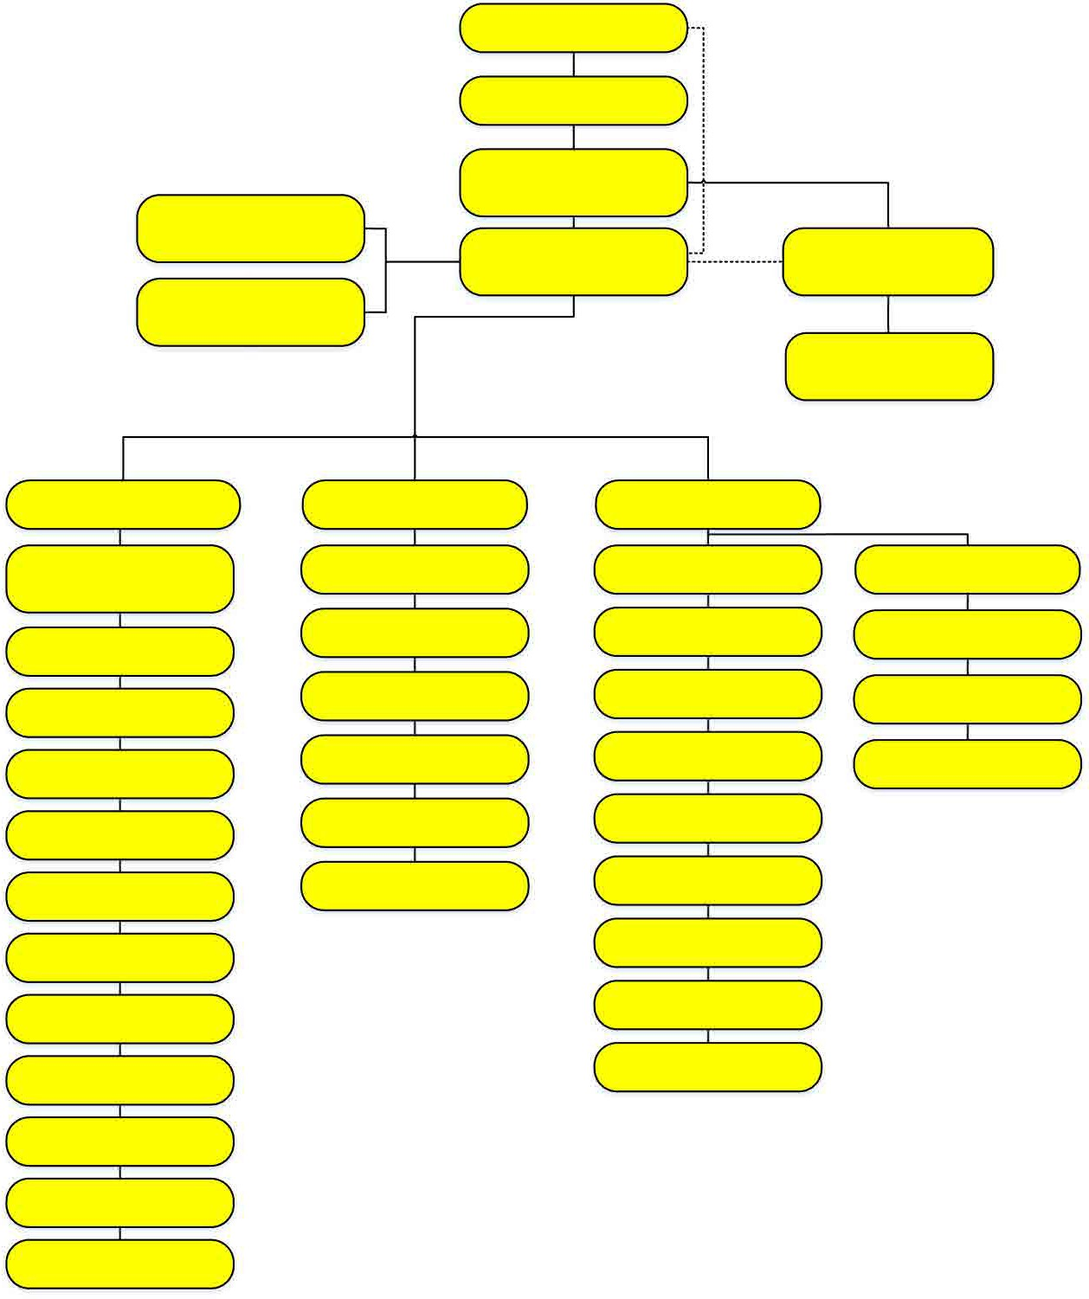

Board of Trustees

Dr. Martha Garcia President/CEO

Sierra Jenkins Walker Admin Specialist IV

Julie Ann Moreno Fiscal Specialist Audit A/P & Payroll

Morris Rodrigue

**Vice President, Administrative Services**

**Delana Miller**

**Chief Fiscal Services Oﬃce**

**Rosa Royce Chief Compliance and College Budget Oﬃcer**

Christine Lam Fiscal Services Analyst

Marisa Ziegenhohn Director, Fiscal Resources

Richard Lee Director, Payroll

Gabriela Sesma Director, Accounting

Emma Valenzuela Coordinator, Budget and Accounting

Kimberly Leisure-Bland Fiscal Specialist

Maria Kline Fiscal Specialist

Maria Correia Fiscal Specialist

Catherine Nguyen Fiscal Specialist

Yvette Shane Fiscal Specialist

Alsace Kam Fiscal Specialist

Kevin Truong Fiscal Specialist

Melanie Lazo Fiscal Specialist

Suzanne Ponce Fiscal Specialist

Lina Setiawan

Fiscal Specialist

Diana Morgan Fiscal Specialist

VACANT Coordinator, Payroll

Kasteel Gumban Coordinator, Payroll

JenMay Anol Retirement Specialist

Amy Cheung Fiscal Technician II

Lakshimi Fontecha Fiscal Technician II

Evelyn Ramirez Fiscal Technician II

Roshawn, Ruiz Fiscal Services Analyst

Fernando Madrigal Fiscal Specialist

Grace Espinoza Fiscal Specialist

Cathy Flores Fiscal Technician

Samantha Chan Fiscal Technician

Jenny Tjandra Fiscal Technician

Evelyn Hermosillo Fiscal Technician

Linda Tackett

Fiscal Technician II

Lia Mason

Fiscal Technician II

**VACANT Coordinator, Cashier’s Oﬃce**

Gazdag, Matt Fiscal Technician I

VACANT

Fiscal Technician I

Lisa Marie Hanlon Fiscal Technician I

Updated 3.12.24