april
28th
thru
30th
3
3
30

Mount San Antonio College • 1100 N. Grand Ave., Walnut, CA 91789

Writers’
Weekend
2017

Mount San Antonio College is hosting its 10th Annual Writers’ Weekend for aspiring writers from our college, other California colleges, and the surrounding community. Fiction, poetry, creative non-fiction writers, scriptwriters, actors, painters, sculptors, and all visual artists: this is your chance to network, workshop, and create with others who share your passion.

WHO IS INVITED
Workshops are available for all ages and experience levels, and we welcome anyone and everyone.

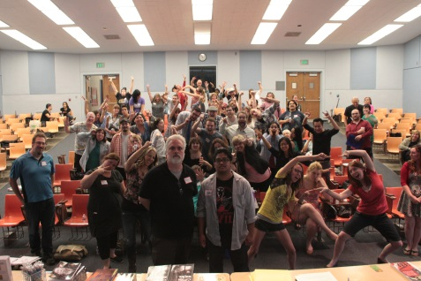

REGISTRATION
All conference attendees must complete the Writers’ Weekend application by March 31st, 2017. Contact us at laquino@mtsac.edu to obtain an application. A registration fee of $5 will cover expenses, such as guest speakers and food.

WRITERS’ WORKSHOPS
Generate new work with creative writing exercises and have your work critiqued by published writers, publishers, and fellow writers in a fun and comfortable environment. Get a unique look into professional writers’ creative process and share your knowledge and love of writing with others.

COLLEGE CREATIVE WRITING PROGRAMS
Learn about the options and opportunities available for a Masters’ degree in the Fine Arts (MFA) programs. Learn about these programs and the admission requirements, and start planning for your future.

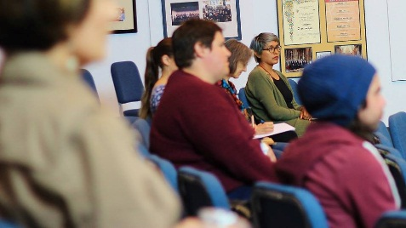

WORKSHOP LEADERS

T. Anders Carson (Poetry) is the author of the collections Death is Not the Worst Thing and I Knew It Would Come to This.

Nikia Chaney (Poetry) is a poet, community organizer, Cal State San Bernardino graduate, and the 2016-2018 Inlandia Literary Laureate.

Jo Scott-Coe (Creative Nonfiction) is an assistant professor of English at Riverside Community College. Her memoir, Teacher at Point Blank, is available through Aunt Lute Books.

Bonnie Hearn Hill (Fiction) is the author of six thrillers, a young adult astrology series, and Ghost Island, a paranormal romance. With Christopher Allan Poe, she wrote DIGITAL INK: Writing Killer Fiction in the e-book Age, a guide for writers.

Christopher Allan Poe (Fiction) is an author and touring musician from Los Angeles, CA. He writes paranormal thrillers, with an emphasis in themes that shed light on social problems for women and children.

YiShun Lai is the author of Not a Self-Help Book: The Misadventures of Marty Wu, and she is an editor the Tahoma Literary Review.

Stephanie Barbé Hammer is the author of How Formal?, a collection of poetry.

Other creative writing workshop leaders will be Syd Bartman, Pam Arterburn, Robert Piluso, Scott Creley, Michaelsun Knapp, Tim Hatch, Andrew Turner, and Elder Zamora.

PRESENTATION OF 2016-2017 WRITERS’ DAY PRIZES
Join us in congratulating our contest winners. This is an annual prize open to Mt. SAC students for fiction, creative non-fiction, poetry, and academic essays.

2017 WRITERS’ WEEKEND CONTEST
For the first time ever, we will have a contest for our attendees. The rules for the contest will be announced on the first day of the conference, and all entries will be due on Sunday, April 30th. Winners will be announced at the end of the conference.

LUNCH
Free pizza will be provided on Friday and Saturday of the conference; however, due to budgetary constraints, we will be unable to provide snacks and free water, so bring your own refreshments.

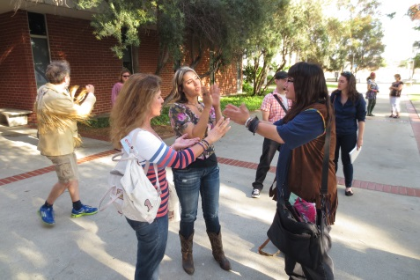

WE WOULD LIKE TO THANK
Mt. SAC English Department
Mt. SAC Theatre Department
Mt. SAC Humanities Division

OUR MISSION STATEMENT
We are committed to celebrating and cultivating the creative works of students at Mount San Antonio College and aspiring artists across the surrounding community.
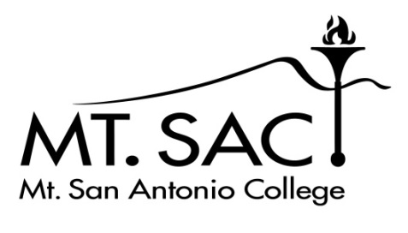

Mt. San Antonio College’s Tenth Annual Writers’ Weekend: April 28 – April 30, 2017

Application Form (JB247)
Application Deadline: April 1, 2017. Register soon. Spots are filling up.
Please Print Neatly

Name _______________________________________________________________________________

Street________________________________________________________________________________

City_____________________________________ State__________ Zip Code______________________

Phone ___________________________ Email ______________________________________________

What days do you plan to attend Writers’ Weekend? ___Friday 4/28 ___Saturday 4/29 ___Sunday 4/30

Classes, workshops, and other events will be scheduled from approximately 9am to 5pm on Friday and Saturday, and Sunday from 9am to 2pm. You may attend as many or as few of these sessions as you like. You will receive a schedule of events closer to the conference date.

You do not need to be a Mt. SAC student to attend the conference.

Student ID number (if you are a Mt. SAC student) ____________________________________

The registration fee for this event is $5. With your application, please include a check for $5 made out to “Mt. San Antonio College.”

____ I would like to apply for the fee waiver in lieu of paying the registration fee.

Send Application to: Questions? Email John Brantingham at
John Brantingham, English Department jbrantingham@mtsac.edu, or Lloyd Aquino
Mt. San Antonio College at laquino@mtsac.edu.
1100 North Grand Avenue
Walnut, CA 91789

