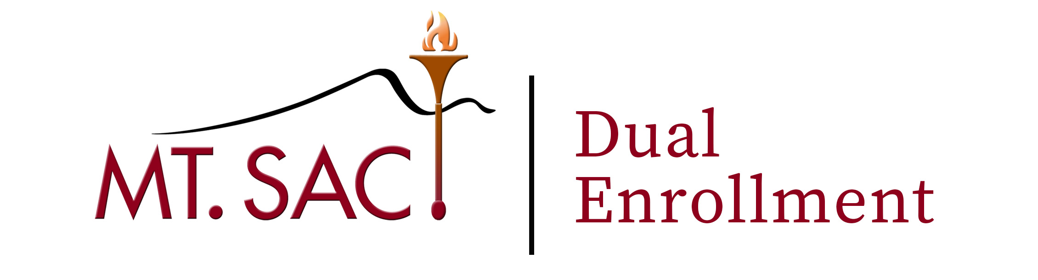

1100 North Grand Avenue · Walnut, CA 91789 · (909) 274-5422 · dualenrollment@mtsac.edu
Student Packet
______________
Student Name: _____________________________ Course*: ____________________
High School: _______________________________ Term: ______________________
Mt. SAC Student ID #: A______________________ Phone #: ____________________
Current grade level: _________________________ DOB: _______________________
Student Signature: X__________________________________________________________

Students must complete ALL required steps. Incomplete paperwork will not be accepted:
- Step 1. Apply to Mt. SAC Online Admissions Application (http://www.mtsac.edu/apply) for term attending
- Step 2. Retrieve Banner Student ID number (i.e. A01768659) and username (i.e. jmountaineer) from Mt. SAC Welcome email
- Step 3. Claim account - Username and Password (http://www.myportal.mtsac.edu)
- Step 4. Fill out High School Dual Enrollment Packet *
  - Parent forms (Signed by parent)
  - School Approval form (Signed by school principal/designee)
- Step 5. Attach “Welcome to Mt. San Antonio College” email copy to this packet
- Step 6. Register for course**
* A completed packet is required for each course the student plans to take.
** Students are advised to check portal for their specific course registration date and time.

Approval of Principal or Designee

The above named student is in the ____________ grade at _______________________School.
By signing this form I further certify that:
- This student is enrolled for at least the “minimum school day” (EC §48801);
- This student would benefit from “advanced scholastic or vocational work” (EC §48800);
- This course recommended is for enrichment purposes (EC §48800);
- The recommended course is not currently offered at this school;
- The recommended course is not alleviating an academic deficiency or being used to replace a school requirement.
- I have not given approval to more than 5 percent of the total number of pupils from this grade level to participate in this program (EC §48800) (d) (2). Courses to be taken by a Dual Enrollment student should be decided in concert with the school counselor. Students are able to enroll in any course if the course prerequisite is met. The student shall receive college credit for community college courses that have been successfully completed at the level determined by Mt. San Antonio College.
Principal/Designee Name: _____________________________Title: ______________________
(please print)
Principal/Designee Signature: _________________________________Date: ______________

1100 North Grand Avenue · Walnut, CA 91789 · (909) 274-5422 · dualenrollment@mtsac.edu
Parent/Guardian Approval
Parent or Legal Guardian Approval
It is imperative that parents and minors understand that as students they are entering a college environment, and that carries with it certain possible scenarios, not all of which can be anticipated. The average age of the Mt. SAC student has increased and the student body has become increasingly diverse in all respects. Thus, the atmosphere of classes will frequently reflect this diverse adult population. Some of the circumstances noted below are not different from the high school setting, while others are significantly different. These precautions are not meant to create undue concern for parents or the minor student, only to serve as an advisory to allow you to manage your particular situation so the minor will have a positive educational experience at Mt. San Antonio College.
Parents and students should be aware that:
- All college coursework and grades become a permanent part of the student’s official college academic history and transcript. Poor grades have a far-reaching effect on future entrance to the college or university of choice, scholarships, financial aid, awards, etc.
- Students must abide by the Student Code of Conduct and are subject to the Student Disciplinary Policy. All disciplinary incidents become a part of the student’s personal history.
- Students are expected to meet all deadlines, classes must be dropped within the deadlines, grade options selected, assignments turned in on time, etc.
- Attendance is required, but not monitored as it is in secondary school systems. Most likely, no one will call if a student is absent.
- Instructors cannot inform parents when classes are cancelled at the last minute or when the class ends early.
- Instructors cannot supervise a minor while they wait to be picked up.
- Courses may include frank discussions on sensitive topics.
- Audio-visual presentations may be graphic in their content.
- Students may be exposed to vulgar language outside of the classroom.
- Students may access pregnancy testing, HIV testing and condoms through the Health Center.
- Group work or class presentations may be expected in class. If required, these activities will be required of all students, regardless of age.
Right to Access
Under section 49061 of the Education Code, parents of community college students do not have a right to access their children’s student records, regardless of whether the student is under the age of 18. In accordance with this regulation, the student’s college records will be released to parents only with the written consent of the student.
I give my approval for the student named above, a minor in my care, to attend Mt. San Antonio College as a Special Admit student.

I verify that I have read this form and understand the responsibilities and expectations of my child taking a Mt. San Antonio College course. I also understand and agree to the possibility that my child may be exposed to adult oriented themes and discussions while in class.

I also have read and understand that according to state and federal regulations, my minor’s college records are available to me only with written consent of the student. Under section 49061 of the Education Code, parents of community college students do not have a right to access their children’s student records, regardless of whether the student is under the age of 18. In accordance with this regulation, student’s college records will be released to parents only with the written consent of the student.
Parent Signature: ___________________________________Date: ______________________________

1100 North Grand Avenue · Walnut, CA 91789 · (909) 274-5422 · dualenrollment@mtsac.edu
Student Checklist

Please read all boxes carefully and check the appropriate box. | Yes | No
My school principal or designee has recommended me.
I have parental approval to participate in the program.
I have completed the Mt. SAC placement test or Assessment Questionnaire (if applicable).
I meet all prerequisites for the class I plan to take including Math/English.
I have read the “Parent/ Guardian Approval” information sheet and agree to abide by the student code of conduct.
I understand that if I do not make satisfactory progress in my course I will not be allowed to continue participating in this program.
I understand that I can only enroll upon approval.

Student signature: X______________________________________ Date: __________________

