Mt. San Antonio College

Year-End Report to Academic Senate, Spring 2021

Contact & Resources Information

Program: Distance Learning

Contact: Meghan Chen, mchen@mtsac.edu, ext. 5888; at home during shelter in place
Carol Impara, cimpara@mtsac.edu, ext. 6369; at home during shelter in place

Committee: Distance Learning Committee (DLC)

Members: Meghan Chen and Carol Impara, co-chairs
Matthew Dawood, Michael Dowdle, Hong Guo, Mike Hood, L.E. Foisia, Tammy Knott-Silva, Catherine McKee, Stacie Nakamatsu, Michelle Newhart, Richard Patterson, Eric Turner, Sandra Weatherilt, and Jem Bonfiglio and Leonardo Rojas, student representatives

Distance Learning Committee Home Page
http://www.mtsac.edu/dlc/

Distance Learning Program Home Page
http://www.mtsac.edu/distancelearning/

AP 4105 on Distance Learning revised September 2016
http://www.mtsac.edu/governance/trustees/apbp/AP4105.pdf

Distance Learning Program Faculty Resources Page
http://www.mtsac.edu/distancelearning/faculty.html

Distance Learning Program Student Resources Page
http://www.mtsac.edu/distancelearning/student-home.html

Skills and Pedagogy for Online Teaching (SPOT)
http://www.mtsac.edu/distancelearning/spot.html/

SPOT Recertification Page
https://www.mtsac.edu/distancelearning/spotrecert.html

SPOT-Certified Faculty
https://www.mtsac.edu/distancelearning/spot-faculty.html

DL Amendment Forms
https://www.mtsac.edu/dlc/dl-forms.html

Approved DL Amendment Forms
https://www.mtsac.edu/dlc/approveddlalpha.html

Faculty Center for Learning Technology Home Page
http://www.mtsac.edu/fclt/

Classroom Visitation Evaluations of Distance Learning Faculty – form H.4.c

Student Evaluations of Distance Learning Faculty – form H.2.e

Canvas
https://mtsac.instructure.com/

Distance Learning Committee Purpose and Function

Purpose:

The purpose of the Distance Learning Committee is to discuss, review, and evaluate distance learning modes of instruction, and recommend and promote best practices and new opportunities for distance learning and teaching.

Function:

Evaluate and recommend approval of Distance Learning Course Amendment Forms
- Recommend policy changes pertaining to distance learning
- Evaluate and promote a variety of effective practices and standards for distance learning
- Support sharing and collaboration among distance learning faculty by working with the
Faculty Center for Learning Technology, Information Technology, and the Faculty Learning Activities Committee
- Facilitate the development of an ongoing Distance Learning Master Plan
- Coordinate with campus committees and other constituencies with regards to distance learning
- Support accreditation processes

Program Mission

The mission of the Distance Learning Program is to foster and promote innovation, excellence, and best practices for online instruction, to provide Mt. SAC faculty with assistance, leadership, expertise, and training in new online teaching and learning technologies, including use in the traditional classroom.

Distance Learning Committee Goals 2020 – 2021

Goal #1: Maintain Distance Learning Committee Website
Links to College Goal # 6, 11, 14

Completed Outcomes/Accomplishments
The DLC website is regularly updated with Committee minutes.

The website has also been updated with the recommendations made by the DLC since the COVID epidemic.
https://www.mtsac.edu/dlc/recommends_resolutions.html

- Recommendations for Camera Use in Online Synchronous Classes - December 2020
- Recommendations for Online Proctoring - December 2020
- Guidelines for Synchronous Online Instruction - June 2020
- Recommendations for Online Campus Offerings in Summer and Fall 2020 - April 2020
- Recommendations for Instructional Continuity - March 2020
- New Distance Learning Course Amendment Form to meet Title 5 Requirements - March 2020

The website has also been updated with resolutions the DLC was involved in.
- 2020 - xx: Emergency COVID-19 Response: Endorse the DLC Recommendations
- 2020 - xx: Emergency COVID-19 Response: Temporary Remote Instruction
- 2020 - 01: Support for the CVC OEI Course Design Rubric

The DL coordinators maintain the smartsheet that lists SPOT-certified faculty and faculty that have achieved SPOT recertification. This smartsheet is accessed via a separate webpage.

A special webpage that explains SPOT recertification, lists approved courses, and provides access point to submit evidence was created in October 2019. It has been updated to reflect courses the DLC approves for SPOT recertification multiple times during the 2020-2021 year.

The DL Forms webpage has been updated to explain the new DL Amendment form submission process through WebCMS and include a link to the instructional video.

Goal #2: Review/revise/approve Distance Learning Amendment Forms.
Links to College Goals # 1, 3, 6, 14

Completed Outcomes/Accomplishments
At a joint meeting hosted by representatives of the CCCCO and ASCCC on Monday, April 13, 2020, it was announced that, as of Summer 2020, online course work would be considered distance education (our DL) and therefore would be subject to DE Addendum (our DL Amendment Form) and local training requirements. Campuses were required to complete DE Addenda for all courses offered online during summer and fall by December 31, 2020.

With nearly 95% of our courses moving online, the DLC estimated that over 1,500 courses would need DL Amendment forms created, reviewed, and approved. The following actions were taken in response.
- In a special meeting with the Chancellor’s Office, Mt. SAC requested and was granted an extension of DL Amendment forms until June 2021.
- The DLC recommendation “Online Course Offerings for Summer and Fall 2020” (April 2020) provided a guideline for a new online category, FOMA – Fully Online by Mutual Agreement.
- Two methods of submitting forms were readied. The Title 5-compliant DL Amendment word document approved by Academic Senate on March 26, 2020 would continue to be used for traditional DL offerings and was accessed via a smartsheet. A new supplemental form in WebCMS was made available Fall 2020 for FOMA and traditional DL.
- A faculty workgroup consisting of the DL Faculty Coordinator (who oversees this process) and eight faculty (six credit, two noncredit) was convened to review forms. The workgroup met weekly during semesters and intersessions. While Mt. SAC had estimated that the faculty workgroup would review 30 forms per week, the group exceeded that goal and reviewed 40 forms per week. The Distance Learning Committee approved faculty workgroup recommendations during scheduled meetings. These forms were then forwarded to EDC via standard procedure.
- The faculty workgroup created an instructional document and a video to instruct faculty how to create their DL Amendment forms. These instructional materials were sent to department chairs and were posted on the DLC website over summer 2020.
- After noncredit faculty expressed concern that their courses would not fit the current DL Amendment form model, a faculty workgroup was convened over late spring and summer 2020, consisting of eight noncredit and credit faculty. Faculty reviewed DE addenda from other colleges and created a correspondence course form, which was approved by Academic Senate for noncredit use on November 12, 2020.

As of May 1, 2021, the DLC has approved 979 courses in the 2020-2021 year.

At our current rate of review, the DLC expects the DL Amendment form review will be completed by the end of summer 2021.

Comparisons:
2019-2020 – DLC approved 156 courses
2018-2019 – DLC approved 68 courses
2017-2018 – DLC approved 94 courses
2016-2017 – DLC approved 22 courses
2015-2016 – DLC approved 9 courses

Goal #3: Review opportunities and resources provided by the California Virtual Campus (CVC) and make recommendations for participation and/or adoption.
Links to College Goal # 1, 2, 4, 6, 7, 8, 13, 14

Completed Outcomes/Accomplishments
Mt. SAC was an initial member of the CVC Consortium, a group of 65 colleges working together to address online achievement gaps. Both of the DLC co-chairs attend CVC meetings once a semester, as well as monthly DE Coordinator’s meetings. During the pandemic, the CCCCO, through the CVC, provided a variety of online tools such as CidiLabs, Labster, Pronto, and Canvas Studio.

With DLC’s support, Mt. SAC’s Distance Learning program applied for and received two Improving Online CTE Pathways Grants. Originally slated to end June 2020, the deadline for grant activities was extended to December 2020. The following activities were achieved through the grant and supported by DLC.
- Creation of Peer Online Course Review (POCR) team and shepherding of courses through CVC Course Design Rubric. The DL Coordinator is the POCR Lead; the Assistant DL Coordinator is also on the team.
  - DLC had introduced and Academic Senate passed Resolution 20-01 in Support of the California Virtual Campus – Online Education Initiative Course Design Rubric on February 27, 2020
  - POCR team members were required to complete a 40-hour training and regular norming sessions
  - Mentored 20 faculty for Quality Review using the CVC Course Design Rubric
  - 6 faculty achieved Quality Review; 4 ready to be submitted; 8 in the pipeline
  - POCR team members held a 1-hour training
  - POCR team surveyed participants, integrated feedback; overall positive response
- 21 faculty in 2 cohorts completed @ONE’s Equity and Culturally Responsive Teaching
  - DLC reviewed positive feedback and recommend continuing offering this program
  - Survey also indicated acceptance of Peralta Equity Rubric
- 16 faculty created OER resources
- Student outreach
  - Formed student mentoring group (Canvasadors)
  - Mapped cross-functional activities for student journey with counseling, IT, Studio 13
- Visibility of online CTE certificates increased via advertising, social media, and Mt. SAC web
- Piloted template for online courses via Studio 13

Goal #4: Provide guidance/input to Distance Learning Coordinators, Instruction Office and Educational Design Committee (EDC) on the integration of the DL Amendment Form into the WebCMS Curriculum system, including tracking for Accreditation Substantive Change Triggers.
Links to College Goal # 6, 12, 14

Completed Outcomes/Accomplishments
The DL Amendment supplemental form is now integrated in WebCMS. However, the volume of WebCMS amendments flooding the system led to workarounds and some interruptions in service.
- The focus is on reviewing the forms that were submitted before December 31, 2020.
- A process for evaluating new forms and a substantive change process still needs to be finalized.

Goal #5: Make recommendations for improving support, equity, and success for diverse online learners based on various data sources.
Links to College Goal # 1, 3, 9, 11, 14

Completed Outcomes/Accomplishments
Dean of Library Learning Resources Dr. Meghan Chen and DL Faculty Coordinator Carol Impara presented a report on the Distance Learning program to the Board of Trustees on November 4, 2020, using data from Spring 2020.
In Spring 2020, the College offered online, hybrid, and in-person, face-to-face (F2F) classes until March 31. After this date, online classes stayed online; hybrid classes became fully online; and F2F classes became Temporary Remote Instruction (TRI). 6% of traditional F2F classes did not transition to online.
Retention
The overall retention rates in online classes in Fall 2019 was 85%. In Spring 2020, it was 78%.
When classes were held F2F in Fall 2019, the overall retention rate was 88%. In Spring 2020, in the face-to-face then TRI classes, it was 72%.
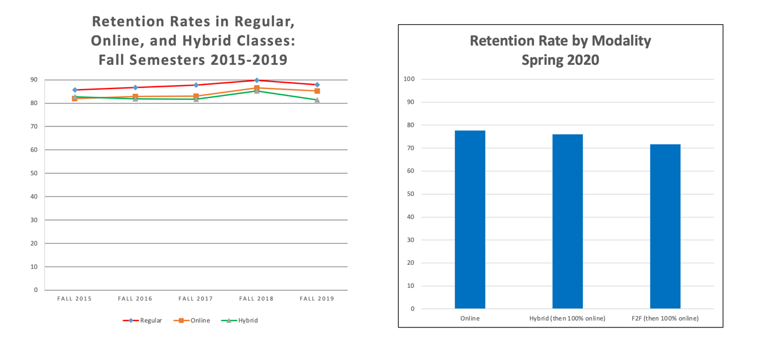

Success Rates

Student Success Rates | Fall 2019 Online | Spring 2020 Online  All Semester | Spring 2020 Hybrid, then online | Spring 2020 F2F,  then TRI
Overall | 62% | 71% | 69% | 63%
Black/African American | 50% | 55% | 44% | 50%
Asian American | 82% | 86% | 83% | 79%
Latinx | 61% | 61% | 42% | 50%
Caucasian/White | 72% | 71% | 72% | 68%

Overall Success Rate

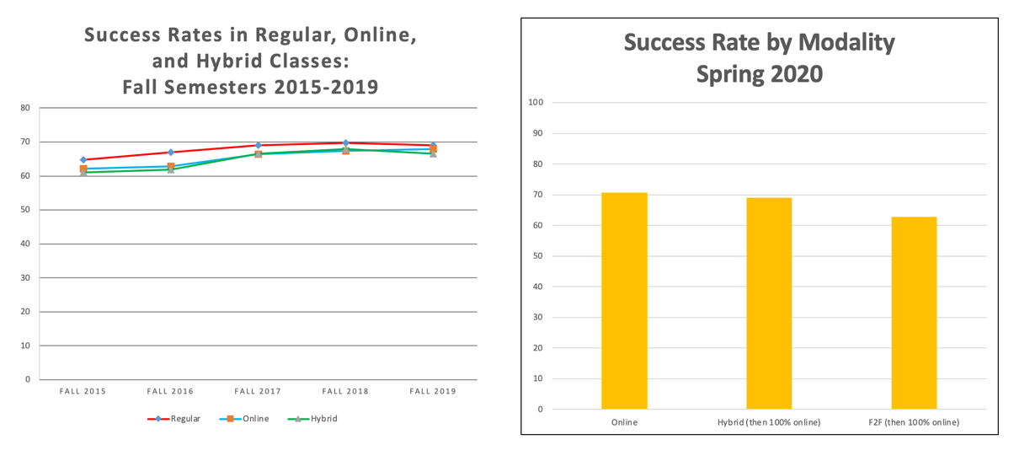

Success by Racial Group

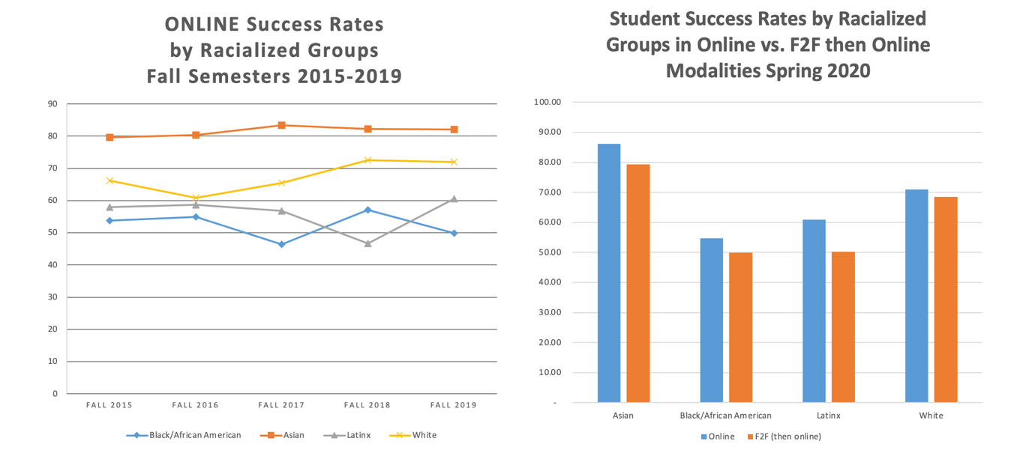

The DLC notes the discrepancy in online achievement and supports the following:
- Support offering equity training such as @ONE’s Equity and Culturally Responsive Teaching (ECRT)
- Working with the Online Equity Coordinator to promote online equity initiatives
- Working with the Online Equity Coordinator to update SPOT training
- Selection of an equity rubric such as the Peralta Equity Rubric for online faculty self-reflection

Goal #6: Review/recommend faculty training for Distance Learning.
Links to College Goal # 8, 10, 12, 14

Completed Outcomes/Accomplishments
SPOT (Skills and Pedagogy for Online Teaching)
SPOT continues as Mt. SAC’s principal training for online teaching. It is an asynchronous, self-paced, competency-based course and is overseen by the Assistant DL Coordinator.
- Since June 1, 2020, 211 faculty have been newly online certified.
- 611 faculty have signed up for SPOT since March 2020.
- 654 faculty are currently in SPOT.
- As of April 27, 2021, 485 faculty are certified to teach online at Mt. SAC.

SPOT has been updated to reflect the campus inclusion of synchronous teaching and stringent accessibility guidelines.
- Added an abbreviated sample course to demonstrate best practices
- Added synchronous best practices section
- Updated Canvas pages to use CidiLabs, increasing accessibility
- Revamped SPOT rubric
- Updated references to CVC Course Design Rubric
- Improved accessibility education based on participant feedback

Because of the number of faculty in SPOT, the SPOT evaluation team was increased from one (Assistant DL Coordinator) to include two part-time reviewers. Optional synchronous help included:
- Assistant DL Coordinator held weekly SPOT office hours via Zoom on Monday afternoons.
- SPOT reviewers presented several SPOT “how to” seminars on Wednesday mornings, including accessibility problem areas, how to create a Home page, and SPOT precheck.

Alternatives to SPOT include earning a badge from @ONE Introduction to Asynchronous Online Teaching and Learning (formerly Introduction to Online Teaching and Learning) and the Online Teaching and Design certificate. The DLC is reviewing other equivalency options and will make a recommendation later this semester.

Comparison to previous years:
2019 – 2020: 45 faculty newly online certified
2018 – 2019: 49 faculty newly online certified
2017 – 2018: 29 faculty newly online certified
2016 – 2017: 20 faculty newly online certified
2015 – 2016: 10 faculty newly online certified

SPOT Recertification
SPOT recertification rolled out September 1, 2019. The original recertification deadline of July 31, 2020 was extended to December 31, 2020 due to campus disruption caused by the pandemic.
- 136 faculty achieved recertification by their December 31, 2020 deadline.
- The SPOT-certified faculty list was updated to reflect retirements.
- 17 of 23 faculty whose recertification deadline is July 31, 2021 have achieved recertification.
- 17 of 35 faculty whose recertification deadline is July 31, 2022 have achieved recertification.
- A process for reinstating lapsed SPOT certification was recommended by DLC in March 2021.

DLC approves SPOT recertification training. The following training was approved during 2020-2021:

- Lights! Camera! Caption! Accessible Courses Made Easy
- Course Design Shortcuts: Borrow, Share, and Leverage Tools to Create Student-Friendly Canvas Courses
- Build Better Courses, Faster, with CidiLabs in Canvas
- Next Level Design with Cidi Labs DesignPlus
- Ally: Your Partner for Simplifying Accessibility in Canvas
- Exam Proctoring in Canvas
- Build Your Class Community with Pronto, Warm Up Activities, and More
- Easy and Engaging Videos in Canvas Studio
- The New and Improved Zoom in Canvas
- Show and Tell with VoiceThread and Closed Captioning
- Make Your Online Course Exemplary with CVC Quality Review
- Creating Dynamic Lectures Online Part A
- Creating Dynamic Lectures Online Part B
- Virtual Facilitation Tools
- Creating an Equity Minded, Universally Designed Syllabus in Canvas
- Humanizing Your Online Course
- 5 Tools to Make You an Accessibility Champ
- @ONE badges for: Equity and Culturally Responsive Teaching; Humanizing Online Teaching and Learning; Creating Accessible Course Content

FOMAR (Fully Online by Mutual Agreement Readiness)
As the campus prepared to move online in March 2020, the DLC recommended FOMAR (Fully Online by Mutual Agreement Readiness) training for faculty to quickly prepare to pivot online. Over 1,000 faculty members completed the four-hour Fully Online by Mutual Agreement Readiness (FOMAR) training in order to teach online courses in Summer and Fall 2020. FOMAR training was designed, built, and implemented by the Faculty Center for Learning Technology (FCLT), DL Faculty Coordinators, and Professional and Organizational Development.
The DL Coordinator sits on FPDC and the Assistant DL Coordinator sits on FLAC in order to facilitate communication between DLC, FPDC, and POD.

Goal #7: Review and make recommendations to update policies and procedures as they pertain to Distance Learning, including AP 4105.
Links to College Goal # 1, 14

Completed Outcomes/Accomplishments
AP 4105 has not been revised since 2016. The DLC has been working on incorporating new Title 5 regulations from March 2019, new federal regulations going into effect July 2021, recommendations from the REC Task Force that were accepted by Academic Senate on February 27, 2020, and new practices that have evolved after the pandemic, such as synchronous teaching.

Goal #8: When requested by Faculty Association, make recommendations to address contract language related to Distance Learning.
Links to College Goal # 10, 14

Completed Outcomes/Accomplishments
The DLC reviewed materials on HyFlex to give feedback to Faculty Association. The DL Coordinators have met with Faculty Association to give input on workload and training requirements.

Goal #9: Provide leadership and input on educational trends pertaining to Distance Learning, including policies related to equity and guided pathways.
Links to College Goal # 10, 14

Completed Outcomes/Accomplishments
The Distance Learning Committee has responded to Academic Senate requests for recommendations for the new online environment.

In June 2020, DLC prepared Guidelines for Synchronous Online Instruction to set forth standards and best practices for online synchronous instruction.
- A synchronous online Community of Practice has been started with faculty facilitators and guest speakers. Starting in April 2021, the group meets the third Friday of the month at noon.

In December 2020, DLC created Recommendations for Camera Use in Online Synchronous Classes and Recommendations for Online Proctoring in response to requests from Academic Senate Exec Board.

- A Cabinet workgroup is following up with one of the recommendations on camera use to discuss the legalities of recording students.
- Following one of the recommendations in the Online Proctoring document, the Assistant DL Coordinator is partnering with the FCLT, faculty, and students to evaluate online proctoring tools in anticipation of the end of the contract with Proctorio. The proctoring workgroup will finalize recommendations in the first week of May.

As part of the Improving Online CTE Pathways grant, 21 faculty completed Equity and Culturally Responsive Teaching (ECRT) and participated in a survey to gauge the usefulness of the Peralta Equity Rubric. The feedback on both was excellent and the DLC recommends both.

Goal #10: Provide leadership and oversight for the college’s compliance with Accreditation Standards pertaining to Distance Learning.
Links to College Goals # 1, 9, 13, ,14

Completed Outcomes/Accomplishments
- Distance learning regulations and accreditation standards comprise a separate module in SPOT. SPOT reviewers ensure that certification courses meet college, state, and federal guidelines.
- As part of SPOT recertification, SPOT-certified faculty are required to take a 1-hour Regulations Update course that describes accreditation standards of: equivalency to in-person courses; definitions and guidelines for regular and substantive interaction, and where they can be found; a description for the college’s LMS features that facilitate regular and substantive interaction; and evidence of faculty training on best practices for online learning.
- A new DL Amendment form, approved March 26, 2020, integrated Title 5 regulations.
- DLC Minutes include accreditation standards that are met during committee activities.

Submitted by: Carol Impara, Distance Learning Faculty Coordinator

