Distance Learning Committee (DLC)

Report to Academic Senate

September 30, 2021

California Virtual Campus (CVC) Updates
POCR Update
- Mt SAC is now officially a POCR-certified campus! POCR stands for Peer Online Course Review. The POCR team reviews faculty courses to determine alignment with the CVC Course Design Rubric. This is an intensive mentoring process that ensures your course meets quality specifications, including a complete accessibility update.
- If you are interested in submitting your fully online, asynchronous course for CVC Quality Review, please contact Carol Impara at cimpara@mtsac.edu. The local POCR team received a SEAP grant to continue POCR certification. Stipends are available to faculty who complete the POCR process by the end of the grant. And, we have hired an accessibility specialist who can help get your course up to stringent accessibility standards! The grant ends June 30, 2022.
- Want more information? Please attend the orientation, Make Your Course Exemplary with CVC Quality Review, on Friday November 5 at 10 a.m. Register via POD Connect.

Student Exchange Update
The CVC sponsors two ways for students to find and enroll in online classes across the state.
- An online course directory at cvc.edu posts available online courses, sortable by CSU or IGETC requirements, course name, or keyword. Students who find courses using this method must enroll and register at colleges in the usual way. This service used to be called Finish Faster Now.
- The Student Exchange is a system by which students at participating colleges can take online courses at another college without going through a separate enrollment process.
  - A student must be enrolled in a Home College to participate.
  - Courses at Teaching Colleges are available for cross-enrollment.
  - The Teaching College gets credit for the enrollment; the Home College gets credit for the certificate or degree.
Number of Home Colleges: 59
Number of Teaching Colleges: 11
- Mt. SAC is currently a Home College, and is aiming to be a Teaching College in Spring 2022.
Maximum cross-enrollments per semester per student: 2
Number of cross-enrollments over the past year: 651
Courses from Teaching Colleges show on student transcripts.
Courses are searchable by category. Within a category, Home Colleges appear first, then eligible Teaching Colleges. Within each College, quality reviewed courses come up first.
Most student searches are for STEM courses.

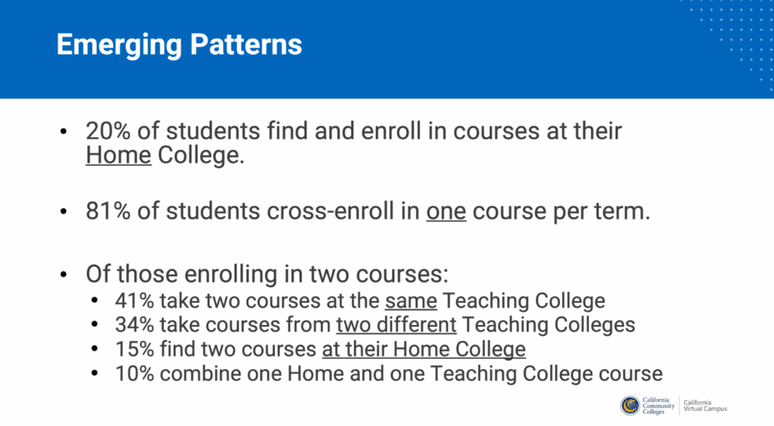
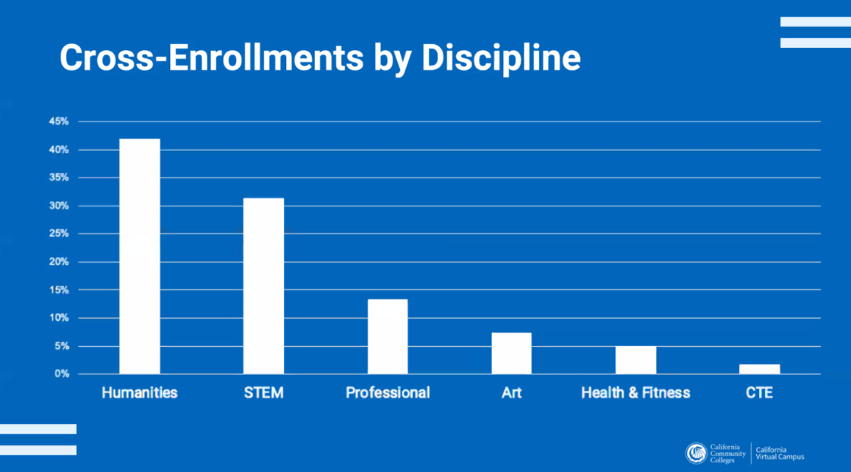
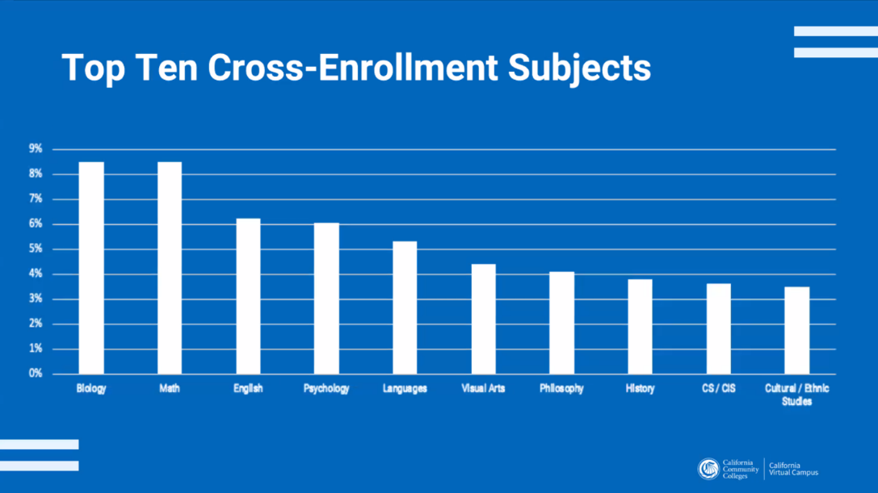

SPOT Reminders – Submit Early!
When we return to campus in fall, online teachers must be SPOT certified.
- Submit your SPOT course by October 1 for certification by Spring 2022. Actual certification timing depends on original course condition, faculty responsiveness, task completion, and accessibility issues. SUBMIT EARLY! We have three reviewers working this fall and winter to certify faculty.
- The SPOT equivalent is the 4-week Introduction to Asynchronous Online Teaching and Learning (formerly IOTL, now IAOTL) offered through @ONE. Send your badge to Catherine McKee.
- Faculty who completed the 12-week Online Teaching and Design (OTD) certificate through @ONE can also earn SPOT certification. Send your badge to Catherine McKee.
- The Distance Learning Committee is in the process of evaluating other college trainings, pending Academic Senate approval. Stay tuned.
Please contact Catherine McKee, Assistant Distance Learning Coordinator, for more information. cmckee@mtsac.edu

Faculty Facilitators
Faculty Facilitators are back! Faculty experienced in online teaching and Canvas can answer your setup and design questions. We have faculty experienced in graphic design, equations editors, and synchronous classes.

Faculty facilitators can reached through the email facfac@mtsac.edu.

Respectfully submitted,
Carol Impara
Distance Learning Faculty Coordinator
POCR Lead
cimpara@mtsac.edu

